Task Guide A05
Introduction and setup project
- Objective
Student learn how to make Instagram’s Bottom Navigation bar
- Requirement
Hardware:
- 4 GB RAM minimum, 8 GB RAM recommended
- 15 GB of available disk space minimum (2 GB for Flutter SDK, 8 GB for Android Studio, 4 GB for AVD, and 1 GB for project’s size)
- 1280 x 800 minimum screen resolution
- Intel processor with support for Intel VT-x, Intel EM64T (Intel 64), and Execute Disable (XD) Bit functionality
Software:
- Microsoft Windows 7/8/10/11 (64-bit)
- JDK 8
- Android Studio IDE
- Git
- Resource
Starter project code : https://github.com/chrisdionisius/clone-instagram-login.git
- Task Description
In this task, student will be implementing a clone of Instagram's Bottom Navigation bar
using Flutter and various widgets such as StatefulWidget, Scaffold, Column, Container, and more. This exercise will help student understand how to structure a Flutter application, utilize different widgets, and build a user interface resembling Instagram's Bottom Navigation bar.

Specification
- Clone project from https://github.com/chrisdionisius/clone-instagram-login/tree/Starter-Code (make sure clone it from code-starter branch) or using the manual setup if you encounter error during cloning project, refer to Guide A.01
- Run flutter pub get in the terminal or if you are using Microsoft Visual Studio Code you could click on Get Package button.
- Using this specification make a list of some widgets below :
- Open bottom_navbar.dart under lib\app\widgets\bottom_navbar.dart directory make sure it is extended from StatelessWidget.
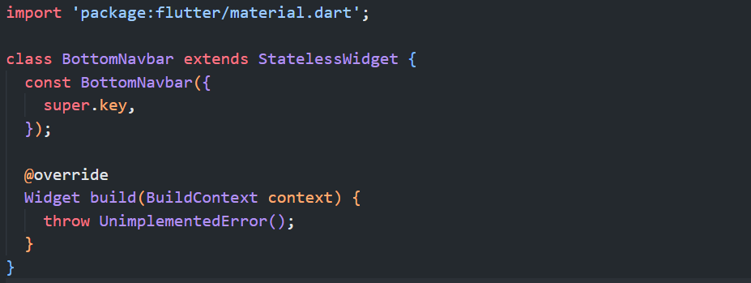
- Add these import
import 'package:example_widget_testing/core/values/constant/navbarmenu_json.dart';
import 'package:flutter_svg/svg.dart';

- Add this parameters to BottomNavbar class
final int pageIndex;
const BottomNavbar({
super.key,
required this.pageIndex,
});

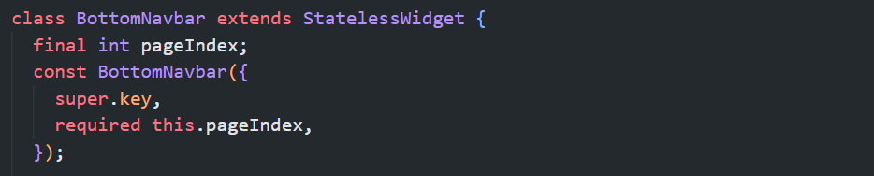
- Add this function inside build method
void navigateToPage(int index) {
Navigator.pushNamed(context, navbarMenuList[index].path!);
}

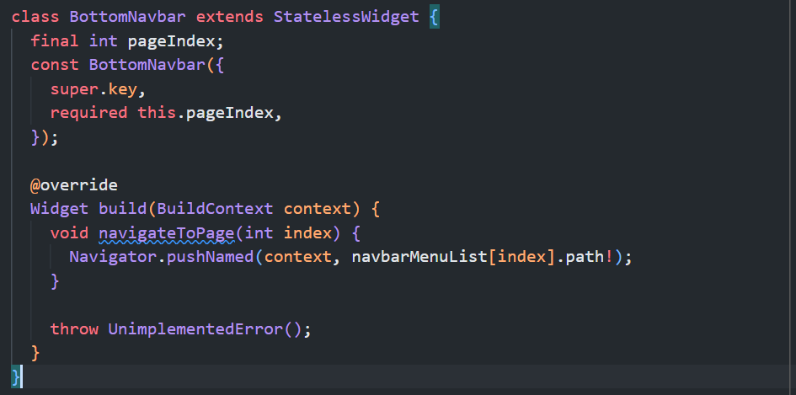
- Add Container widget as return following this specifications :
No | Widget | Property | Value
1 | Container | key | Key("bottom_navigation_bar_container")
 |  | width | double.infinity
 |  | height | 55
 |  | color | Colors.black
 |  | padding | EdgeInsets.only(  left: 20, right: 20, bottom: 20, top: 15)
 |  | child | Row(  key: const Key("bottom_navigation_bar_row"))
Row(key: const Key("bottom_navigation_bar_row")) properties :
2 | Row | key | Key("bottom_navigation_bar_row")
 |  | mainAxisAlignment | MainAxisAlignment.spaceBetween
 |  | children | List.generate(navbarMenuList.length, (index) {  return InkWell(  key: Key("bottom_item_$index"),  onTap: () => navigateToPage(index),  child: SvgPicture.asset(  pageIndex == index  ? navbarMenuList[index].activeIcon!  : navbarMenuList[index].inactiveIcon!,  width: 27,  ),  );  })

return Container(
key: const Key("bottom_navigation_bar_container"),
width: double.infinity,
height: 55,
color: Colors.black,
padding: const EdgeInsets.only(left: 20, right: 20, bottom: 20, top: 15),
child: Row(
key: const Key("bottom_navigation_bar_row"),
mainAxisAlignment: MainAxisAlignment.spaceBetween,
children: List.generate(navbarMenuList.length, (index) {
return InkWell(
key: Key("bottom_item_$index"),
onTap: () => navigateToPage(index),
child: SvgPicture.asset(
pageIndex == index
? navbarMenuList[index].activeIcon!
: navbarMenuList[index].inactiveIcon!,
width: 27,
),
);
}),
),
);

- Open home_page.dart file, add this import so BottomNavbar widget will be accessible from this page.
import '../../widgets/bottom_navbar.dart';

- Find Scaffold widget with key home_page_scaffold, add bottomNavigationBar property
bottomNavigationBar: const BottomNavbar(
key: Key('home_page_bottom_navbar'),
pageIndex: 0),

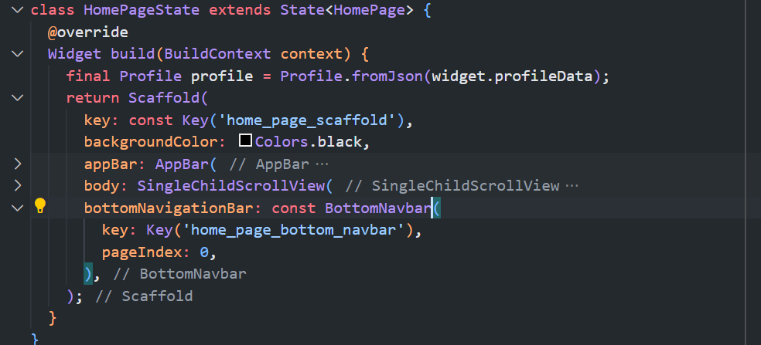

- Run the project and check if there’s no error it will return home page similar like this.
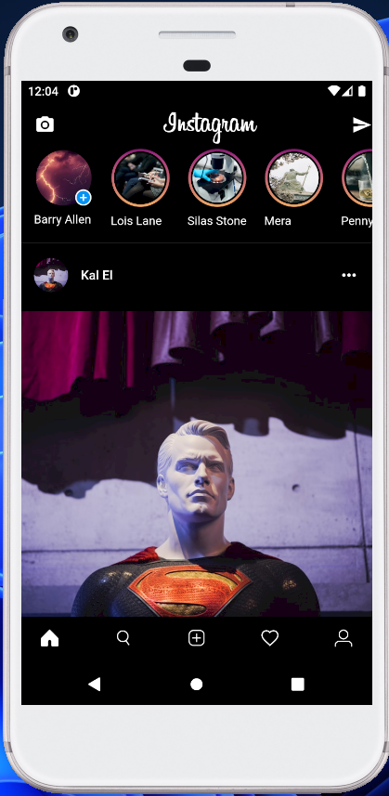

Testing
- Open home_page_test.dart file under test folder
- Find main method it will look similar like this
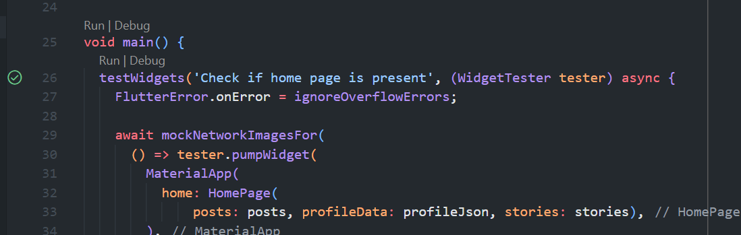
- Click Run
- Make sure these 8 test are passed
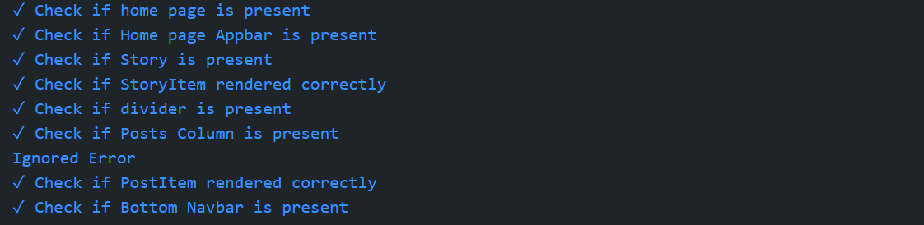
- If there is an error try to check the message and fix the error usually It’s because of wrong key name or missing property of specific widget

FULL CODE

BottomNavbar
import 'package:example_widget_testing/core/values/constant/navbarmenu_json.dart';
import 'package:flutter/material.dart';
import 'package:flutter_svg/svg.dart';

class BottomNavbar extends StatelessWidget {
final int pageIndex;
const BottomNavbar({super.key, required this.pageIndex});

@override
Widget build(BuildContext context) {
void navigateToPage(int index) {
Navigator.pushNamed(context, navbarMenuList[index].path!);
}

return Container(
key: const Key("bottom_navigation_bar_container"),
width: double.infinity,
height: 55,
color: Colors.black,
padding: const EdgeInsets.only(left: 20, right: 20, bottom: 20, top: 15),
child: Row(
key: const Key("bottom_navigation_bar_row"),
mainAxisAlignment: MainAxisAlignment.spaceBetween,
children: List.generate(navbarMenuList.length, (index) {
return InkWell(
key: Key("bottom_item_$index"),
onTap: () {
navigateToPage(index);
},
child: SvgPicture.asset(
pageIndex == index
? navbarMenuList[index].activeIcon!
: navbarMenuList[index].inactiveIcon!,
width: 27,
),
);
}),
),
);
}
}

HomePage
import 'package:example_widget_testing/app/modules/home/components/user_story.dart';
import 'package:example_widget_testing/app/widgets/post_item.dart';
import 'package:example_widget_testing/app/modules/home/components/story_item.dart';
import 'package:flutter/material.dart';

import '../../../core/theme/colors.dart';
import '../../data/models/profile.dart';
import '../../widgets/bottom_navbar.dart';

class HomePage extends StatefulWidget {
const HomePage({
super.key,
required this.posts,
required this.stories,
required this.profileData,
});
final List posts;
final List stories;
final Map<String, dynamic> profileData;

@override
HomePageState createState() => HomePageState();
}

class HomePageState extends State<HomePage> {
@override
Widget build(BuildContext context) {
final Profile profile = Profile.fromJson(widget.profileData);
return Scaffold(
key: const Key('home_page_scaffold'),
backgroundColor: Colors.black,
appBar: AppBar(
key: const Key("home_page_appbar"),
backgroundColor: Colors.black,
leading: const Icon(
key: Key('home_page_camera_icon'),
Icons.camera_alt,
),
title: const Center(
key: Key('home_page_title_center'),
child: Text(
key: Key('home_page_title_text'),
"Instagram",
style: TextStyle(fontFamily: 'Billabong', fontSize: 35),
),
),
actions: const <Widget>[
Icon(key: Key('home_page_send_icon'), Icons.send),
],
),
body: SingleChildScrollView(
key: const Key('home_page_single_child_scroll_view'),
child: Column(
key: const Key('home_page_column'),
children: <Widget>[
SingleChildScrollView(
key: const Key('stories_scroll_view'),
scrollDirection: Axis.horizontal,
child: Row(
key: const Key('stories_row'),
children: <Widget>[
const UserStory(key: Key('user_story')),
Row(
key: const Key('following_stories_row'),
children: List.generate(
widget.stories.length,
(index) {
return StoryItem(
key: Key('story_item_$index'),
img: widget.stories[index]['img'],
name: widget.stories[index]['name'],
);
},
),
),
],
),
),
Divider(
key: const Key('home_page_divider'),
color: white.withOpacity(0.3),
),
Column(
key: const Key('posts_column'),
children: List.generate(
widget.posts.length,
(index) {
return PostItem(
key: Key('post_item_$index'),
postImg: widget.posts[index]['postImg'],
profileImg: widget.posts[index]['profileImg'],
name: widget.posts[index]['name'],
caption: widget.posts[index]['caption'],
isLoved: widget.posts[index]['isLoved'],
viewCount: widget.posts[index]['commentCount'],
likedBy: widget.posts[index]['likedBy'],
dayAgo: widget.posts[index]['timeAgo'],
userPhoto: profile.profilePic!,
);
},
),
)
],
),
),
bottomNavigationBar: const BottomNavbar(
key: Key('home_page_bottom_navbar'),
pageIndex: 0,
),
);
}
}

