Task Guide A04
Introduction and setup project
- Objective
Student learn how to make Instagram’s home screen story list
- Requirement
Hardware:
- 4 GB RAM minimum, 8 GB RAM recommended
- 15 GB of available disk space minimum (2 GB for Flutter SDK, 8 GB for Android Studio, 4 GB for AVD, and 1 GB for project’s size)
- 1280 x 800 minimum screen resolution
- Intel processor with support for Intel VT-x, Intel EM64T (Intel 64), and Execute Disable (XD) Bit functionality
Software:
- Microsoft Windows 7/8/10/11 (64-bit)
- JDK 8
- Android Studio IDE
- Git
- Resource
Starter project code : https://github.com/chrisdionisius/clone-instagram-login.git
- Task Description
In this task, student will be implementing a clone of Instagram's home page post list using Flutter and various widgets such as StatefulWidget, Scaffold, Column, Container, and more. This exercise will help student understand how to structure a Flutter application, utilize different widgets, and build a user interface resembling Instagram's home page post list.

Specification
- Clone project from https://github.com/chrisdionisius/clone-instagram-login/tree/Refactoring (make sure clone it from code-starter branch) or using the manual setup if you encounter error during cloning project, refer to Guide A.01
- Run flutter pub get in the terminal or if you are using Microsoft Visual Studio Code you could click on Get Package button.
- Using this specification make a list of some widgets below :
- Open post_item.dart file under directory lib\app\widgets and make sure if PostItem widget is extended from StatelessWidget
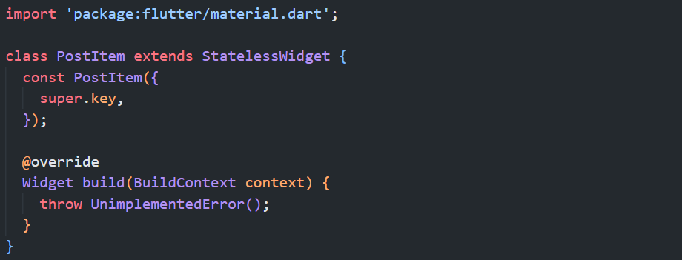
- Add this import to post_item.dart file
import 'package:flutter/material.dart';
import 'package:flutter_svg/flutter_svg.dart';

- Add this parameter to PostItem class
final String profileImg;
final String name;
final String postImg;
final String caption;
final bool isLoved;
final String likedBy;
final String viewCount;
final String dayAgo;
final String userPhoto;

const PostItem({
super.key,
required this.profileImg,
required this.name,
required this.postImg,
required this.caption,
required this.isLoved,
required this.likedBy,
required this.viewCount,
required this.dayAgo,
required this.userPhoto,
});

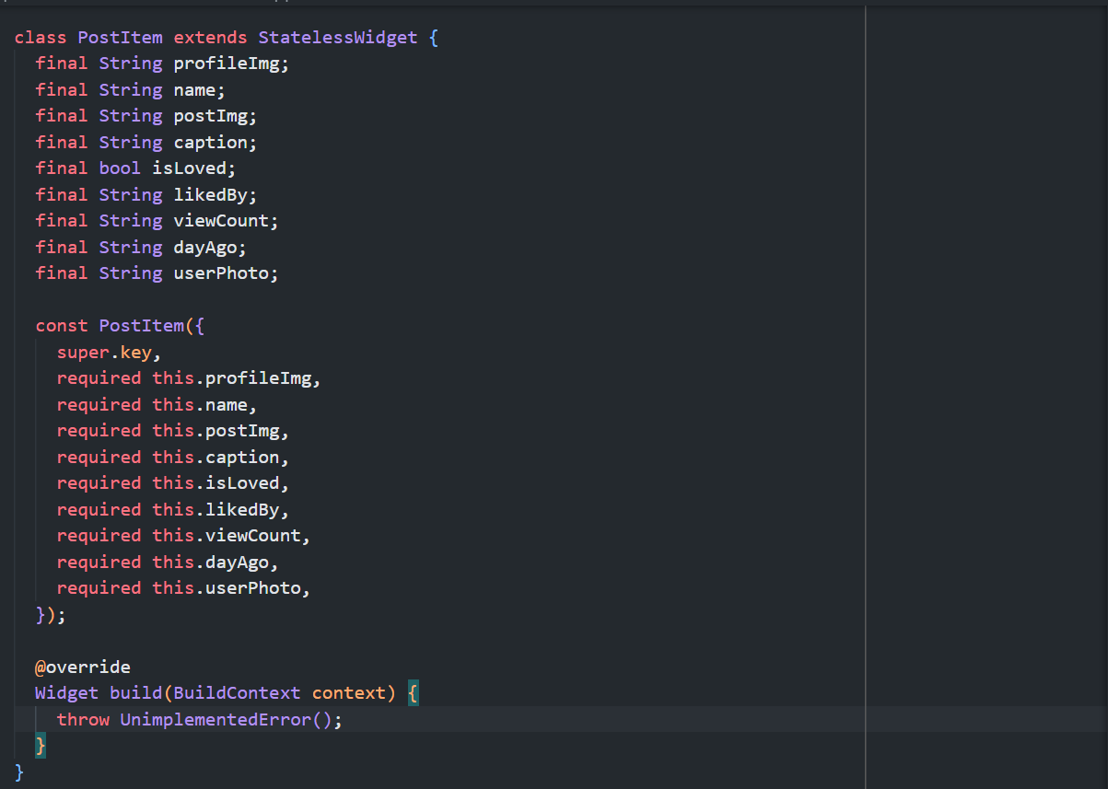
- Add Padding widget as a return following this specifications
No | Widget | Property | Value
1 | Padding | key | Key('post_item_padding')
 |  | padding | EdgeInsets.only(bottom: 10)
 |  | child | Column(  key: const Key('post_item_column')
Column(key: const Key('post_item_column') properties :
2 | Column | key | Key('post_item_column')
 |  | crossAxisAlignment | CrossAxisAlignment.start
 |  | children | []

return Padding(
key: const Key('post_item_padding'),
padding: const EdgeInsets.only(bottom: 10),
child: Column(
key: const Key('post_item_column'),
crossAxisAlignment: CrossAxisAlignment.start,
children: [],
),
);
}

ADDING POST’S USER INFO
- Check on Column widget with key post_item_column, add Container widget as children following this specification:
No | Widget | Property | Value
3 | Container | key | Key('post_item_user_info_container')
 |  | padding | EdgeInsets.symmetric(vertical: 10, horizontal: 15)
 |  | margin | EdgeInsets.only(bottom: 12)
 |  | child | Row(  key: const Key('post_item_user_info_row')
Row(key: const Key('post_item_user_info_row') properties :
4 | Row | key | Key('post_item_user_info_row')
 |  | mainAxisAlignment | MainAxisAlignment.spaceBetween
 |  | children | Container(  key: Key('post_item_user_profile_img_container'),  Expanded(  key: Key('post_item_user_name_expanded'),)  Icon(key: Key('post_item_user_more_icon'))
Container(key: Key('post_item_user_profile_img_container') properties :
5 | Container | key | Key('post_item_user_profile_img_container')
 |  | width | 40
 |  | height | 40
 |  | margin | EdgeInsets.only(right: 15)
 |  | decoration | BoxDecoration(  shape: BoxShape.circle,  image: DecorationImage(  image: NetworkImage(profileImg),  fit: BoxFit.cover,),)
Expanded(key: Key('post_item_user_name_expanded')) properties :
6 | Expanded | key | Key('post_item_user_name_expanded')
 |  | child | Text(key: const Key('post_item_user_name_text')
Text(key: const Key('post_item_user_name_text') properties :
7 | Text | key | Key('post_item_user_name_text')
 |  | value | name
 |  | style | TextStyle(  color: white,  fontSize: 15,  fontWeight: FontWeight.w500)
Icon(key: Key('post_item_user_more_icon')) properties :
8 | Icon | key | Key('post_item_user_more_icon')
 |  | value | Icons.more_horiz
 |  | color | white

Column(
key: const Key('post_item_column'),
crossAxisAlignment: CrossAxisAlignment.start,
children: <Widget>[
Container(
key: const Key('post_item_user_info_container'),
padding: const EdgeInsets.symmetric(vertical: 10, horizontal: 15),
margin: const EdgeInsets.only(bottom: 12),
child: Row(
key: const Key('post_item_user_info_row'),
mainAxisAlignment: MainAxisAlignment.spaceBetween,
children: <Widget>[
Container(
key: const Key('post_item_user_profile_img_container'),
width: 40,
height: 40,
margin: const EdgeInsets.only(right: 15),
decoration: BoxDecoration(
shape: BoxShape.circle,
image: DecorationImage(
image: NetworkImage(profileImg),
fit: BoxFit.cover,
),
),
),
Expanded(
key: const Key('post_item_user_name_expanded'),
child: Text(
key: const Key('post_item_user_name_text'),
name,
style: const TextStyle(
color: white,
fontSize: 15,
fontWeight: FontWeight.w500,
),
),
),
const Icon(
key: Key('post_item_user_more_icon'),
Icons.more_horiz,
color: white,
)
],
),
),
)

ADDING POST’S IMAGE
- Still on Column widget with key post_item_column, add another Container widget as children following this specification:
No | Widget | Property | Value
9 | Container | key | Key('post_item_image_container')
 |  | height | 400
 |  | margin | EdgeInsets.only(bottom: 10)
 |  | decoration | BoxDecoration(  image: DecorationImage(  image: NetworkImage(postImg),  fit: BoxFit.cover,  ),  )

Column(
key: const Key('post_item_column'),
crossAxisAlignment: CrossAxisAlignment.start,
children: <Widget>[
...
Container(
key: const Key('post_item_image_container'),
height: 400,
margin: const EdgeInsets.only(bottom: 10),
decoration: BoxDecoration(
image: DecorationImage(
image: NetworkImage(postImg),
fit: BoxFit.cover,
),
),
),
)

ADDING POST’S ITEM ACTION BUTTONS
- Still on Column widget with key post_item_column, add another Container widget as children following this specifications :
No | Widget | Property | Value
10 | Container | key | Key('post_item_actions_container')
 |  | padding | EdgeInsets.fromLTRB(15, 3, 15, 0)
 |  | margin | EdgeInsets.only(bottom: 12)
 |  | child | Row(key: const Key('post_item_actions_row')
Row(key: const Key('post_item_actions_row') properties :
11 | Row | key | Key('post_item_actions_row')
 |  | mainAxisAlignment | MainAxisAlignment.spaceBetween
 |  | children | Row(  key: const Key('post_item_actions_left_row')),  SvgPicture.asset(  "assets/images/save_icon.svg",  key: const Key('post_item_actions_save_icon'),  width: 27,)
Row(key: const Key('post_item_actions_left_row')) properties :
12 | Row | key | Key('post_item_actions_left_row')
 |  | children | SvgPicture.asset(  key: const Key('post_item_actions_love_icon'),  width: 27  isLoved? "assets/images/loved_icon.svg"  : "assets/images/love_icon.svg"),  SizedBox(width:20),  SvgPicture.asset(  "assets/images/comment_icon.svg",  key: const Key('post_item_actions_comment_icon'),  width: 27),  SizedBox(width: 20),  SvgPicture.asset(  "assets/images/message_icon.svg",  key: const Key('post_item_actions_message_icon'),  width: 27),

Column(
key: const Key('post_item_column'),
crossAxisAlignment: CrossAxisAlignment.start,
children: <Widget>[
...
Container(
key: const Key('post_item_actions_container'),
padding: const EdgeInsets.fromLTRB(15, 3, 15, 0),
margin: const EdgeInsets.only(bottom: 12),
child: Row(
key: const Key('post_item_actions_row'),
mainAxisAlignment: MainAxisAlignment.spaceBetween,
children: <Widget>[
Row(
key: const Key('post_item_actions_left_row'),
children: <Widget>[
SvgPicture.asset(
key: const Key('post_item_actions_love_icon'),
isLoved
? "assets/images/loved_icon.svg"
: "assets/images/love_icon.svg",
width: 27,
),
const SizedBox(width: 20),
SvgPicture.asset(
"assets/images/comment_icon.svg",
key: const Key('post_item_actions_comment_icon'),
width: 27,
),
const SizedBox(width: 20),
SvgPicture.asset(
"assets/images/message_icon.svg",
key: const Key('post_item_actions_message_icon'),
width: 27,
),
],
),
SvgPicture.asset(
"assets/images/save_icon.svg",
key: const Key('post_item_actions_save_icon'),
width: 27,
),
],
),
),
)

ADDING POST’S ITEM LIKES INFORMATION
- Still on Column widget with key post_item_column, add another Container widget as children following this specifications :
No | Widget | Property | Value
19 | Container | key | Key('post_item_likes_container')
 |  | padding | EdgeInsets.symmetric(horizontal: 15)
 |  | margin | EdgeInsets.only(bottom: 12)
 |  | child | RichText(key: const Key('post_item_likes_rich_text')
20 | RichText | key | Key('post_item_likes_rich_text')
 |  | text | TextSpan(  children: [  TextSpan(  text: "Liked by $likedBy and Other",  style: const TextStyle(  fontSize: 15,  fontWeight: FontWeight.w500,  ),  ),  ],  )

Column(
key: const Key('post_item_column'),
crossAxisAlignment: CrossAxisAlignment.start,
children: <Widget>[
...
Container(
key: const Key('post_item_likes_container'),
padding: const EdgeInsets.symmetric(horizontal: 15),
margin: const EdgeInsets.only(bottom: 12),
child: RichText(
key: const Key('post_item_likes_rich_text'),
text: TextSpan(
children: [
TextSpan(
text: "Liked by $likedBy and Other",
style: const TextStyle(
fontSize: 15,
fontWeight: FontWeight.w500,
),
),
],
),
),
),
],
),

ADDING POST’S CAPTION
- Still on Column widget with key post_item_column, add another Container widget as children following this specifications :
No | Widget | Property | Value
21 | Container | key | Key('post_item_caption_container')
 |  | padding | EdgeInsets.symmetric(horizontal: 15)
 |  | margin | EdgeInsets.only(bottom: 12)
 |  | child | RichText(  key: const Key('post_item_caption_rich_text')
RichText(key: const Key('post_item_caption_rich_text') properties :
22 | RichText | key | Key('post_item_caption_rich_text')
 |  | text | TextSpan(  children: [  TextSpan(  text: "$name ",  style: const TextStyle(  fontSize: 15,  fontWeight: FontWeight.w700)),  TextSpan(  text: caption,  style: const TextStyle(  fontSize: 15,  fontWeight: FontWeight.w500),  ),  ],  )

Column(
key: const Key('post_item_column'),
crossAxisAlignment: CrossAxisAlignment.start,
children: <Widget>[
...
Container(
key: const Key('post_item_caption_container'),
padding: const EdgeInsets.symmetric(horizontal: 15),
margin: const EdgeInsets.only(bottom: 12),
child: RichText(
key: const Key('post_item_caption_rich_text'),
text: TextSpan(
children: [
TextSpan(
text: "$name ",
style: const TextStyle(
fontSize: 15, fontWeight: FontWeight.w700),
),
TextSpan(
text: caption,
style: const TextStyle(
fontSize: 15, fontWeight: FontWeight.w500),
),
],
),
),
),
]),

ADDING POST’S COMMENTS COUNT
- Still on Column widget with key post_item_column, add another Container widget as children following this specifications :
No | Widget | Property | Value
23 | Container | key | Key('post_item_view_comments_container')
 |  | padding | EdgeInsets.symmetric(horizontal: 15)
 |  | margin | EdgeInsets.only(bottom: 12)
 |  | child | Text(key: const Key('post_item_view_comments_text')
24 | Text | key | Key('post_item_view_comments_text')
 |  | value | "View $viewCount comments"
 |  | style | TextStyle(  color: white.withOpacity(0.5),  fontSize: 15,  fontWeight: FontWeight.w500))

Column(
key: const Key('post_item_column'),
crossAxisAlignment: CrossAxisAlignment.start,
children: <Widget>[
...
Container(
key: const Key('post_item_view_comments_container'),
padding: const EdgeInsets.symmetric(horizontal: 15),
margin: const EdgeInsets.only(bottom: 12),
child: Text(
key: const Key('post_item_view_comments_text'),
"View $viewCount comments",
style: TextStyle(
color: white.withOpacity(0.5),
fontSize: 15,
fontWeight: FontWeight.w500),
),
),
]),

ADDING POST’S ADD-COMMENTS
- Still on Column widget with key post_item_column, add another Container widget as children following this specifications :
No | Widget | Property | Value
24 | Container | key | Key('post_item_add_comment_container')
 |  | padding | EdgeInsets.symmetric(horizontal: 15)
 |  | margin | EdgeInsets.only(bottom: 12)
 |  | child | Row(  key: const Key('post_item_add_comment_row')
Row(key: const Key('post_item_add_comment_row') properties :
25 | Row | key | Key('post_item_add_comment_row')
 |  | mainAxisAlignment | MainAxisAlignment.spaceBetween
 |  | children | Row(  key: const Key('post_item_add_comment_left_row'),)  Row(  key: const Key('post_item_add_comment_right_row'),)
Row(key: const Key('post_item_add_comment_left_row') properties :
26 | Row | key | Key('post_item_add_comment_left_row')
 |  | children | Container(  key: Key('post_item_add_comment_avatar_container'))  Text (key:Key('post_item_add_comment_text'))
Container(key: Key('post_item_add_comment_avatar_container')) properties :
27 | Container | key | Key('post_item_add_comment_avatar_container')
 |  | width | 30
 |  | height | 30
 |  | margin | EdgeInsets.only(right: 15)
 |  | decoration | BoxDecoration(  shape: BoxShape.circle,  image: DecorationImage(  image: NetworkImage(userPhoto),  fit: BoxFit.cover))
Text (key:Key('post_item_add_comment_text')) properties :
28 | Text | key | Key('post_item_add_comment_text')
 |  | value | "Add a comment..."
 |  | style | TextStyle(  color: white.withOpacity(0.5),  fontSize: 15,  fontWeight: FontWeight.w500)
Row(key: const Key('post_item_add_comment_right_row')) properties :
29 | Row | key | Key('post_item_add_comment_right_row')
 |  | children | Text(key: Key('post_item_add_laugh_emoji_text'),  SizedBox(width: 10),  Text(key: Key('post_item_add_love_emoji_text'))  SizedBox(width: 10),  Icon(key: Key('post_item_add_circle_icon'))
Text(key: Key('post_item_add_laugh_emoji_text')) properties :
30 | Text | key | Key('post_item_add_laugh_emoji_text')
 |  | value | "😂"
 |  | style | TextStyle(fontSize: 20)
Text(key: Key('post_item_add_love_emoji_text')) properties :
32 | Text | key | Key('post_item_add_love_emoji_text')
 |  | value | "😍"
 |  | style | TextStyle(fontSize: 20)
Icon(key: Key('post_item_add_circle_icon')) properties :
34 | Icon | key | Key('post_item_add_circle_icon')
 |  | value | Icons.add_circle
 |  | color | white.withOpacity(0.5)
 |  | size | 18

Column(
key: const Key('post_item_column'),
crossAxisAlignment: CrossAxisAlignment.start,
children: <Widget>[
...
Container(
key: const Key('post_item_add_comment_container'),
padding: const EdgeInsets.symmetric(horizontal: 15),
margin: const EdgeInsets.only(bottom: 12),
child: Row(
key: const Key('post_item_add_comment_row'),
mainAxisAlignment: MainAxisAlignment.spaceBetween,
children: <Widget>[
Row(
key: const Key('post_item_add_comment_left_row'),
children: <Widget>[
Container(
key: const Key('post_item_add_comment_avatar_container'),
width: 30,
height: 30,
margin: const EdgeInsets.only(right: 15),
decoration: BoxDecoration(
shape: BoxShape.circle,
image: DecorationImage(
image: NetworkImage(userPhoto),
fit: BoxFit.cover,
),
),
),
Text(
key: const Key('post_item_add_comment_text'),
"Add a comment...",
style: TextStyle(
color: white.withOpacity(0.5),
fontSize: 15,
fontWeight: FontWeight.w500,
),
),
],
),
Row(
key: const Key('post_item_add_comment_right_row'),
children: <Widget>[
const Text(
key: Key('post_item_add_laugh_emoji_text'),
"😂",
style: TextStyle(fontSize: 20),
),
const SizedBox(width: 10),
const Text(
key: Key('post_item_add_love_emoji_text'),
"😍",
style: TextStyle(fontSize: 20),
),
const SizedBox(width: 10),
Icon(
key: const Key('post_item_add_circle_icon'),
Icons.add_circle,
color: white.withOpacity(0.5),
size: 18,
)
],
)
],
),
),
]),

ADDING POST’S DAY AGO
- Still on Column widget with key post_item_column, add Padding widget as children following this specifications :
No | Widget | Property | Value
35 | Padding | key | Key('post_item_day_ago_padding')
 |  | padding | EdgeInsets.symmetric(horizontal: 15)
 |  | child | Text(key: const Key('post_item_day_ago_text')
Text(key: const Key('post_item_day_ago_text') properties :
36 | Text | key | Key('post_item_day_ago_text')
 |  | value | dayAgo
 |  | style | TextStyle(  color: white.withOpacity(0.5),  fontSize: 15,  fontWeight: FontWeight.w500)
Column(
key: const Key('post_item_column'),
crossAxisAlignment: CrossAxisAlignment.start,
children: <Widget>[
...
Padding(
key: const Key('post_item_day_ago_padding'),
padding: const EdgeInsets.symmetric(horizontal: 15),
child: Text(
key: const Key('post_item_day_ago_text'),
dayAgo,
style: TextStyle(
color: white.withOpacity(0.5),
fontSize: 15,
fontWeight: FontWeight.w500,
),
),
)
])

- Move to home_page.dart file and add this import so that PostItem widget will be accessible from this page
import 'package:example_widget_testing/app/widgets/post_item.dart';
- Move to Column widget with key home_page_column, add another Column widget as it’s children following this specifications:
No | Widget | Property | Value
15 | Column | Key | Key('posts_column')
 |  | children | List.generate(  widget.posts.length,  (index) {  return PostItem(  key: Key('post_item_$index'),  postImg: widget.posts[index]['postImg'],  profileImg: widget.posts[index]['profileImg'],  name: widget.posts[index]['name'],  caption: widget.posts[index]['caption'],  isLoved: widget.posts[index]['isLoved'],  viewCount: widget.posts[index]['commentCount'],  likedBy: widget.posts[index]['likedBy'],  dayAgo: widget.posts[index]['timeAgo'],  userPhoto: profile.profilePic!,  );  },  )

Column(
key: const Key('home_page_column'),
children: <Widget>[
...
Column(
key: const Key('posts_column'),
children: List.generate(
widget.posts.length,
(index) {
return PostItem(
key: Key('post_item_$index'),
postImg: widget.posts[index]['postImg'],
profileImg: widget.posts[index]['profileImg'],
name: widget.posts[index]['name'],
caption: widget.posts[index]['caption'],
isLoved: widget.posts[index]['isLoved'],
viewCount: widget.posts[index]['commentCount'],
likedBy: widget.posts[index]['likedBy'],
dayAgo: widget.posts[index]['timeAgo'],
userPhoto: profile.profilePic!,
);
},
),
)
],
)

- Run the project and check if there’s no error it will return login page similar like this.
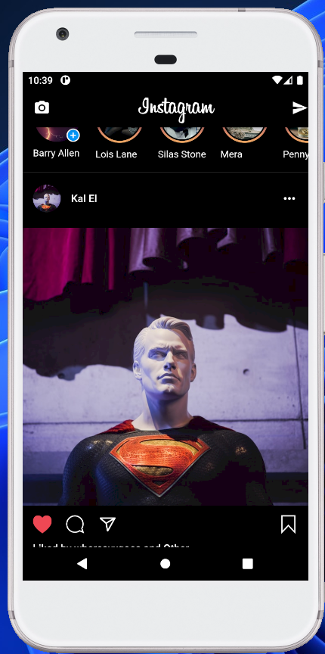

Testing
- Open home_page_test.dart file under test folder
- Find main method it will look similar like this
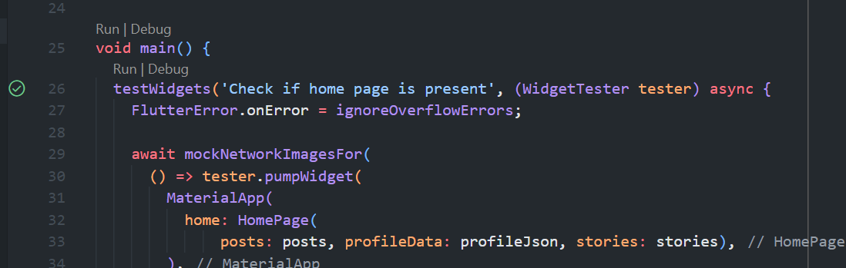
- Click Run
- If there’s an error while running the test, especially around line 1013 onward simply press close to remove the warning
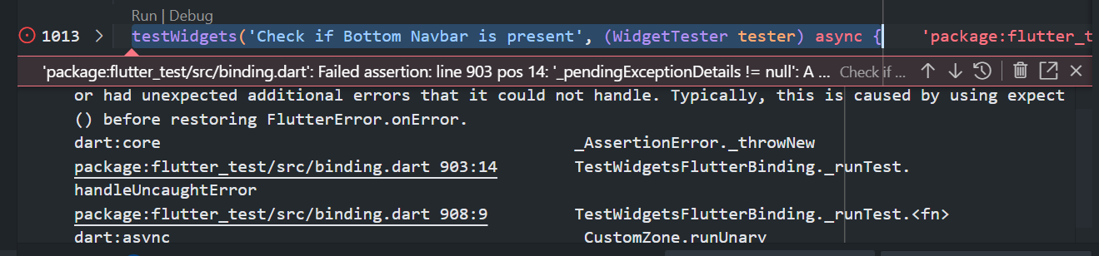
- At the moment not all test are passed since we’ve not finished implementing home page, just make sure these 7 test are passed
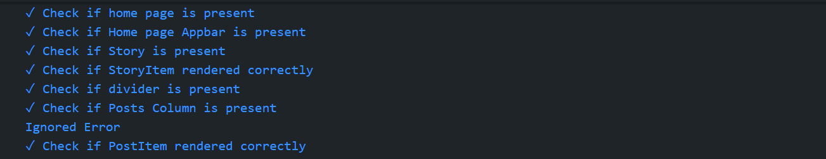
- If there is an error try to check the message and fix the error usually It’s because of wrong key name or missing property of specific widget

FULL CODE
PostItem
import 'package:example_widget_testing/core/theme/colors.dart';
import 'package:flutter/material.dart';
import 'package:flutter_svg/flutter_svg.dart';
// import 'package:line_icons/line_icons.dart';

class PostItem extends StatelessWidget {
final String profileImg;
final String name;
final String postImg;
final String caption;
final bool isLoved;
final String likedBy;
final String viewCount;
final String dayAgo;
final String userPhoto;

const PostItem({
super.key,
required this.profileImg,
required this.name,
required this.postImg,
required this.caption,
required this.isLoved,
required this.likedBy,
required this.viewCount,
required this.dayAgo,
required this.userPhoto,
});

@override
Widget build(BuildContext context) {
return Padding(
key: const Key('post_item_padding'),
padding: const EdgeInsets.only(bottom: 10),
child: Column(
key: const Key('post_item_column'),
crossAxisAlignment: CrossAxisAlignment.start,
children: <Widget>[
Container(
key: const Key('post_item_user_info_container'),
padding: const EdgeInsets.symmetric(vertical: 10, horizontal: 15),
margin: const EdgeInsets.only(bottom: 12),
child: Row(
key: const Key('post_item_user_info_row'),
mainAxisAlignment: MainAxisAlignment.spaceBetween,
children: <Widget>[
Container(
key: const Key('post_item_user_profile_img_container'),
width: 40,
height: 40,
margin: const EdgeInsets.only(right: 15),
decoration: BoxDecoration(
shape: BoxShape.circle,
image: DecorationImage(
image: NetworkImage(profileImg),
fit: BoxFit.cover,
),
),
),
Expanded(
key: const Key('post_item_user_name_expanded'),
child: Text(
key: const Key('post_item_user_name_text'),
name,
style: const TextStyle(
color: white,
fontSize: 15,
fontWeight: FontWeight.w500,
),
),
),
const Icon(
key: Key('post_item_user_more_icon'),
Icons.more_horiz,
color: white,
)
],
),
),
Container(
key: const Key('post_item_image_container'),
height: 400,
margin: const EdgeInsets.only(bottom: 10),
decoration: BoxDecoration(
image: DecorationImage(
image: NetworkImage(postImg),
fit: BoxFit.cover,
),
),
),
Container(
key: const Key('post_item_actions_container'),
padding: const EdgeInsets.fromLTRB(15, 3, 15, 0),
margin: const EdgeInsets.only(bottom: 12),
child: Row(
key: const Key('post_item_actions_row'),
mainAxisAlignment: MainAxisAlignment.spaceBetween,
children: <Widget>[
Row(
key: const Key('post_item_actions_left_row'),
children: <Widget>[
SvgPicture.asset(
key: const Key('post_item_actions_love_icon'),
isLoved
? "assets/images/loved_icon.svg"
: "assets/images/love_icon.svg",
width: 27,
),
const SizedBox(
key: Key('post_item_actions_left_row_sized_box_1'),
width: 20),
SvgPicture.asset(
"assets/images/comment_icon.svg",
key: const Key('post_item_actions_comment_icon'),
width: 27,
),
const SizedBox(
key: Key('post_item_actions_left_row_sized_box_2'),
width: 20),
SvgPicture.asset(
"assets/images/message_icon.svg",
key: const Key('post_item_actions_message_icon'),
width: 27,
),
],
),
SvgPicture.asset(
"assets/images/save_icon.svg",
key: const Key('post_item_actions_save_icon'),
width: 27,
),
],
),
),
Container(
key: const Key('post_item_likes_container'),
padding: const EdgeInsets.symmetric(horizontal: 15),
margin: const EdgeInsets.only(bottom: 12),
child: RichText(
key: const Key('post_item_likes_rich_text'),
text: TextSpan(
children: [
TextSpan(
text: "Liked by $likedBy and Other",
style: const TextStyle(
fontSize: 15,
fontWeight: FontWeight.w500,
),
),
],
),
),
),
Container(
key: const Key('post_item_caption_container'),
padding: const EdgeInsets.symmetric(horizontal: 15),
margin: const EdgeInsets.only(bottom: 12),
child: RichText(
key: const Key('post_item_caption_rich_text'),
text: TextSpan(
children: [
TextSpan(
text: "$name ",
style: const TextStyle(
fontSize: 15, fontWeight: FontWeight.w700),
),
TextSpan(
text: caption,
style: const TextStyle(
fontSize: 15, fontWeight: FontWeight.w500),
),
],
),
),
),
Container(
key: const Key('post_item_view_comments_container'),
padding: const EdgeInsets.symmetric(horizontal: 15),
margin: const EdgeInsets.only(bottom: 12),
child: Text(
key: const Key('post_item_view_comments_text'),
"View $viewCount comments",
style: TextStyle(
color: white.withOpacity(0.5),
fontSize: 15,
fontWeight: FontWeight.w500),
),
),
Container(
key: const Key('post_item_add_comment_container'),
padding: const EdgeInsets.symmetric(horizontal: 15),
margin: const EdgeInsets.only(bottom: 12),
child: Row(
key: const Key('post_item_add_comment_row'),
mainAxisAlignment: MainAxisAlignment.spaceBetween,
children: <Widget>[
Row(
key: const Key('post_item_add_comment_left_row'),
children: <Widget>[
Container(
key: const Key('post_item_add_comment_avatar_container'),
width: 30,
height: 30,
margin: const EdgeInsets.only(right: 15),
decoration: BoxDecoration(
shape: BoxShape.circle,
image: DecorationImage(
image: NetworkImage(userPhoto),
fit: BoxFit.cover,
),
),
),
Text(
key: const Key('post_item_add_comment_text'),
"Add a comment...",
style: TextStyle(
color: white.withOpacity(0.5),
fontSize: 15,
fontWeight: FontWeight.w500,
),
),
],
),
Row(
key: const Key('post_item_add_comment_right_row'),
children: <Widget>[
const Text(
key: Key('post_item_add_laugh_emoji_text'),
"😂",
style: TextStyle(fontSize: 20),
),
const SizedBox(width: 10),
const Text(
key: Key('post_item_add_love_emoji_text'),
"😍",
style: TextStyle(fontSize: 20),
),
const SizedBox(width: 10),
Icon(
key: const Key('post_item_add_circle_icon'),
Icons.add_circle,
color: white.withOpacity(0.5),
size: 18,
)
],
)
],
),
),
Padding(
key: const Key('post_item_day_ago_padding'),
padding: const EdgeInsets.symmetric(horizontal: 15),
child: Text(
key: const Key('post_item_day_ago_text'),
dayAgo,
style: TextStyle(
color: white.withOpacity(0.5),
fontSize: 15,
fontWeight: FontWeight.w500,
),
),
)
],
),
);
}
}

HomePage
import 'package:example_widget_testing/app/modules/home/components/user_story.dart';
import 'package:example_widget_testing/app/widgets/post_item.dart';
import 'package:example_widget_testing/app/modules/home/components/story_item.dart';
import 'package:flutter/material.dart';

import '../../../core/theme/colors.dart';
import '../../data/models/profile.dart';
import '../../widgets/bottom_navbar.dart';

class HomePage extends StatefulWidget {
const HomePage({
super.key,
required this.posts,
required this.stories,
required this.profileData,
});
final List posts;
final List stories;
final Map<String, dynamic> profileData;

@override
HomePageState createState() => HomePageState();
}

class HomePageState extends State<HomePage> {
@override
Widget build(BuildContext context) {
final Profile profile = Profile.fromJson(widget.profileData);
return Scaffold(
key: const Key('home_page_scaffold'),
backgroundColor: Colors.black,
appBar: AppBar(
key: const Key("home_page_appbar"),
backgroundColor: Colors.black,
leading: const Icon(
key: Key('home_page_camera_icon'),
Icons.camera_alt,
),
title: const Center(
key: Key('home_page_title_center'),
child: Text(
key: Key('home_page_title_text'),
"Instagram",
style: TextStyle(fontFamily: 'Billabong', fontSize: 35),
),
),
actions: const <Widget>[
Icon(key: Key('home_page_send_icon'), Icons.send),
],
),
body: SingleChildScrollView(
key: const Key('home_page_single_child_scroll_view'),
child: Column(
key: const Key('home_page_column'),
children: <Widget>[
SingleChildScrollView(
key: const Key('stories_scroll_view'),
scrollDirection: Axis.horizontal,
child: Row(
key: const Key('stories_row'),
children: <Widget>[
const UserStory(key: Key('user_story')),
Row(
key: const Key('following_stories_row'),
children: List.generate(
widget.stories.length,
(index) {
return StoryItem(
key: Key('story_item_$index'),
img: widget.stories[index]['img'],
name: widget.stories[index]['name'],
);
},
),
),
],
),
),
Divider(
key: const Key('home_page_divider'),
color: white.withOpacity(0.3),
),
Column(
key: const Key('posts_column'),
children: List.generate(
widget.posts.length,
(index) {
return PostItem(
key: Key('post_item_$index'),
postImg: widget.posts[index]['postImg'],
profileImg: widget.posts[index]['profileImg'],
name: widget.posts[index]['name'],
caption: widget.posts[index]['caption'],
isLoved: widget.posts[index]['isLoved'],
viewCount: widget.posts[index]['commentCount'],
likedBy: widget.posts[index]['likedBy'],
dayAgo: widget.posts[index]['timeAgo'],
userPhoto: profile.profilePic!,
);
},
),
)
],
),
),
);
}
}

