Task Guide A03
Introduction and setup project
- Objective
Student learn how to make Instagram’s home screen story list
- Requirement
Hardware:
- 4 GB RAM minimum, 8 GB RAM recommended
- 15 GB of available disk space minimum (2 GB for Flutter SDK, 8 GB for Android Studio, 4 GB for AVD, and 1 GB for project’s size)
- 1280 x 800 minimum screen resolution
- Intel processor with support for Intel VT-x, Intel EM64T (Intel 64), and Execute Disable (XD) Bit functionality
Software:
- Microsoft Windows 7/8/10/11 (64-bit)
- JDK 8
- Android Studio IDE
- Git
- Resource
Starter project code : chrisdionisius/clone-instagram-login at Refactoring (github.com)
- Task Description
In this task, student will be implementing a clone of Instagram's home page story list using Flutter and various widgets such as StatefulWidget, Scaffold, Column, Container, and more. This exercise will help student understand how to structure a Flutter application, utilize different widgets, and build a user interface resembling Instagram's home page story list.

Specification
- Clone project from https://github.com/chrisdionisius/clone-instagram-login/tree/Refactoring (make sure clone it from starter branch) or using the manual setup if you encounter error during cloning project, refer to Guide A.01
- Run flutter pub get in the terminal or if you are using Microsoft Visual Studio Code you could click on Get Package button.
- Using this specification make a list of some widgets below :
- Open home_page.dart file under lib\app\modules\home folder make sure it is extended from StatefulWidget
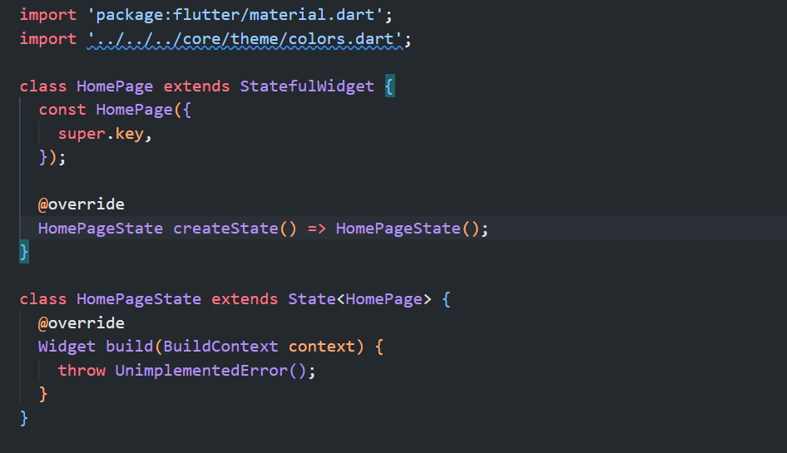
- Add this media query to HomePage class :
final List posts;
final List stories;
final Map<String, dynamic> profileData;
const HomePage({
super.key,
required this.posts,
required this.stories,
required this.profileData});

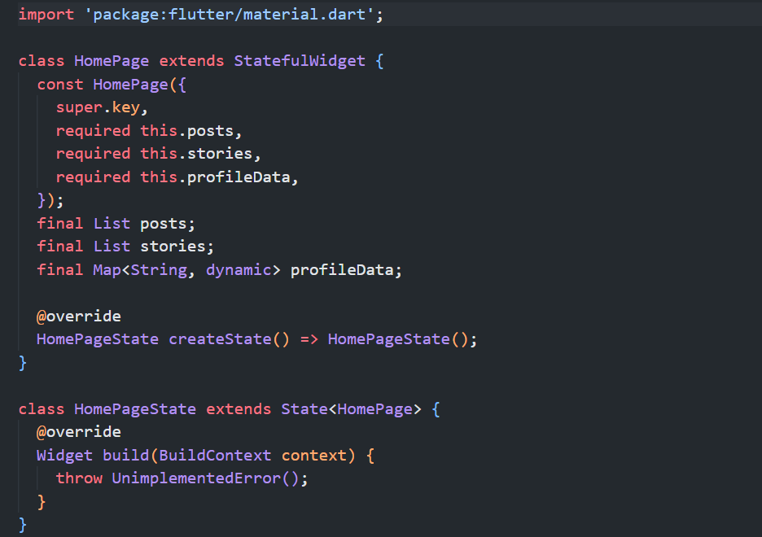
- Add this import so that Profile object would be accessible from HomePage
import '../../data/models/profile.dart';

- Add this line of code inside HomePageState’s Widget build to convert the parameter into Profile instance.
final Profile profile = Profile.fromJson(widget.profileData);

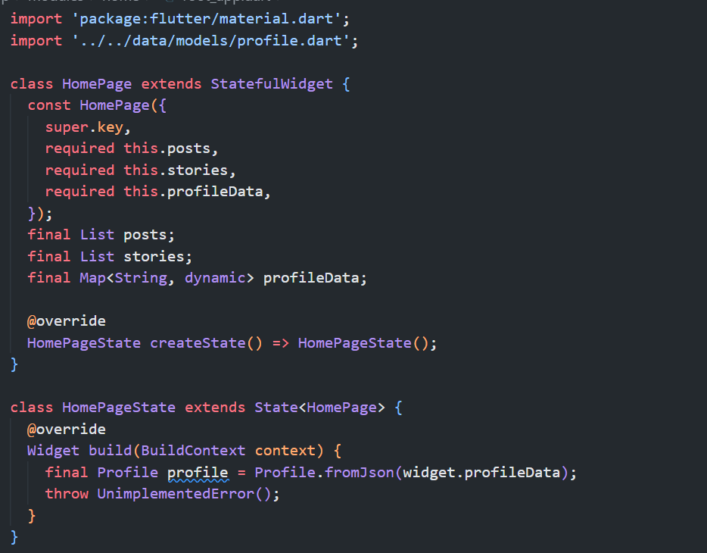
- Add Scaffold Widget as return following this specifications
No | Widget | Property | Value
1 | Scaffold | key | Key('home_page_scaffold')
 |  | backgroundColor | Colors.black
 |  | appBar | AppBar(  key: const Key("home_page_appbar")
 |  | body | SingleChildScrollView(  key: const Key('home_page_single_child_scroll_view'))
AppBar(key: const Key("home_page_appbar") properties :
2 | AppBar | key | Key("app_bar_home")
 |  | backgroundColor | Colors.black
 |  | leading | Icon(  key: Key('home_page_camera_icon'),  Icons.camera_alt)
 |  | title | const Center(  key: Key('home_page_title_center'),  child: Text(  key: Key('home_page_title_text'),  "Instagram",  style: TextStyle(fontFamily: 'Billabong', fontSize: 35))),
 |  | Action | const <Widget>[  Icon(  key: Key('home_page_send_icon'),  Icons.send),  ],
SingleChildScrollView(key: const Key('home_page_single_child_scroll_view')) properties :
3 | SingleChildScrollView | key | Key('home_page_single_child_scroll_view')
 |  | child | Column(key: const Key('home_page_column')
Column(key: const Key('home_page_column') properties
4 | Column | key | Key('home_page_column')
 |  | children | []

return Scaffold(
key: const Key('home_page_scaffold'),
backgroundColor: Colors.black,
appBar: AppBar(
key: const Key("home_page_appbar"),
backgroundColor: Colors.black,
leading: const Icon(
key: Key('home_page_camera_icon'),
Icons.camera_alt,
),
title: const Center(
key: Key('home_page_title_center'),
child: Text(
key: Key('home_page_title_text'),
"Instagram",
style: TextStyle(fontFamily: 'Billabong', fontSize: 35),
),
),
actions: const <Widget>[
Icon(key: Key('home_page_send_icon'), Icons.send),
],
),
body: SingleChildScrollView(
key: const Key('home_page_single_child_scroll_view'),
child: Column(
key: const Key('home_page_column'),
children: [],
),
),
);

- Move to user_story.dart file under directory lib\app\modules\home\components\user_story.dart make sure it’s extended from StatelessWidget
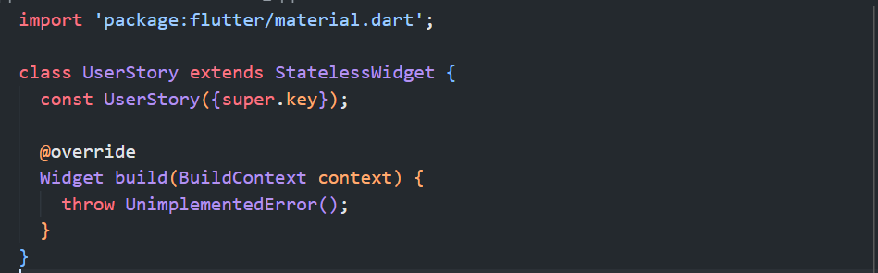
- Add this import so UserStory class will be able to access user profile data and color constants
import 'package:example_widget_testing/core/theme/colors.dart';
import 'package:example_widget_testing/core/values/constant/story_json.dart';

- Add Padding widget as return following this specifications:
No | Widget | Property | Value
5 | Padding | key | Key('user_story_padding')
 |  | padding | EdgeInsets.only(right: 20, left: 15, bottom: 10)
 |  | child | Column(  key: const Key('user_story_column')
Column(key: const Key('user_story_column') properties :
5.1 | Column | key | Key('user_story_column')
 |  | children | SizedBox(  key: const Key('user_story_sized_box'),  SizedBox(height:8),  SizedBox(  key: const Key('user_story_sized_box_name')
SizedBox(key: const Key('user_story_sized_box') properties :
5.1.1 | SizedBox | key | Key('user_story_sized_box')
 |  | width | 65
 |  | height | 65
 |  | child | Stack(key: const Key('user_story_stack')
Stack(key: const Key('user_story_stack') properties :
5.1.1.1 | Stack | key | Key('user_story_stack')
 |  | children | Container(key: const Key('user_story_container'),  Positioned(  key: const Key('user_story_positioned')),
Container(key: const Key('user_story_container') properties :
5.1.1.1.1 | Container | key | Key('user_story_container')
 |  | width | 65
 |  | height | 65
 |  | decoration | BoxDecoration(  shape: BoxShape.circle,  image: DecorationImage(  image: NetworkImage(profile),  fit: BoxFit.cover,  ),  )
Positioned(key: const Key('user_story_positioned')) properties :
5.1.1.1.2 | Positioned | key | Key('user_story_positioned')
 |  | bottom | 0
 |  | right | 0
 |  | child | Container(  key: const Key('user_story_outline_container')
Container(key: const Key('user_story_outline_container') properties :
5.1.1.1.1.2.1 | Container | key | Key('user_story_outline_container')
 |  | width | 19
 |  | height | 19
 |  | decoration | BoxDecoration(  shape: BoxShape.circle,  color: Colors.white)
 |  | child | Icon(key: Key('user_story_add_circle_icon')
Icon(key: Key('user_story_add_circle_icon') properties :
5.1.1.1.1.2.1.1 | Icon | key | Key('user_story_add_circle_icon')
 |  | value | Icons.add_circle
 |  | color | buttonFollowColor
 |  | size | 19
SizedBox(key: const Key('user_story_sized_box_name') properties :
5.1.2 | SizedBox | key | Key('user_story_sized_box_name')
 |  | width | 70
 |  | child | Text(key: const Key('user_story_text_name')
5.1.2.1 | Text | key | Key('user_story_text_name')
 |  | value | name
 |  | overflow | TextOverflow.ellipsis
 |  | style | TextStyle(color: Colors.white)

return Padding(
key: const Key('user_story_padding'),
padding: const EdgeInsets.only(right: 20, left: 15, bottom: 10),
child: Column(
key: const Key('user_story_column'),
children: <Widget>[
SizedBox(
key: const Key('user_story_sized_box'),
width: 65,
height: 65,
child: Stack(
key: const Key('user_story_stack'),
children: <Widget>[
Container(
key: const Key('user_story_container'),
width: 65,
height: 65,
decoration: BoxDecoration(
shape: BoxShape.circle,
image: DecorationImage(
image: NetworkImage(profile),
fit: BoxFit.cover,
),
),
),
Positioned(
key: const Key('user_story_positioned'),
bottom: 0,
right: 0,
child: Container(
key: const Key('user_story_outline_container'),
width: 19,
height: 19,
decoration: const BoxDecoration(
shape: BoxShape.circle,
color: Colors.white,
),
child: const Icon(
key: Key('user_story_add_circle_icon'),
Icons.add_circle,
color: buttonFollowColor,
size: 19,
),
),
)
],
),
),
const SizedBox(
key: Key('user_story_sized_box_spacer'),
height: 8,
),
SizedBox(
key: const Key('user_story_sized_box_name'),
width: 70,
child: Text(
key: const Key('user_story_text_name'),
name,
overflow: TextOverflow.ellipsis,
style: const TextStyle(color: Colors.white),
),
)
],
),
);

- Back to home_page.dart file add this import so that UserStory widget would be accessible from HomePage.
import 'package:example_widget_testing/app/modules/home/components/user_story.dart';

- Move to Column Widget with key home_page_column, on children properties add SingleChildScrollView widget following this specifications:
No | Widget | Property | Value
6 | SingleChildScrollView | key | Key('stories_scroll_view')
 |  | scrollDirection | Axis.horizontal
 |  | child | Row(key: const Key('stories_row')
Row(key: const Key('stories_row') properties :
7 | Row | key | const Key('stories_row')
 |  | children | const UserStory(key: Key('user_story'))

Column(
key: const Key('home_page_column'),
children: <Widget>[
SingleChildScrollView(
key: const Key('stories_scroll_view'),
scrollDirection: Axis.horizontal,
child: Row(
key: const Key('stories_row'),
children: <Widget>[
const UserStory(key: Key('user_story')),
],
),
),
],
),

- Move to story_item.dart file under directory \lib\app\modules\home\components\story_item.dart and make sure it’s extended from StatelessWidget
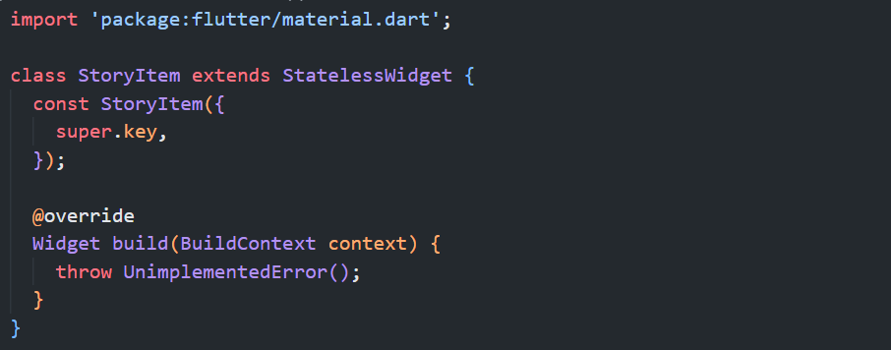
- Add this import so that StoryItem be able to use Color constants
import 'package:example_widget_testing/core/theme/colors.dart';

- Add this parameters to StoryItem class
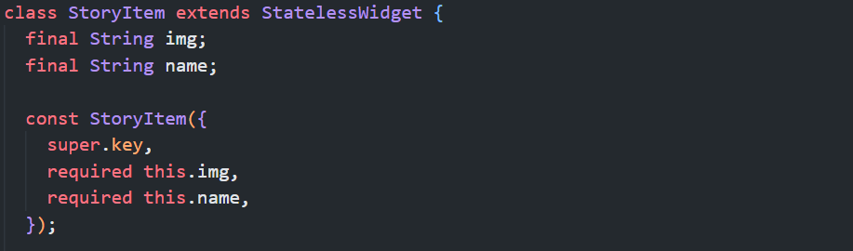
- Add Padding widget as a return for StoryItem class following this specification
No | Widget | Property | Value
1 | Padding | key | Key('story_item_padding')
 |  | padding | EdgeInsets.only(right: 20, bottom: 10)
 |  | child | Column(key: const Key('story_item_column')
2 | Column | key | Key('story_item_column')
 |  | children | Container(  key: const Key('story_item_container')),  SizedBox(  key : const Key('story_item_username_sizedbox'))
Container(key: const Key('story_item_container')) property :
3 | Container | key | Key('story_item_container')
 |  | width | 68
 |  | height | 68
 |  | margin | EdgeInsets.only(bottom: 8)
 |  | decoration | BoxDecoration(  shape: BoxShape.circle,  gradient: LinearGradient(  begin: Alignment.topCenter,  end: Alignment.bottomCenter,  colors: storyBorderColor))
 |  | child | Container(  key: const Key('story_item_image_container')
Container(key: const Key('story_item_image_container') properties :
4 | Container | key | Key('story_item_image_container')
 |  | margin | EdgeInsets.all(3)
 |  | width | 65
 |  | height | 65
 |  | decoration | BoxDecoration(  border: Border.all(color: black, width: 2),  shape: BoxShape.circle,  image: DecorationImage(  image: NetworkImage(img),  fit: BoxFit.cover,  ),  )
SizedBox(key : const Key('story_item_username_sizedbox')) properties :
5 | SizedBox | key | Key('story_item_username_sizedbox')
 |  | width | 70
 |  | child | Text(key: const Key('story_item_username_text')
Text(key: const Key('story_item_username_text') properties :
6 | Text | value | name
 |  | key | Key('story_item_username_text')
 |  | overflow | TextOverflow.ellipsis
 |  | style | TextStyle(color: white)

- Back to home_page.dart file and add this import so that StoryItem widget will be accessible from this page :
import 'package:example_widget_testing/app/modules/home/components/story_item.dart';

- Move to Row widget with key stories_row and add another row as children following this specification
No | Widget | Property | Value
1 | Row | key | Key('following_stories_row')
 |  | children | List.generate(  widget.stories.length,  (index) {  return StoryItem(  key: Key('story_item_$index'),  img: widget.stories[index]['img'],  name: widget.stories[index]['name'],  );  },  )

Row(
key: const Key('stories_row'),
children: <Widget>[
...
Row(
key: const Key('following_stories_row'),
children: List.generate(
widget.stories.length,
(index) {
return StoryItem(
key: Key('story_item_$index'),
img: widget.stories[index]['img'],
name: widget.stories[index]['name'],
);
},
),
),
],
);

- Still on the home_page.dart file find Column widget with key home_page_column and add Divider widget as children following this specifications
No | Widget | Property | Value
1 | Divider | key | Key('home_page_divider')
 |  | color | white.withOpacity(0.3)

Column(
key: const Key('home_page_column'),
children: <Widget>[
...
Divider(
key: const Key('home_page_divider'),
color: white.withOpacity(0.3),
)
],
)

- Move to main.dart file under directory lib\main.dart
- Add this import so HomePage would be registered at main.dart
import 'package:example_widget_testing/app/modules/home/home_page.dart';

- Add this code to register HomePage into routes
routes: {
'/home': (context) =>
HomePage(posts: posts, stories: stories, profileData: profileJson),
},

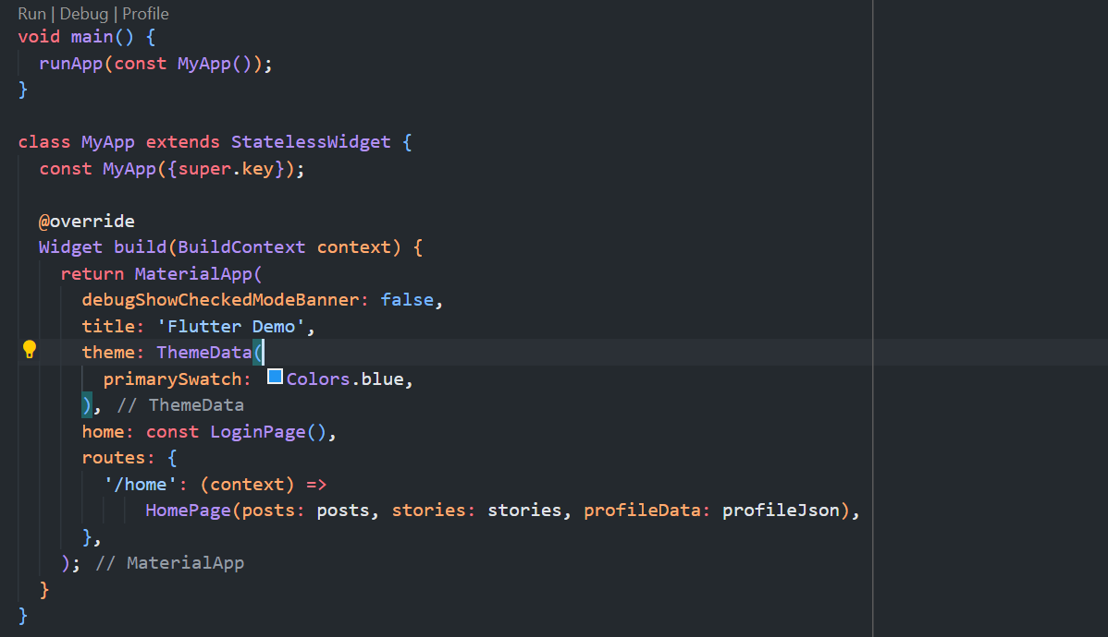
- Move to login_page.dart, find openHomePage() method and modify it into like this
void openHomePage() {
inputTextNotNull ? Navigator.pushNamed(context, '/home') : null;
}

- Run the project by login first then hit Login button. If there’s no error it will shows home page similar like this.
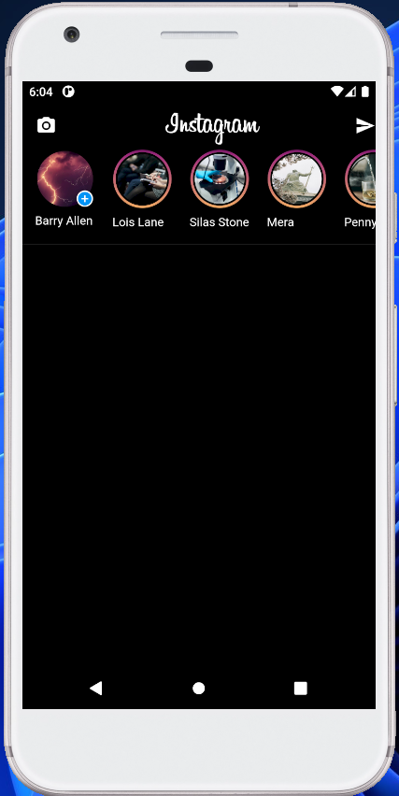
Testing
- Open home_page_test.dart file under test folder
- Find main method it will look similar like this
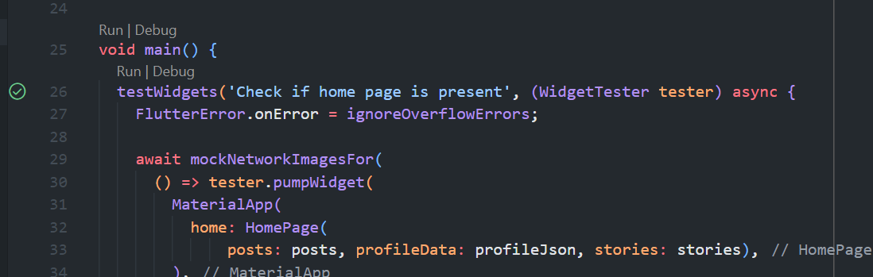
- Click Run
- If there’s an error while running the test, especially around line 312 onward simply press close to remove the warning
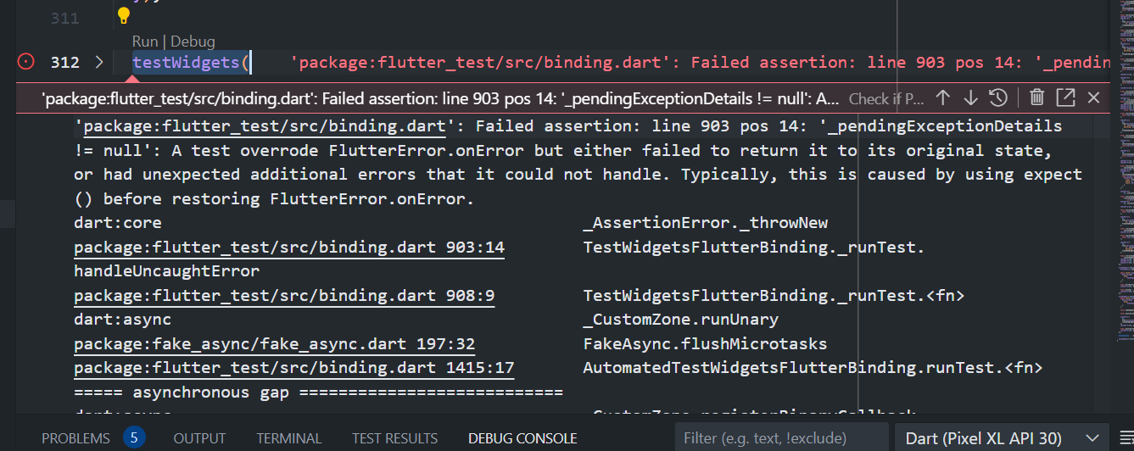
- At the moment not all test are passed sine we’ve not finished implementing home page, just make sure these 5 test are passed
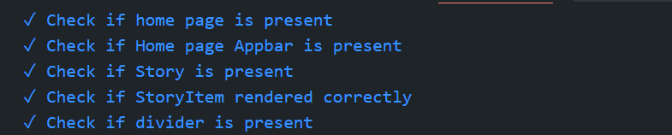
- If there is an error try to check the message and fix the error usually It’s because of wrong key name or missing property of specific widget

