Task Guide A01
Introduction and setup project
- Objective
Student learn how to make Instagram’s login screen
- Requirement
Hardware:
- 4 GB RAM minimum, 8 GB RAM recommended
- 15 GB of available disk space minimum (2 GB for Flutter SDK, 8 GB for Android Studio, 4 GB for AVD, and 1 GB for project’s size)
- 1280 x 800 minimum screen resolution
- Intel processor with support for Intel VT-x, Intel EM64T (Intel 64), and Execute Disable (XD) Bit functionality
Software:
- Microsoft Windows 7/8/10/11 (64-bit)
- JDK 8
- Android Studio IDE
- Git
- Resource
Guide, Supplementary, and Test File : https://drive.google.com/drive/folders/1WrVHMNwOUsuOZtfxEQ5pufhKCqBD7X62?usp=drive_link
- Task Description
In this task, student will setup the starter project

Specification
- Create new flutter project and name it example_widget_testing
- Wait until flutter finished the setup
- Add this 2 package by running this command in the terminal inside the project’s folder
flutter pub add flutter_svg
flutter pub add network_image_mock
- Wait until finished downloading
- Download the the supplementary file from this link https://drive.google.com/drive/folders/1UJu_JsRDmZtunSA79sIOUnOqfa_9CISM?usp=sharing
- Extract and place the asset folder inside project’s file
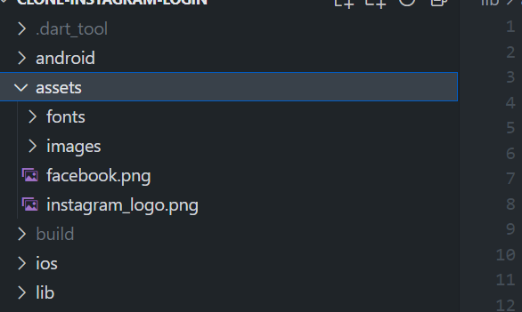
- Add those asset to pubspec.yaml file so the assets will be recognized by the application
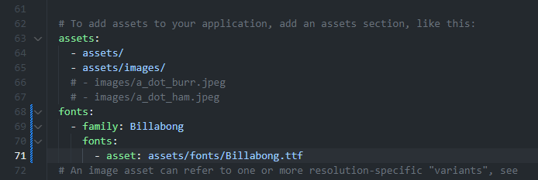

- Download the starter code file from this link
https://drive.google.com/drive/folders/1M9TTH7WjZ2ADjpydGFJIVB_NXFlpMnZK?usp=sharing
- Extract and place the content of that folder inside lib folder
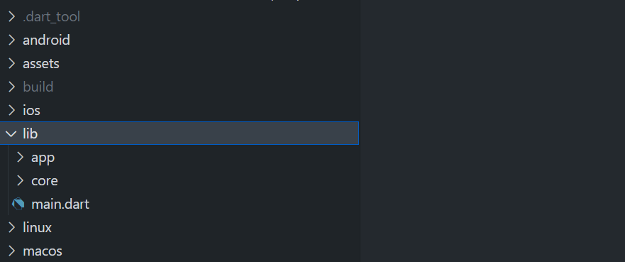
- Perhaps you might encounter error from the import section, try to fix the error by replacing the of the project’s name with your current project’s name
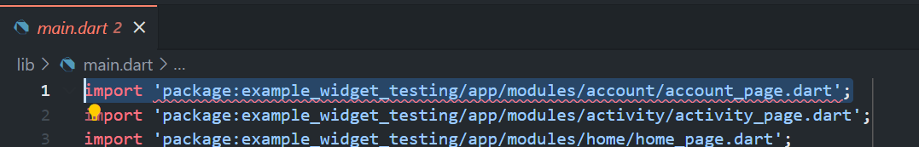
- Apply those fixing until there’s no error left
- Download test files from this link
https://drive.google.com/drive/folders/1fxffAi49cV1n2M6kuCfVwKPIbTdgts_y?usp=sharing
- Extract and place the file under test folder
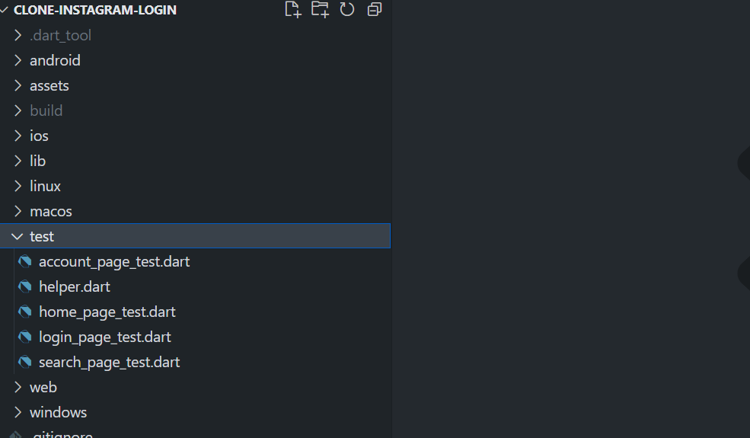
- Open main.dart file under lib folder
- Remove everything and replace it with this code
import 'package:flutter/material.dart';

void main() {
runApp(const MyApp());
}

class MyApp extends StatelessWidget {
const MyApp({super.key});

@override
Widget build(BuildContext context) {
throw UnimplementedError();
}
}

- Using this specification make a list of some widgets below :
- Open main.dart file on under lib folder make sure it’s extended from StatelessWidget
import 'package:flutter/material.dart';

void main() {
runApp(const MyApp());
}

class MyApp extends StatelessWidget {
const MyApp({super.key});

@override
Widget build(BuildContext context) {
throw UnimplementedError();
}
}

- Add MaterialApp as return following this specification
No | Widget | Property | Value
1 | MaterialApp | debugShowCheckedModeBanner | false
 |  | Title | Flutter Demo
 |  | theme | ThemeData(primarySwatch: Colors.blue),
 |  | home | const LoginPage(),
class MyApp extends StatelessWidget {
const MyApp({super.key});

@override
Widget build(BuildContext context) {
return MaterialApp(
debugShowCheckedModeBanner: false,
title: 'Flutter Demo',
theme: ThemeData(
primarySwatch: Colors.blue,
),
home: const LoginPage(),
);
}
}

