Task Guide A02
Introduction and setup project
- Objective
Student learn how to make Instagram’s login screen
- Requirement
Hardware:
- 4 GB RAM minimum, 8 GB RAM recommended
- 15 GB of available disk space minimum (2 GB for Flutter SDK, 8 GB for Android Studio, 4 GB for AVD, and 1 GB for project’s size)
- 1280 x 800 minimum screen resolution
- Intel processor with support for Intel VT-x, Intel EM64T (Intel 64), and Execute Disable (XD) Bit functionality
Software:
- Microsoft Windows 7/8/10/11 (64-bit)
- JDK 8
- Android Studio IDE
- Git
- Resource
Guide, Supplementary, and Test File : https://drive.google.com/drive/folders/1WrVHMNwOUsuOZtfxEQ5pufhKCqBD7X62?usp=drive_link
- Task Description
In this task, student will be implementing a clone of Instagram's login page using Flutter and various widgets such as StatefulWidget, Scaffold, Column, Container, and more. This exercise will help student understand how to structure a Flutter application, utilize different widgets, and build a user interface resembling Instagram's login page.

Specification
- Run flutter pub get in the terminal or if you are using Microsoft Visual Studio Code you could click on Get Package button.
- Using this specification make a list of some widgets below :
- Open login_page.dart file under lib\app\modules\login folder make sure it is extended from StatefulWidget
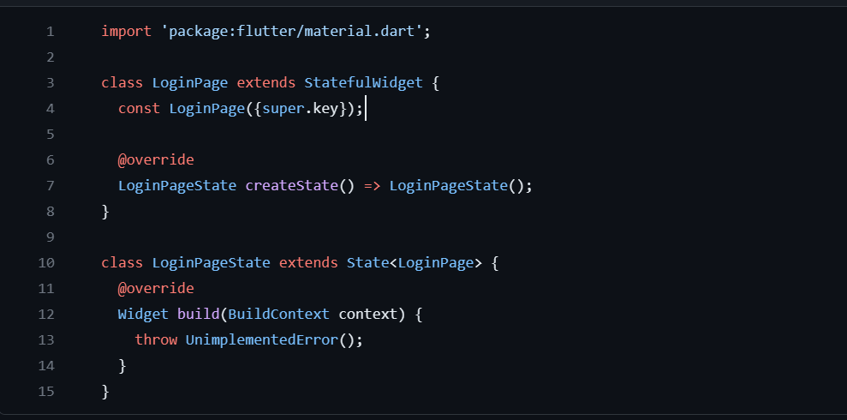
- Add this media query to LoginPage class :
final width = MediaQuery.of(context).size.width;
final height = MediaQuery.of(context).size.height;
double getAvailableHeight() {
return height –
MediaQuery.of(context).padding.top –
MediaQuery.of(context).padding.bottom;
}
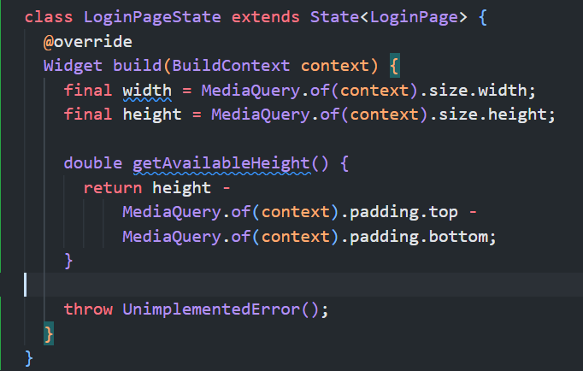
- Using this widget specification, make number of widgets below to make the base of LoginPage
No | Widget | Property | Value
1 | Scaffold | key | Key('login_page_scaffold')
 |  | body | SafeArea(  key: const Key('login_page_safe_area')
2 | SafeArea | key | Key('login_page_safe_area')
 |  | child | SingleChildScrollView(  key: const Key('login_page_scroll_view')
3 | SingleChildScrollView | key | Key('login_page_scroll_view')
 |  | child | ConstrainedBox(  key: const Key('login_page_constrained_box')
4 | ConstrainedBox | Key | Key('login_page_constrained_box')
 |  | constraints | BoxConstraints(minHeight: getAvailableHeight())
 |  | child | Column(key: const Key('login_page_column')
class LoginPage extends StatefulWidget {
const LoginPage({super.key});

@override
LoginPageState createState() => LoginPageState();
}

class LoginPageState extends State<LoginPage> {
@override
Widget build(BuildContext context) {
final width = MediaQuery.of(context).size.width;
final height = MediaQuery.of(context).size.height;

double getAvailableHeight() {
return height -
MediaQuery.of(context).padding.top -
MediaQuery.of(context).padding.bottom;
}

return Scaffold(
key: const Key('login_page_scaffold'),
body: SafeArea(
key: const Key('login_page_safe_area'),
child: SingleChildScrollView(
key: const Key('login_page_scroll_view'),
child: ConstrainedBox(
key: const Key('login_page_constrained_box'),
constraints: BoxConstraints(minHeight: getAvailableHeight()),
child: Column(
key: const Key('login_page_column'),
),
),
),
),
);
}
}

- Modify Column with id : login_page_column into this based on this specification
No | Widget | Property | Value
5 | Column | key | Key('login_page_column')
 |  | children | []
Column(
key: const Key('login_page_column'),
children: [],
),

- Open LanguageDropdown() on directory lib\app\modules\login\components\language_dropdown.dart make sure it is extended from StatefulWidget
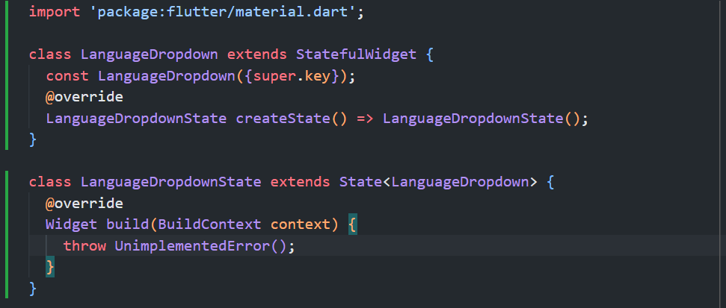

- Add this line of code to LanguageDropdownState class
String dropdownValue = 'English';
final List<String> languages = ['English', 'Arabic', 'Italian', 'French'];

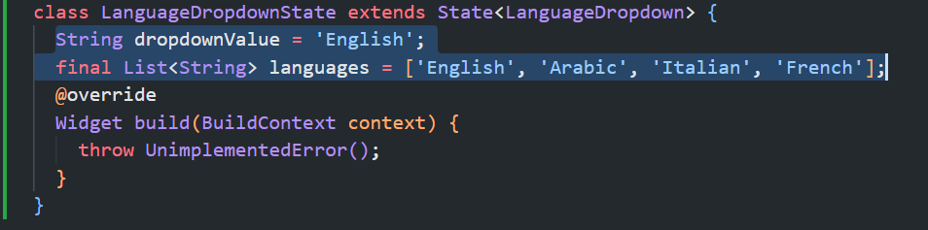
- Add DropdownButton<String> widget as return following this specification
No | Widget | Property | Value
6 | DropdownButton<String> | key | Key('language_dropdown')
 |  | dropdownColor | Colors.white
 |  | value | dropdownValue
 |  | icon | Icon(Icons.arrow_drop_down)
 |  | iconSize | 24
 |  | Elevation | 10
 |  | style | TextStyle(color: Colors.black54)
 |  | underline | Container()
 |  | onChanged | (String? newValue) =>  setState(() => dropdownValue = newValue!)
 |  | Items | languages.map<DropdownMenuItem<String>>((String value) {  return DropdownMenuItem<String>(  key: Key('language_dropdown_item_$value'),  value: value,  child: Text(  value,  style: const TextStyle(fontSize: 16),  ),  );  }).toList(),

class LanguageDropdownState extends State<LanguageDropdown> {
String dropdownValue = 'English';
final List<String> languages = ['English', 'Arabic', 'Italian', 'French'];
@override
Widget build(BuildContext context) {
return DropdownButton<String>(
key: const Key('language_dropdown'),
dropdownColor: Colors.white,
value: dropdownValue,
icon: const Icon(Icons.arrow_drop_down),
iconSize: 24,
elevation: 10,
style: const TextStyle(color: Colors.black54),
underline: Container(),
onChanged: (String? newValue) =>
setState(() => dropdownValue = newValue!),
items: languages.map<DropdownMenuItem<String>>((String value) {
return DropdownMenuItem<String>(
key: Key('language_dropdown_item_$value'),
value: value,
child: Text(
value,
style: const TextStyle(fontSize: 16),
),
);
}).toList(),
);
}
}

- Back to login_page.dart file add this import so that LanguageDropdown widget would be accessible from this file.
import 'modules/login/components/language_dropdown.dart';

- Still at login_page.dart, find Column widget with key login_page_column. On children property, add a Container widget by following this specification
No | Widget | Property | Value
7 | Container | key | Key('login_page_language_dropdown_container')
 |  | width | width
 |  | alignment | Alignment.topCenter
 |  | child | LanguageDropdown()

Column(
key: const Key('login_page_column'),
children: [
Container(
key: const Key('login_page_language_dropdown_container'),
width: width,
alignment: Alignment.topCenter,
child: const LanguageDropdown(),
),
],
)
*note if there’s an error on LanguageDropdown, make sure to import the LanguageDropdown widget on login_page.dart

- Still on the Column widget with id login_page_column add another widget for Children property following this specification
No | Widget | Property | Value
8 | Column | key | Key('login_page_content_column')
 |  | mainAxisAlignment | MainAxisAlignment.center
 |  | children | []

Column(
key: const Key('login_page_column'),
children: [
Container(
key: const Key('login_page_language_dropdown_container')
…
),
Column(
key: const Key('login_page_content_column'),
mainAxisAlignment: MainAxisAlignment.center,
children: [],
),
],
)

- Add Instagram logo using this Image.Asset widget following this specification
No | Widget | Property | Value
9 | Image.Asset | key | Key('login_page_instagram_logo')
 |  |  | assets/instagram_logo.png
 |  | width | width * .5

Column(
key: const Key('login_page_content_column'),
mainAxisAlignment: MainAxisAlignment.center,
children: [
Image.asset(
key: const Key('login_page_instagram_logo'),
'assets/instagram_logo.png',
width: width * .5,
),
],
),

- On the Column widget with key login_page_column add another widget for Children property following this specification
No | Widget | Property | Value
10 | SizedBox | height | 15

Column(
key: const Key('login_page_content_column'),
mainAxisAlignment: MainAxisAlignment.center,
children: [
...
const SizedBox(height: 15),
],
),

- Move to username_textbox.dart file on directory lib\app\modules\login\components\username_textbox.dart make sure it’s extended from StatelessWidget
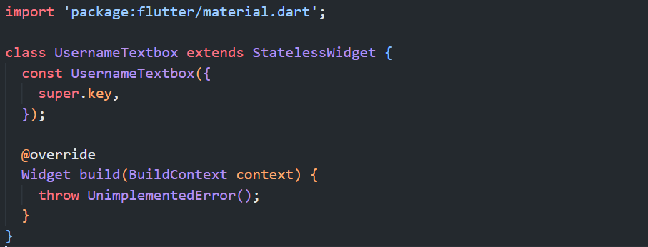
- Add this parameters to the UsernameTextbox class
const UsernameTextbox({
super.key,
required this.width,
required this.checkInputNotNull,
required this.usernameController,
});

final double width;
final TextEditingController usernameController;
final VoidCallback checkInputNotNull;

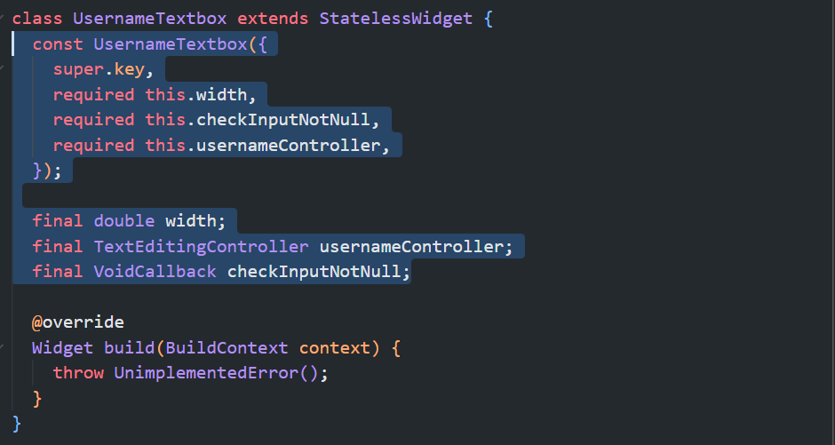
- Add this Container widget as return following this specification:
No | Widget | Property | Value
11 | Container | key | Key('username_textbox_container')
11 | Container | width | width * .90
11 | Container | height | width * .14
11 | Container | decoration | BoxDecoration(  color: Color(0xffE8E8E8),  borderRadius: BorderRadius.all(  Radius.circular(5),  ),  )
11 | Container | child | Padding(key: const Key('username_textbox_padding')
Padding(key: const Key('username_textbox_padding') properties :
12 | Padding | key | Key('username_textbox_padding')
12 | Padding | padding | EdgeInsets.symmetric(horizontal: 15)
12 | Padding | child | Center(key: const Key('username_textbox_center')
Center(key: const Key('username_textbox_center') properties :
13 | Center | key | Key('username_textbox_center')
13 | Center | child | TextField(key: const Key('username_textfield')
TextField(key: const Key('username_textfield') properties :
14 | TextField | key | Key('username_textfield')
14 | TextField | onChanged | (text) => checkInputNotNull()
14 | TextField | controller | usernameController
14 | TextField | style | TextStyle(fontSize: 15)
14 | TextField | decoration | InputDecoration.collapsed(  hintText: 'Phone number , email or username')
return Container(
key: const Key('username_textbox_container'),
width: width * .90,
height: width * .14,
decoration: const BoxDecoration(
color: Color(0xffE8E8E8),
borderRadius: BorderRadius.all(Radius.circular(5)),
),
child: Padding(
key: const Key('username_textbox_padding'),
padding: const EdgeInsets.symmetric(horizontal: 15),
child: Center(
key: const Key('username_textbox_center'),
child: TextField(
key: const Key('username_textfield'),
onChanged: (text) => checkInputNotNull(),
controller: usernameController,
style: const TextStyle(fontSize: 15),
decoration: const InputDecoration.collapsed(
hintText: 'Phone number , email or username',
),
),
),
),
);

- Move to password_textbox.dart file on directory lib\app\modules\login\components\ password_textbox.dart make sure it’s extended from StatelessWidget
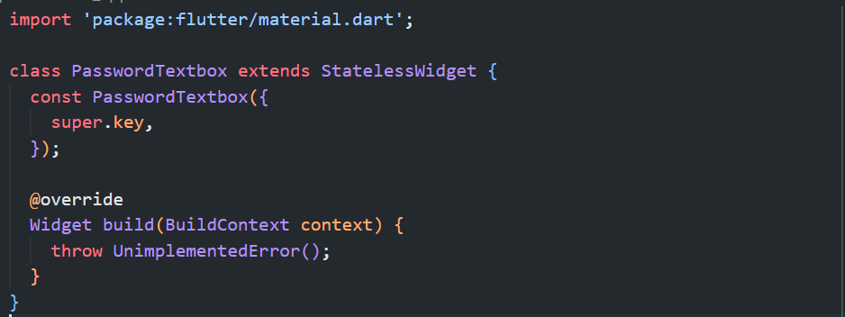
- Add this parameters to PasswordTextbox class
const PasswordTextbox({
super.key,
required this.width,
required this.checkInputNotNull,
required this.passwordController,
});

final double width;
final TextEditingController passwordController;
final VoidCallback checkInputNotNull;

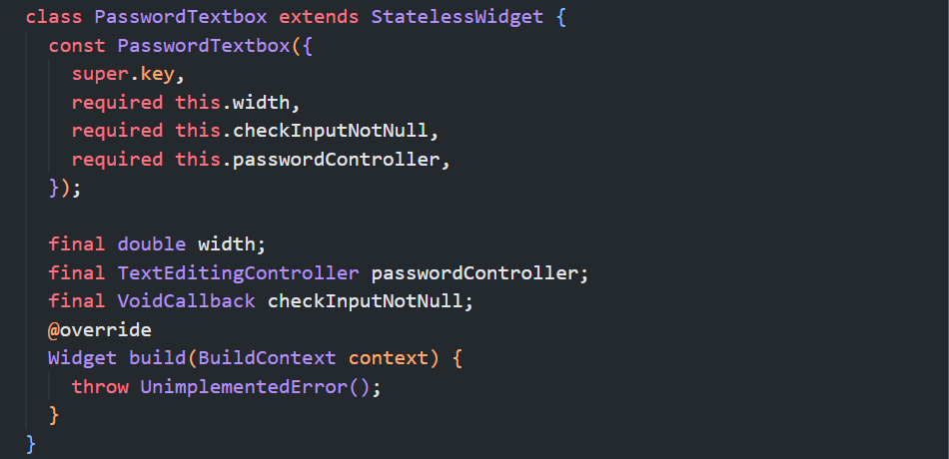
- Add Container widget as return with this specification

No | Widget | Property | Value
15 | Container | key | Key('password_textbox_container')
 |  | width | width * .90
 |  | height | width * .14
 |  | decoration | BoxDecoration(  color: Color(0xffE8E8E8),  borderRadius: BorderRadius.all(Radius.circular(5)),  )
 |  | child | Padding(key: const Key('password_textbox_padding')
Padding(key: const Key('password_textbox_padding') properties :
16 | Padding | key | Key('password_textbox_padding')
 |  | padding | EdgeInsets.symmetric(horizontal: 15)
 |  | child | Center(key: const Key('password_textfield')
Center(key: const Key('password_textfield') properties :
17 | Center | key | Key('password_textfield_center')
 |  | child | TextField(key: const Key('password_textfield')
TextField(key: const Key('password_textfield') properties :
18 | TextField | key | Key('password_textfield')
 |  | onChanged | (text) => checkInputNotNull()
 |  | controller | passwordController
 |  | obscureText | true
 |  | style | TextStyle(fontSize: 15)
 |  | decoration | InputDecoration.collapsed(hintText: 'Password')

return Container(
key: const Key('password_textbox_container'),
width: width * .90,
height: width * .14,
decoration: const BoxDecoration(
color: Color(0xffE8E8E8),
borderRadius: BorderRadius.all(Radius.circular(5)),
),
child: Padding(
key: const Key('password_textbox_padding'),
padding: const EdgeInsets.symmetric(horizontal: 15),
child: Center(
key: const Key('password_textfield_center'),
child: TextField(
key: const Key('password_textfield'),
onChanged: (text) => checkInputNotNull(),
controller: passwordController,
obscureText: true,
style: const TextStyle(fontSize: 15),
decoration: const InputDecoration.collapsed(
hintText: 'Password',
),
),
),
),
);

- Move to login_button.dart file on directory lib\app\modules\login\components\ login_button.dart make sure it’s extended from StatelessWidget
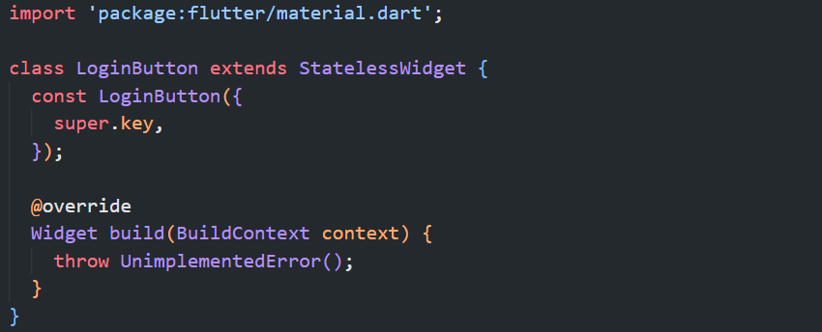
- Add this parameters to LoginButton class
final double width;
final bool inputTextNotNull;
final VoidCallback onPressed;

const LoginButton({
super.key,
required this.width,
required this.inputTextNotNull,
required this.onPressed,
});

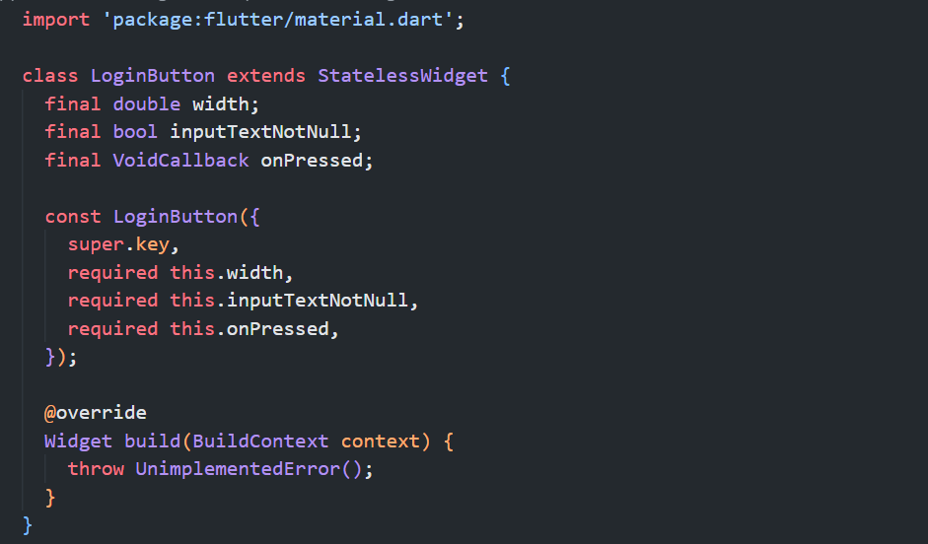
- Add SizedBox widget as return following this specifications
No | Widget | Property | Value
19 | SizedBox | key | Key('login_button_sized_box')
 |  | width | width * .90
 |  | height | width * .14
 |  | child | ElevatedButton(  key: const Key('login_button_elevated_button')
ElevatedButton(key: const Key('login_button_elevated_button') properties :
20 | ElevatedButton | key | Key('login_button_elevated_button')
 |  | onPressed | onPressed
 |  | style | ElevatedButton.styleFrom(  backgroundColor: inputTextNotNull  ? const Color(0xff26A9FF)  : const Color(0xff78C9FF),  )
 |  | child | Text(key: const Key('login_button_text')
Text(key: const Key('login_button_text') properties :
21 | Text | key | Key('login_button_text')
 |  | value | 'Log In'
 |  | style | TextStyle(  color: Colors.white,  fontSize: width * .040,  fontWeight: FontWeight.bold)

return SizedBox(
key: const Key('login_button_sized_box'),
width: width * .90,
height: width * .14,
child: ElevatedButton(
key: const Key('login_button_elevated_button'),
onPressed: onPressed,
style: ElevatedButton.styleFrom(
backgroundColor: inputTextNotNull
? const Color(0xff26A9FF)
: const Color(0xff78C9FF),
),
child: Text(
key: const Key('login_button_text'),
'Log In',
style: TextStyle(
color: Colors.white,
fontSize: width * .040,
fontWeight: FontWeight.bold,
),
),
),
);

- Back to login_page.dart file and add these lines of code on LoginPageState class
TextEditingController usernameController = TextEditingController();
TextEditingController passwordController = TextEditingController();
bool inputTextNotNull = false;

void checkInputNotNull() {
setState(() {
if (usernameController.text.length >= 2 &&
passwordController.text.length >= 2) {
inputTextNotNull = true;
} else {
inputTextNotNull = false;
}
});
}

void openHomePage() => debugPrint('Login button pressed');

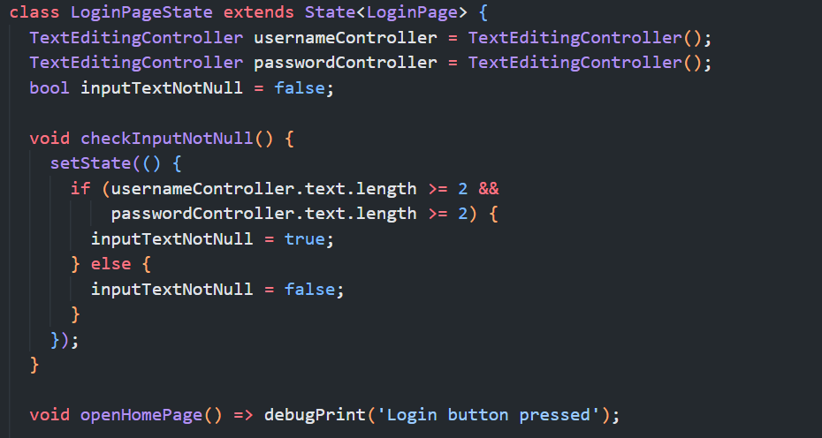
- Still on login_page.dart file add this import so that UsernameTextbox, PasswordTextbox, and LoginButton widgets that previously made would be accessible from this file.
import 'components/username_textbox.dart';
import 'components/password_textbox.dart';
import 'components/login_button.dart';

- Find Column widget with key login_page_content_column, on child properties add UsernameTextbox, PasswordTextbox, and LoginButton following this requirements
No | Widget | Property | Value
22 | UsernameTextbox | Key | const Key('login_page_username_textbox')
 |  | width | width
 |  | checkInputNotNull | checkInputNotNull
 |  | usernameController | usernameController
23 | SizedBox | Height | 10
24 | PasswordTextbox | Key | const Key('login_page_password_textbox')
 |  | width | width
 |  | checkInputNotNull | checkInputNotNull
 |  | passwordController | passwordController
25 | SizedBox | height | 10
26 | LoginButton | Key | const Key('login_page_login_button')
 |  | width | width
 |  | inputTextNotNull | inputTextNotNull
 |  | onPressed | () => openHomePage()
27 | SizedBox | height | 15

Column(
key: const Key('login_page_content_column'),
children: [
...
UsernameTextbox(
key: const Key('login_page_username_textbox'),
width: width,
checkInputNotNull: checkInputNotNull,
usernameController: usernameController,
),
const SizedBox(height: 10),
PasswordTextbox(
key: const Key('login_page_password_textbox'),
width: width,
checkInputNotNull: checkInputNotNull,
passwordController: passwordController,
),
const SizedBox(height: 10),
LoginButton(
key: const Key('login_page_login_button'),
width: width,
inputTextNotNull: inputTextNotNull,
onPressed: () => openHomePage(),
),
const SizedBox(height: 15),
],
),

- Move to forgot_access.dart file under directory lib\app\modules\login\components\ forgot_access.dart make sure it’s extended from StatelessWidget
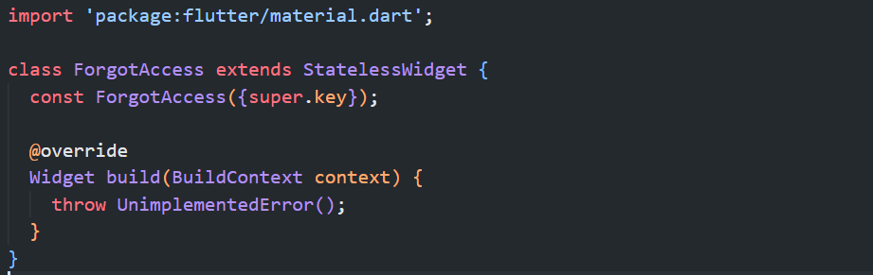
- Add this parameters to ForgotAccess class
final double width;
const ForgotAccess({super.key, required this.width});

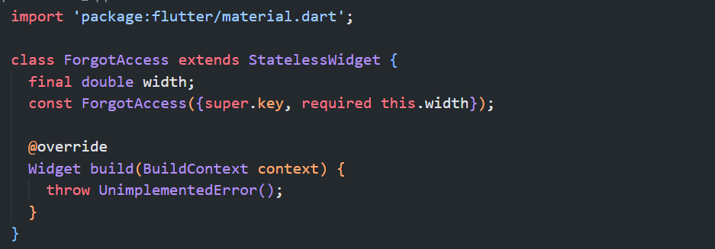
- Add Row widget as return following this specifications :
No | Widget | Property | Value
28 | Row | key | Key('forgot_access_row')
 |  | mainAxisAlignment | MainAxisAlignment.center
 |  | children | Text(key:Key('forgot_access_text'),  GestureDetector(  key : Key('get_help_gesture_detector'))
Text(key:Key('forgot_access_text') properties :
29 | Text | key | Key('forgot_access_text')
 |  | value | 'Forgot your login details? '
 |  | style | TextStyle(  fontSize: 13,  fontWeight: FontWeight.normal,  color: Colors.black)
GestureDetector(key : Key('get_help_gesture_detector')) properties :
30 | GestureDetector | key | Key('get_help_gesture_detector')
 |  | onTap | () => debugPrint('Get help')
 |  | child | Text(key: Key('get_help_text')
Text(key: Key('get_help_text') properties :
31 | Text | key | Key('get_help_text')
 |  | value | 'Get help'
 |  | style | TextStyle(  fontSize: 13,  color: Color(0xff002588),  fontWeight: FontWeight.bold)

return Row(
key: const Key('forgot_access_row'),
mainAxisAlignment: MainAxisAlignment.center,
children: [
const Text(
'Forgot your login details? ',
style: TextStyle(
fontSize: 13,
fontWeight: FontWeight.normal,
color: Colors.black,
),
key: Key('forgot_access_text'),
),
GestureDetector(
key: const Key('get_help_gesture_detector'),
onTap: () => debugPrint('Get help'),
child: const Text(
'Get help',
style: TextStyle(
fontSize: 13,
color: Color(0xff002588),
fontWeight: FontWeight.bold,
),
key: Key('get_help_text'),
),
),
],
);

- Back to login_page.dart file add this import so that ForgotAccess widget would be accessible from this page.
import 'components/forgot_access.dart';

- Move into Column widget within login_page.dart with key login_page_column and add ForgotAccess and SizedBox widget as children following this specification
No | Widget | Property | Value
32 | ForgotAccess | Key | const Key('login_page_forgot_access')
 |  | width | Width
33 | SizedBox | height | 15

Column(
key: const Key('login_page_content_column'),
mainAxisAlignment: MainAxisAlignment.center,
children: [
...
ForgotAccess(
key: const Key('login_page_forgot_access'),
width: width,
),
const SizedBox(height: 15),
],
),

- Move to or_divider.dart file under directory
lib\app\modules\login\components\ or_divider.dart
make sure it’s extended from StatelessWidget
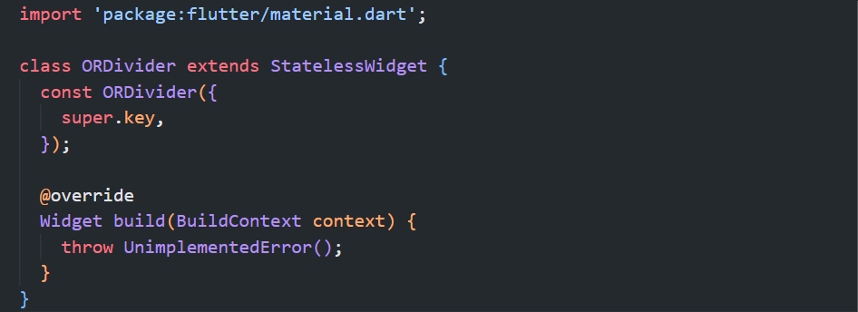
- Add this parameters to ORDivider class
final double width;
const ORDivider({
super.key,
required this.width,
});

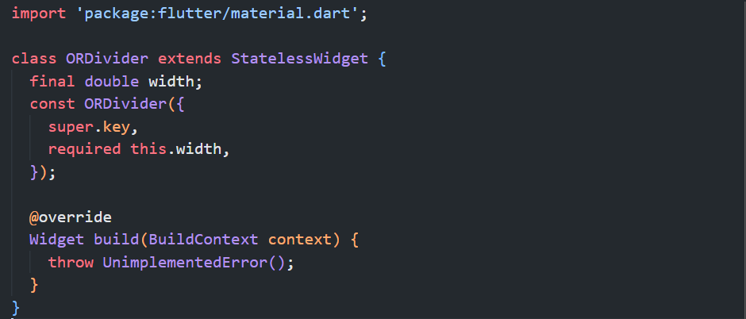
- Add Row widget as return following this specifications :
No | Widget | Property | Value
34 | Row | key | Key('or_divider_row')
 |  | mainAxisAlignment | MainAxisAlignment.center
 |  | children | Container(  key: const Key('or_divider_container_left'),  SizedBox(width: 10),  Text(key: const Key('or_divider_text')),  SizedBox(width: 10),  Container(  key: const Key('or_divider_container_right'))
Container(key: const Key('or_divider_container_left') properties :
35 | Container | key | Key('or_divider_container_left')
 |  | height | 1
 |  | width | width * .40
 |  | color | Color(0xffA2A2A2)
Text(key: const Key('or_divider_text')) properties :
36 | Text | key | Key('or_divider_text')
 |  | value | 'OR'
 |  | style | TextStyle(fontSize: width * .040)
Container(key: const Key('or_divider_container_right')) properties :
37 | Container | key | Key('or_divider_container_right')
 |  | height | 1
 |  | width | width * .40
 |  | color | Color(0xffA2A2A2)

return Row(
key: const Key('or_divider_row'),
mainAxisAlignment: MainAxisAlignment.center,
children: [
Container(
key: const Key('or_divider_container_left'),
height: 1,
width: width * .40,
color: const Color(0xffA2A2A2),
),
const SizedBox(width: 10),
Text(
key: const Key('or_divider_text'),
'OR',
style: TextStyle(fontSize: width * .040),
),
const SizedBox(width: 10),
Container(
key: const Key('or_divider_container_right'),
height: 1,
width: width * .40,
color: const Color(0xffA2A2A2),
),
],
);

- Back to login_page.dart file, add this import so ORDivider widget would be accessible from this page
import 'components/or_divider.dart';

- Move to Column widget with key login_page_content_column, on child properties add ORDivider and SizedBox widget following this specifications:
No | Widget | Property | Value
38 | ORDivider | Key | const Key('login_page_or_divider')
 |  | width | width
39 | SizedBox | height | 20

Column(
key: const Key('login_page_content_column'),
mainAxisAlignment: MainAxisAlignment.center,
children: [
...
ORDivider(
key: const Key('login_page_or_divider'),
width: width,
),
const SizedBox(height: 20),
],
)

- Move to facebook_login.dart file under directory lib\app\modules\login\components\facebook_login.dart make sure it’s extended from StatelessWidget
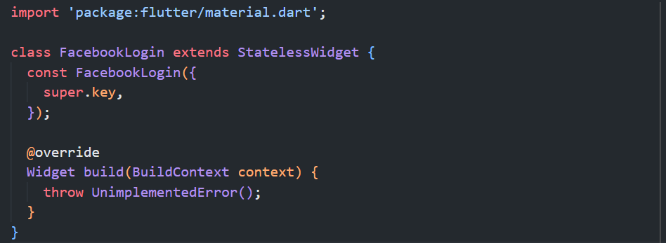
- Add this parameters to FacebookLogin class
final double width;
const FacebookLogin({
super.key,
required this.width,
});

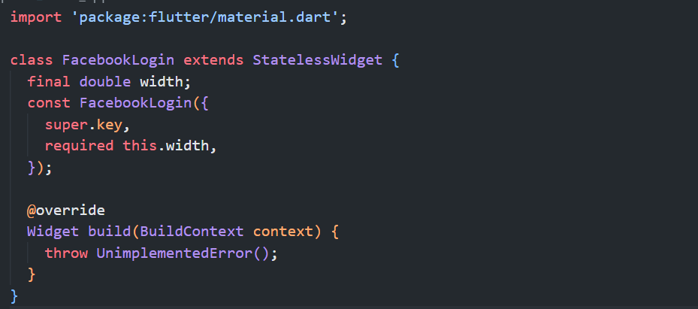
- Add Row widget as return following this specifications
No | Widget | Property | Value
40 | Row | key | Key('facebook_login')
 |  | mainAxisAlignment | MainAxisAlignment.center
 |  | children | Image.asset(key:Key('facebook_logo'),  SizedBox(width:5),  Text(key: Key('facebook_login_text'))
Image.asset(key:Key('facebook_logo') properties :
41 | Image | key | Key('facebook_logo')
 |  | value | 'assets/facebook.png'
 |  | height | width * .060
Text(key: Key('facebook_login_text')) properties :
43 | Text | key | Key('facebook_login_text')
 |  | value | 'Login with facebook'
 |  | style | TextStyle(  color: const Color(0xff1877f2),  fontSize: width * .040,  fontWeight: FontWeight.w800)

return Row(
key: const Key('facebook_login'),
mainAxisAlignment: MainAxisAlignment.center,
children: [
Image.asset(
'assets/facebook.png',
key: const Key('facebook_logo'),
height: width * .060,
),
const SizedBox(width: 5),
Text(
'Login with facebook',
key: const Key('facebook_login_text'),
style: TextStyle(
color: const Color(0xff1877f2),
fontSize: width * .040,
fontWeight: FontWeight.w800,
),
),
],
);

- Back to login_page.dart file add this import so FacebookLogin widget would be accessible from this page.
import 'components/facebook_login.dart';

- Move to Column widget with key login_page_content_column, on child properties add FacebookLogin widget following this specifications
No | Widget | Property | Value
44 | FacebookLogin | key | const Key('login_page_facebook_login')
 |  | width | width

Column(
key: const Key('login_page_content_column'),
mainAxisAlignment: MainAxisAlignment.center,
children: [
...
FacebookLogin(
key: const Key('login_page_facebook_login'),
width: width,
),
],
),

- Move to signup_section.dart file under directory lib\app\modules\login\components\signup_section.dart make sure it’s extended from StatelessWidget
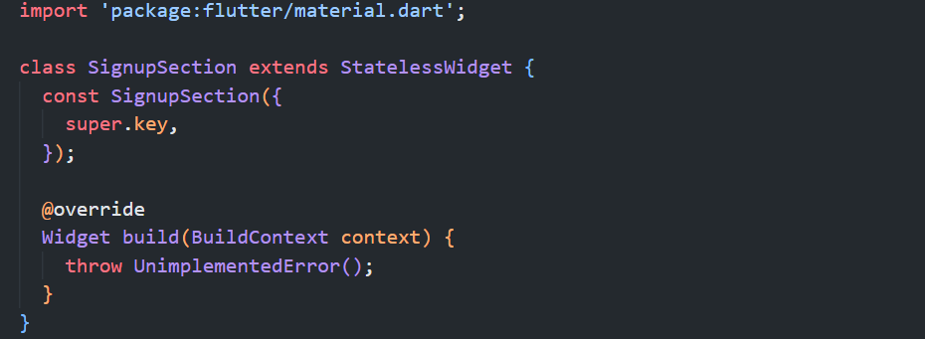

- Add this parameters on SignupSection class
final double width;

const SignupSection({
super.key,
required this.width,
});

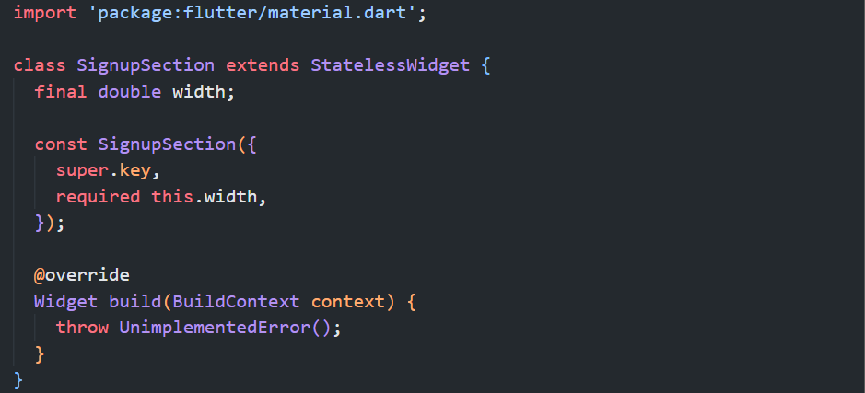

- Add Column widget as return following this specifications:
No | Widget | Property | Value
45 | Column | key | Key('signup_section_column')
 |  | mainAxisAlignment | MainAxisAlignment.center
 |  | children | Container(  key: const Key('signup_section_container'),  SizedBox (height: 5),  Row(key: const Key('signup_section'))
Container(key: const Key('signup_section_container') properties :
46 | Container | key | Key('signup_section_container')
 |  | width | width
 |  | height | 1
 |  | color | Color(0xffA2A2A2)
Row(key: const Key('signup_section')) properties :
48 | Row | key | Key('signup_section')
 |  | mainAxisAlignment | MainAxisAlignment.center
 |  | children | Text(key: const Key('signup_section_text'),  TextButton(  key: const Key('signup_section_button'))
Text(key: const Key('signup_section_text') properties :
49 | Text | value | "Don't have an account? "
 |  | key | Key('signup_section_text')
 |  | style | TextStyle(fontSize: width * .040)
TextButton(key: const Key('signup_section_button')) properties :
50 | TextButton | key | Key('signup_section_button')
 |  | child | Text(Key('signup_section_text'))
Text(Key('signup_section_text')) properties :
51 | Text | value | 'Sign up'
 |  | style | TextStyle(  color: const Color(0xff00258B),  fontSize: width * .040,  fontWeight: FontWeight.bold,  )
 |  | onPressed | () => debugPrint('Sign Up'),
 |  | key | Key('signup_section_text')

return Column(
key: const Key('signup_section_column'),
mainAxisAlignment: MainAxisAlignment.center,
children: [
Container(
key: const Key('signup_section_container'),
width: width,
height: 1,
color: const Color(0xffA2A2A2),
),
const SizedBox(height: 5),
Row(
key: const Key('signup_section'),
mainAxisAlignment: MainAxisAlignment.center,
children: [
Text(
"Don't have an account? ",
key: const Key('signup_section_text'),
style: TextStyle(fontSize: width * .040),
),
TextButton(
key: const Key('signup_section_button'),
child: Text(
'Sign up',
style: TextStyle(
color: const Color(0xff00258B),
fontSize: width * .040,
fontWeight: FontWeight.bold,
),
),
onPressed: () => debugPrint('Sign Up'),
),
],
),
],
);

- Back to login_page.dart file add this import so SignupSection widget would be accessible from this page.
import 'components/signup_section.dart';

- Move to Column widget with key login_page_column, on child properties add SignupSection widget following this specifications
No | Widget | Property | Value
52 | SignupSection | key | const Key('login_page_signup_section'),
 |  | width | width
Column(
key: const Key('login_page_column'),
children: [
Container(key: const
Key('login_page_language_dropdown_container')
...
),
Column(
key: const Key('login_page_content_column'),
...
),
SignupSection(
key: const Key('login_page_signup_section'),
width: width,
),
],
),

- Still on the same Column, add this property
No | Widget | Property | Value
53 | Column | key | const Key('login_page_signup_section'),
 |  | mainAxisAlingment | MainAxisAlignment.spaceBetween,

Column(
key: const Key('login_page_column'),
mainAxisAlignment: MainAxisAlignment.spaceBetween,
children: [
Container(key: const
Key('login_page_language_dropdown_container')
...
),
Column(
key: const Key('login_page_content_column'),
...
),
SignupSection(
key: const Key('login_page_signup_section'),
...
),
],
),
- Run the project and check if there’s no error it will return login page similar like this.
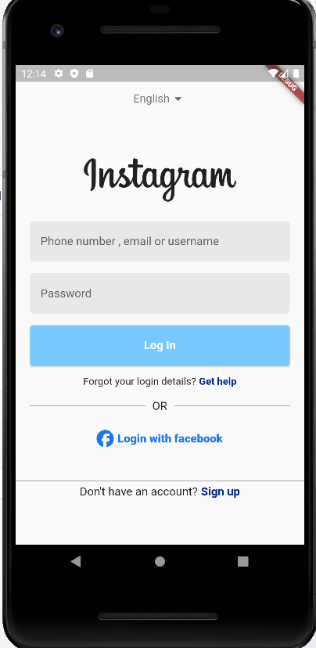
Testing
- Open login_page_test.dart file under test folder
- Find main method it will look similar like this
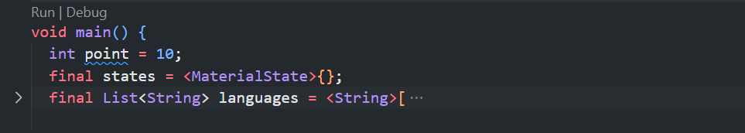
- Click Run
- If there is an error try to check the message and fix the error usually It’s because of wrong key name or missing property of specific widget e.g :
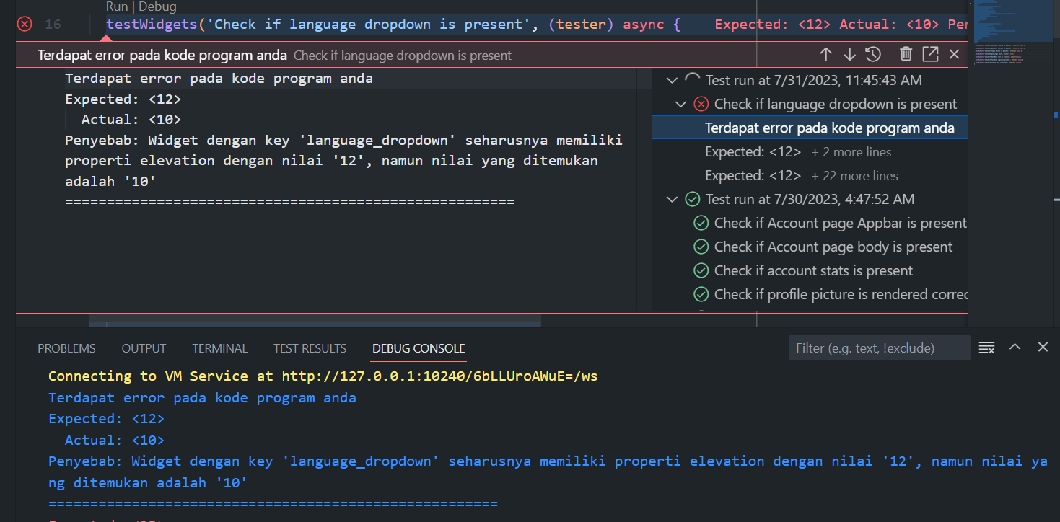
In this error try to fix the elevation property value on widget with key ‘language_dropdown’ from 10 to 12
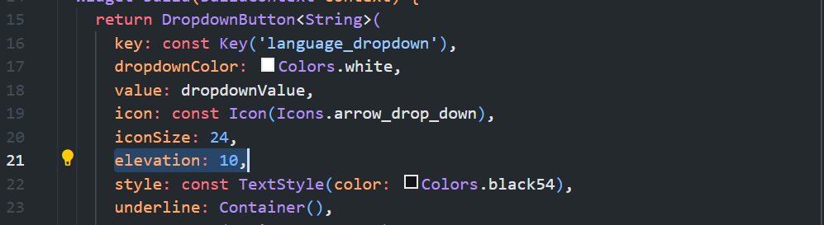
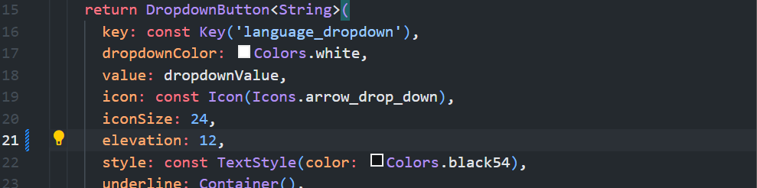
- Continue repeat fixing the code until there’s no error appear on test
