TASK GUIDE (C2.10)

- Objectives.
Student will start to design the Seller Cart Activity layout and create the function.

- Requirements.
Hardware:
- 2 GB RAM minimum, 8 GB RAM recommended
- 2 GB of available disk space minimum, 4 GB Recommended (500 MB for IDE + 1.5 GB for Android SDK and emulator system image)
- 1280 x 800 minimum screen resolution
- Intel processor with support for Intel VT-x, Intel EM64T (Intel 64), and Execute Disable (XD) Bit functionality
Software:
- Microsoft Windows 7/8/10 (32-bit or 64-bit)
- JDK 8
- Android Studio IDE (Minimum 3.2) with AndroidX library.

- Resources.
Documents:
- Guide
Supplement files:
Test code:
- TestC2MyShop010.java

- Task Description.
Student start to modify the Seller Cart Activity layout and function.

- Specification.

- Create an empty class with name “SellerCartActivity”
- Open “activity_seller_cart.xml” in layout resource folder. Changer the root layout become “LinearLayout” and orientation “vertical”.
- Add a text in TextView as Title with this information:
- Id: titleCartSeller
- Text: “SELLER CART”
- Add a ReclyclerView with this information
- Id : recyclerViewCarts
- Add 2 Buttons with this information:
Id | Text
ButtonRefreshProduct | Refresh Cart
ButtonCancel | Cancel
- Open “CartActivitySeller.java” and create a method with name “initViews” like below
private void initViews() {
textViewName = (AppCompatTextView) findViewById(R.id.textViewName);
recyclerViewCarts = (RecyclerView) findViewById(R.id.recyclerViewCarts);
buttonRefreshProduct = (Button)findViewById(R.id.ButtonRefreshProduct);
buttonBack = (Button)findViewById(R.id.ButtonBack);
}

- Create a method with name “initObjects” like below
private void initObjects() {
listCarts = new ArrayList<>();
cartsRecyclerAdapter = new CartsRecyclerAdapter(mContext, listCarts);

recyclerViewCarts.setLayoutManager(new LinearLayoutManager(this, recyclerViewCarts.VERTICAL, false));
recyclerViewCarts.setItemAnimator(new DefaultItemAnimator());
recyclerViewCarts.setHasFixedSize(false);
recyclerViewCarts.setAdapter(cartsRecyclerAdapter);
database = new Database(activity);
cart = new Cart();

getDataFromSQLite();

cartsRecyclerAdapter.setOnItemClickListener(new CartsRecyclerAdapter.OnItemClickListener() {
@Override
public void onItemClick(View view, int position) {
TextView cartId = (TextView) view.findViewById(R.id.CartID);
openDetailCartActivity(Integer.parseInt(cartId.getText().toString()));
}
});

- Create a method with name “getDataFromSQLite” like below
private void getDataFromSQLite() {
// AsyncTask is used that SQLite operation not blocks the UI Thread.
new AsyncTask<Void, Void, Void>() {
@SuppressLint("StaticFieldLeak")
@Override
protected Void doInBackground(Void... params) {
String Username = getIntent().getStringExtra("Username");
listCarts.clear();
listCarts.addAll(database.getAllCart());

return null;
}

@Override
protected void onPostExecute(Void aVoid) {
super.onPostExecute(aVoid);
cartsRecyclerAdapter.notifyDataSetChanged();
}
}.execute();
}
- Open “SellerHomeActivity.java” and add a new case in method “onClick” like below
case R.id.ButtonBuyerCart:
Intent buyercart = new Intent(activity, CartActivitySeller.class);
startActivity(buyercart);
break;

- Add a setOnClickListener” in method “initListener” like below
private void initListeners() {
ButtonAddProduct.setOnClickListener(this);
ButtonRefreshProduct.setOnClickListener(this);
ButtonBuyerCart.setOnClickListener(this);
ButtonLogout.setOnClickListener(this);
}
Testing.
- Copy “TestC2MyShop081.java” file to “org.aplas.myshop (test)” folder.

- Right click on the “TestC2MyShop081.java” file then choose Run. It may take long time to execute.

- Get the result of your task. If passed you will get green check like below. If the test failed, you will get orange check get the messages and you must check your work again.
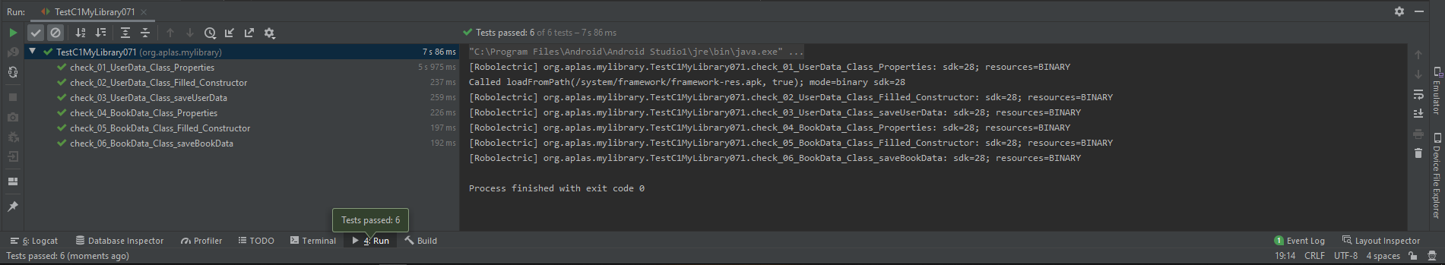

You have to try until get all green checkes and continue to the next task.

