TASK GUIDE (C2.06)

- Objectives.
Student will start to design the Buyer Home Activity layout and create the function.

- Requirements.
Hardware:
- 2 GB RAM minimum, 8 GB RAM recommended
- 2 GB of available disk space minimum, 4 GB Recommended (500 MB for IDE + 1.5 GB for Android SDK and emulator system image)
- 1280 x 800 minimum screen resolution
- Intel processor with support for Intel VT-x, Intel EM64T (Intel 64), and Execute Disable (XD) Bit functionality
Software:
- Microsoft Windows 7/8/10 (32-bit or 64-bit)
- JDK 8
- Android Studio IDE (Minimum 3.2) with AndroidX library.

- Resources.
Documents:
- Guide
Supplement files:
Test code:
- TestC2MyShop06.java

- Task Description.
Student start to modify the Buyer Home Activity layout and function.

- Specification.

- Create an empty activity with name “BuyerHomeActivity”

- Open “activity_buyer_home.xml” in layout resource folder. Change the root layout become “LinearLayout” and orientation “vertical”.

- Add a text in a TextView as Title with this information:
- id: "titleBuyerHome"
- text: "BUYER HOME"
- Add a text in RecycleView with this information:
- Id: “recycleViewProducts”
- Add 4 buttons with information:
Id | Text
ButtonRefreshProduct | Refresh Product
ButtonBuyerCart | See Cart
ButtonLogout | Logout

- Open “BuyerHomeActivity.java” and create a method with name “initViews” to declare xml properties like below
private void initViews() {
recyclerViewProducts = (RecyclerView) findViewById(R.id.recyclerViewProducts);
ButtonRefreshProduct = (Button)findViewById(R.id.ButtonRefreshProduct);
ButtonBuyerCart = (Button)findViewById(R.id.ButtonBuyerCart);
ButtonLogout = (Button)findViewById(R.id.ButtonLogout);
}

- Create method with name “initObjects” to declare objects like below
private void initObjects() {
listProducts = new ArrayList<>();
productsRecyclerAdapter = new ProductsRecyclerAdapter(mContext, listProducts);

recyclerViewProducts.setLayoutManager(new LinearLayoutManager(this, recyclerViewProducts.VERTICAL, false));
recyclerViewProducts.setItemAnimator(new DefaultItemAnimator());
recyclerViewProducts.setHasFixedSize(false);
recyclerViewProducts.setAdapter(productsRecyclerAdapter);
database = new Database(activity);
getDataFromSQLite();
productsRecyclerAdapter.setOnItemClickListener(new ProductsRecyclerAdapter.OnItemClickListener() {
@Override
public void onItemClick(View view, int position) {
TextView productId = (TextView) view.findViewById(R.id.ProductID);
openDetailProductActivity(Integer.parseInt(productId.getText().toString()));
}
});
}
- Create a method with name “onClick” to declare button click like below
@Override
public void onClick(View v) {
switch (v.getId()){
case R.id.ButtonRefreshProduct:
getDataFromSQLite();
break;
case R.id.ButtonLogout:
finish();
break; }}

- Create a method with name “getDataFromSQLite” to collect data from SQLite like below
private void getDataFromSQLite() {
// AsyncTask is used that SQLite operation not blocks the UI Thread.
new AsyncTask<Void, Void, Void>() {
@SuppressLint("StaticFieldLeak")
@Override
protected Void doInBackground(Void... params) {
listProducts.clear();
listProducts.addAll(database.getAllProduct());
return null;
}
@Override
protected void onPostExecute(Void aVoid) {
super.onPostExecute(aVoid); productsRecyclerAdapter.notifyDataSetChanged();
}
}.execute();
}

- Testing.
- Copy “•TestC2MyShop06.java” file to “org.aplas.myshop (test)” folder.

- Right click on the “TestC2MyShop06.java” file then choose Run. It may take long time to execute.

- Get the result of your task. If passed you will get green check like below. If the test failed, you will get orange check get the messages and you must check your work again.
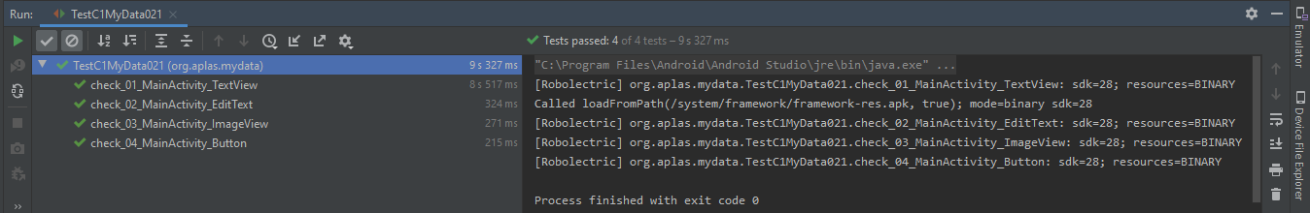

You have to try until get all green checkes and continue to the next task.
You can get the screen display like below when running this Activity. The style of layout depends on your layout design.
