TASK GUIDE (C2.05)

- Objectives.
Student will start to design the Seller Detail Product layout. And modify the function.

- Requirements.
Hardware:
- 2 GB RAM minimum, 8 GB RAM recommended
- 2 GB of available disk space minimum, 4 GB Recommended (500 MB for IDE + 1.5 GB for Android SDK and emulator system image)
- 1280 x 800 minimum screen resolution
- Intel processor with support for Intel VT-x, Intel EM64T (Intel 64), and Execute Disable (XD) Bit functionality
Software:
- Microsoft Windows 7/8/10 (32-bit or 64-bit)
- JDK 8
- Android Studio IDE (Minimum 3.2) with AndroidX library.

- Resources.
Documents:
- Guide
Supplement files:
Test code:
- TestC2MyShop051.java

- Task Description.
Student create a Seller Detail Product and design the layout. And modify the function of Seller Detail Product Activity.

- Specification.

- Create an empty activity with name “SellerDetailProductActivity”
- Open “activity_ seller_detail_product.xml” in layout resource folder. Change the roor layout become “LinearLayout” and orientation “vertical”
- Add a text in TextView as Title with this information
- Id: “titleProductDetailSeller”
- Text: “PRODUCT DETAIL”
- Add 2 TextInputLayout with this information
Id | Enable
textInputLayoutProductName | False
textEditLayoutProductPrice | False

- Add 2 TextInputEditText with this information
Id | Hint | Inside
TextInputEditTextProductName | Product Name | textInputLayoutProductName
TextInputEditTextProductPrice | Product Price | textEditLayoutProductPrice

- Add 2 Buttons with this information
Id | Text
ButtonRemoveProduct | Remove Product
ButtonBack | Back

- Open “DetailProductSeller.java” declare variable like below
“accessModifier” “type” “name”;
Access Modifier | Type | Name
Private | TextInputEditText | textInputEditTextProductName,  textInputEditTextProductPrice
Private | AppCompatButton | ButtonRemoveProduct, ButtonBack
Private | Database | database
Private | Product | product

- Create method with name “initView” to declare variable from xml file like below
private void initViews(){
textInputEditTextProductName=(TextInputEditText) findViewById(R.id.textInputEditTextProductName);
textInputEditTextProductName.setKeyListener(null);
textInputEditTextProductPrice=(TextInputEditText) findViewById(R.id.textInputEditTextProductPrice);
textInputEditTextProductPrice.setKeyListener(null);
ButtonBack=(AppCompatButton)findViewById(R.id.ButtonBack);
ButtonRemoveProduct=(AppCompatButton)findViewById(R.id.ButtonRemoveProduct);
}
- Create a method with name “initObjects” to declare activity like below
private void initObjects() {
database = new Database(this);
product = new Product();
}
- Create a method with name “onClick” to declare onClickListener like below
@Override
public void onClick(View v) {
switch (v.getId()) {
case R.id.ButtonRemoveProduct:
removeProductFromSQLite();
Toast.makeText(getApplicationContext(), "Remove product successfully", Toast.LENGTH_LONG).show();
finish();
break;
case R.id.ButtonBack:
finish();
break;
}
}

- Create a method with name “initListener” to call method in “onClick” like below
private void initListeners() {
ButtonRemoveProduct.setOnClickListener(this);
ButtonBack.setOnClickListener(this);
}

- Create a method with name “removeProductFromSQLite” to delete product from table “product” like below
private void removeProductFromSQLite(){
product.setId(cursor.getInt(0));
database.deleteProduct(product);
Toast.makeText(getApplicationContext(), "Product has been removed", Toast.LENGTH_LONG).show();
}

- Edit method “onCreate” like below
@Override
protected void onCreate(Bundle savedInstanceState) {
super.onCreate(savedInstanceState);
setContentView(R.layout.activity_detail_product_seller);
getSupportActionBar().hide();

initViews();
initListeners();
initObjects();

SQLiteDatabase db = database.getReadableDatabase();
cursor = db.rawQuery("SELECT * FROM Product WHERE product_id ='" +(getIntent().getIntExtra("productID", 0))+"'",null);
cursor.moveToFirst();

if (cursor.getCount()>0){
cursor.moveToPosition(0);
textInputEditTextProductName.setText(cursor.getString(1).toString());
textInputEditTextProductPrice.setText(cursor.getString(2).toString());
}
}

- Open “BuyerHomeActivity.java” and add a method with name “openDetailProductActivity like below
private void openDetailProductActivity(int productId) {
Intent intent = new Intent(getApplicationContext(),DetailProductSeller.class);
intent.putExtra("productID", productId);
startActivity(intent);
}

- Testing.
- Copy “TestC2MyShop051.java” file to “org.aplas.myshop (test)” folder.

- Right click on the “TestC2MyShop051.java” file then choose Run. It may take long time to execute.

- Get the result of your task. If passed you will get green check like below. If the test failed, you will get orange check get the messages and you must check your work again.
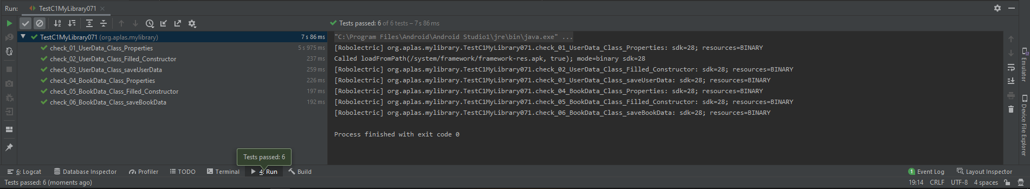

You have to try until get all green checkes and continue to the next task.

