TASK GUIDE (C2.01)

- Objectives.
Student will start an Android project to create an Android application that contains several activities entitled MyShop. Project configuration and resource configuration. And design user interface for Login Activity.

- Requirements.
Hardware:
- 2 GB RAM minimum, 8 GB RAM recommended
- 2 GB of available disk space minimum, 4 GB Recommended (500 MB for IDE + 1.5 GB for Android SDK and emulator system image)
- 1280 x 800 minimum screen resolution
- Intel processor with support for Intel VT-x, Intel EM64T (Intel 64), and Execute Disable (XD) Bit functionality
Software:
- Microsoft Windows 7/8/10 (32-bit or 64-bit)
- JDK 8
- Android Studio IDE (Minimum 3.2) with AndroidX library.

- Resources.
Documents:
- Guide
Supplement files:
- myshop.png
Test code:
- TestC2MyShop01.java

- Task Description.
Student start to create a project configuration, resource configuration, change first activity as loginActivity and modify the UI.

- Specification.

- Create New Project on Android Studio and choose “Empty Activity”, then Next.
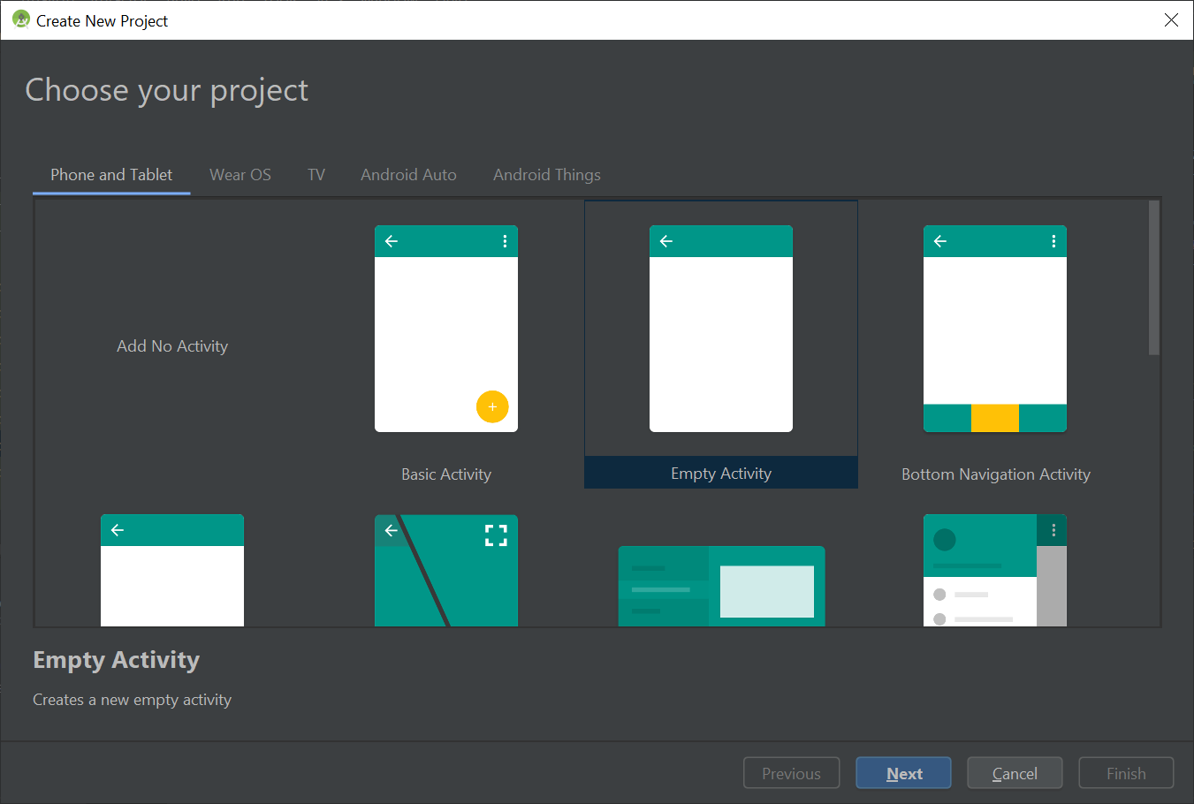

- Project Configuration.
- Project Name: MyShop
- Package Name: org.aplas.myshop
- Project Location: any
- Language: Java
- Target API Level: Android 6.0 (Marshmallow)
- Support instant apps: uncheck
Then Click Finish.

- Change the content of “build.graddle (Module: app)” file like below, then Sync it.
plugins {
id 'com.android.application'
}

android {
compileSdkVersion 28
buildToolsVersion "30.0.3"

defaultConfig {
applicationId "org.aplas.myshop"
minSdkVersion 21
targetSdkVersion 28
versionCode 1
versionName "1.0"

testInstrumentationRunner "androidx.test.runner.AndroidJUnitRunner"
}

buildTypes {
release {
minifyEnabled false
proguardFiles getDefaultProguardFile('proguard-android-optimize.txt'), 'proguard-rules.pro'
}
}
compileOptions {
sourceCompatibility JavaVersion.VERSION_1_8
targetCompatibility JavaVersion.VERSION_1_8
}
testOptions {
unitTests {
includeAndroidResources = true
}
}
}

dependencies {

implementation 'androidx.appcompat:appcompat:1.2.0'
implementation 'com.google.android.material:material:1.3.0'
implementation 'androidx.constraintlayout:constraintlayout:2.0.4'
implementation 'androidx.legacy:legacy-support-v4:1.0.0'
testImplementation 'junit:junit:4.+'
androidTestImplementation 'androidx.test.ext:junit:1.1.2'
androidTestImplementation 'androidx.test.espresso:espresso-core:3.3.0'
testImplementation 'org.robolectric:robolectric:4.2.1'
testImplementation 'androidx.test:core:1.3.0'
}

RESOURCE CONFIGURATION
- Configure the necessary string resource(s)
name | value
app_name | MyShop
hint_name | Name
hint_username | Username
hint_password | Password
hint_confirm_password | Confirm Password
text_login | Login
text_register | Register
error_message_username | Enter Username
error_message_password | Enter Password
error_message_role | Select Your Role
success_message | Registration Successful
text_not_member | No Account Yet? Create One
text_already_member | Already A Member? Login
error_username_exist | Username Already Exist
error_password_match | Password Does Not Matches
error_valid_email_password | Wrong Email or Password
action_settings | Settings
radio_seller | Seller
radio_buyer | Buyer
hint_product_name | Product Name
hint_product_price | Product Price
text_add_product | Add Product
text_cance | Cancel
error_message_product_name | Enter Product Name
error_message_product_price | Enter Product Price
product_success_message | Add Product Successful
error_product_exists | Product Already Exist

Note: you can add other string resource definitions by yourself if necessary.
- Configure the necessary string array resource(s)
name | value
roles | ---You Want to Be A ?---  Seller  Buyer

- Configure the necessary color resource(s)
name | value
black | #FF000000
white | #FFFFFFFF
colorPrimary | #51d8c7
colorPrimaryDark | #51d8c7
colorAccent | #FFFFFF
colorBackgroud | #001a33
colorText | #FFFFFF
colorTextHint | #51d8c7

- Configure the necessary drawable resource(s)
Copy all pictures in supplement folder to drawable resource folder in Android Studio:
- myShop.png
- Change the name of ‘MainActivity’ into ‘LoginActivity’ and ‘activity_main’ into ‘activity_login’.
- Open ‘AndroidManifest.xml’ create ‘LoginActivity’ as first activity like below
<activity android:name=".LoginActivity">
<intent-filter>
<action android:name="android.intent.action.MAIN" />

<category android:name="android.intent.category.LAUNCHER" />
</intent-filter>
</activity>
- Open ‘activity_login.xml’in layout resource folder. Change the root layout become “LinearLayout” and give id “inputLayout” and orientation “vertical” with background “@color/colorBackground”.
- Add a picture in ImageView as Logo with this information:
- Id : “imgLogo”
- Src : myshop.png
- Add a EditText with this information:
- id: "textInputEditTextUsername"
- hint: "@string/hint_username"
- Add a EditText with this information:
- Id: “textInputEditTextPassword”
- Hint:” @string/hint_password”
- Add a Button with this information:
- Id:” appCompatButtonLogin”
- Text:” @string/text_login”
- Background:” @color/colorTextHint”
- Add a textView woth this information:
- Id:” textViewLinkRegister”
- Text:” @string/text_not_member”

- Create package with name “model”
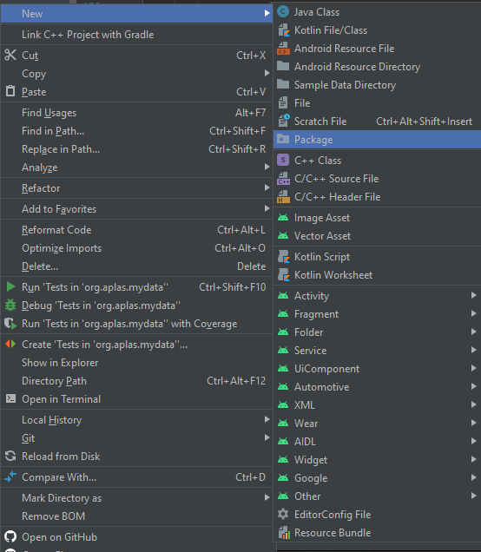

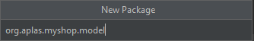

- Create class with name “user.java” in “model” package
- Open “user.java” and create variable like table
“accessModifier” “type” “name”;
Access Modifier | Type | Name
private | int | id
private | String | name
private | String | password
private | String | role

- Create method to get and set in “user.java” with variable like table
Variable
id
name
password
role
Note: you can add other image/drawable resource definitions by yourself if necessary.

- Testing.
- Copy “ResourceTest.java”, “ViewTest.java” and “TestC2MyShop011.java” file to “org.aplas.myshop(test)” folder.

- Right click on the “TestC2MyShop011.java” file then choose Run. It may take long time to execute.

- Get the result of your task. If passed you will get green check like below. If the test failed, you will get orange check get the messages and you must check your work again.
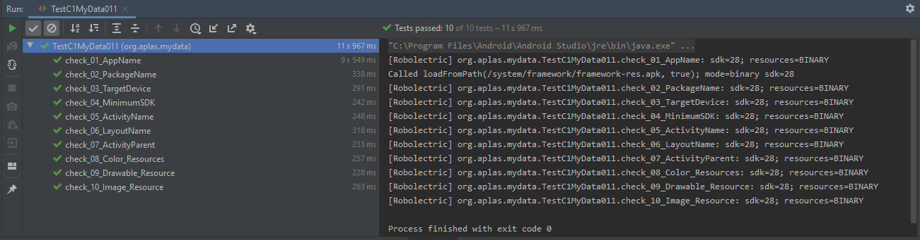

You have to try until get all green checkes and continue to the next task.

