TASK GUIDE (C2.09)

- Objectives.
Student will start to design the Detail Buyer Cart Activity layout and create the function.

- Requirements.
Hardware:
- 2 GB RAM minimum, 8 GB RAM recommended
- 2 GB of available disk space minimum, 4 GB Recommended (500 MB for IDE + 1.5 GB for Android SDK and emulator system image)
- 1280 x 800 minimum screen resolution
- Intel processor with support for Intel VT-x, Intel EM64T (Intel 64), and Execute Disable (XD) Bit functionality
Software:
- Microsoft Windows 7/8/10 (32-bit or 64-bit)
- JDK 8
- Android Studio IDE (Minimum 3.2) with AndroidX library.

- Resources.
Documents:
- Guide
Supplement files:
Test code:
- TestC2MyShop09.java

- Task Description.
Student start to modify the Detail Buyer Cart Activity layout and function.

- Specification.

- Create an empty “BuyerDetailCartActivity”
- Open “activity_buyer_detail_cart_product.xml” in layout resource folder. Changer the root layout become “LinearLayout” and orientation “vertical”.
- Add a text in TextView as Title with this information:
- Id: “titleDetailCartBuyer”
- Text: “PRODUCT DETAIL”
- Add 4 TextInputLayout with this information:
Id | Enable
textInputLayoutProductName | False
textEditLayoutProductPrice | False
textEditLayoutProductQuantity | False
textEditLayoutProductBuyer | False

4. Add 4 TextInputEditText with this information:
Id | Hint | Inside
TextInputEditTextProductName | Product Name | textInputLayoutProductName
TextInputEditTextProductPrice | Product Price | textEditLayoutProductPrice
TextInputEditTextProductQuantity | Quantity | textEditLayoutProductQuantity
TextInputEditTextProductBuyer | Product Buyer | textEditLayoutProductBuyer

- Add 2 Buttons with information:
Id | Text
ButtonDeleteFromCart | Delete From Cart
ButtonCancel | Back

- Open ‘DetailCartBuyer.java’ declare variable like below
“accessModifier” “type” “name”;

Access Modifier | Type | Name
Private | TextInputEditText | textInputEditTextProductName, textInputEditTextProductPrice, textInputEditTextProductBuyer, textInputEditTextProductQuantity
Private | AppCompatButton | ButtonDeleteFromCart
Private | AppCompatButton | ButtonCancel
Private | ProductsRecyclerAdapter | productsRecyclerAdapter
Private | Database | database
Private | Cart | cart

- Create method with name “initView” to declare variables from xml file
- Create method with name “initObjects” like below
private void initObjects() {
database = new Database(this);
cart = new Cart();
}
- Create method with name “initListener” like below
private void initListeners() {
ButtonDeleteFromCart.setOnClickListener(this);
ButtonBack.setOnClickListener(this);
}

- Create method with name “onClick” like below
@Override
public void onClick(View v) {
switch (v.getId()) {
case R.id.ButtonDeleteFromCart:
removeCartFromSQLite();
Toast.makeText(getApplicationContext(), "Deleted From Cart", Toast.LENGTH_LONG).show();
finish();
break;
case R.id.ButtonBack:
finish();
break;
}
}

- Edit method “onCreate” like below
@Override
protected void onCreate(Bundle savedInstanceState) {
super.onCreate(savedInstanceState);
setContentView(R.layout.activity_detail_cart_product_buyer);
getSupportActionBar().hide();

initViews();
initListeners();
initObjects();

SQLiteDatabase db = database.getReadableDatabase();
cursor = db.rawQuery("SELECT * FROM Cart WHERE cart_id ='" +(getIntent().getIntExtra("cartID", 0))+"'",null);
cursor.moveToFirst();

if (cursor.getCount()>0){
cursor.moveToPosition(0);
textInputEditTextProductName.setText(cursor.getString(3).toString());
textInputEditTextProductPrice.setText(cursor.getString(4).toString());
textInputEditTextProductQuantity.setText(cursor.getString(5).toString());
textInputEditTextProductBuyer.setText(cursor.getString(1).toString());
}
}
- Create a method with name “initObjects” to declare activity like below
- Create a method with name “removeCartFromSQLite” to declare activity like below
private void removeCartFromSQLite(){
cart.setId(cursor.getInt(0));
database.deleteCart(cart);
Toast.makeText(getApplicationContext(), "Cart has been removed", Toast.LENGTH_LONG).show();}
- Open “CartActivityBuyer.java” and add method with name “openDetailCartActivity like below
private void openDetailCartActivity(int cartId) {
Intent intent = new Intent(getApplicationContext(),DetailCartProductBuyer.class);
intent.putExtra("cartID", cartId);
startActivity(intent);
}

Testing.
- Copy “TestC2MyShop041.java” file to “org.aplas.myshop (test)” folder.

- Right click on the “TestC2MyShop041.java” file then choose Run. It may take long time to execute.

- Get the result of your task. If passed you will get green check like below. If the test failed, you will get orange check get the messages and you must check your work again.
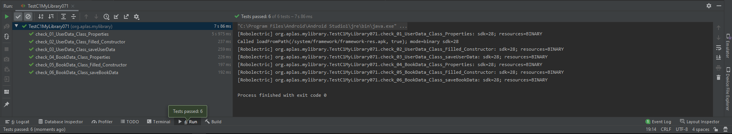

You have to try until get all green checkes and continue to the next task.

