IMPLEMENTATION OF DATA ANALYTICS LEARNING IN PYTHON PROGRAMMING LEARNING ASSISTANCE SYSTEM

THESIS

By:
NOORA AULIA HIDAYAT Student ID. 2041720046



INFORMATICS ENGINEERING STUDY PROGRAM
INFORMATION TECHNOLOGY DEPARTMENT
STATE POLYTECHNIC OF MALANG
2024

APPROVAL SHEET
IMPLEMENTATION OF DATA ANALYTICS LEARNING IN PYTHON PROGRAMMING LEARNING ASSISTANCE SYSTEM

by:
NOORA AULIA HIDAYAT NIM. 2041720046

This thesis proposal was tested on July 29, 2024
Approved by:

1. | Supervisor | : | Yan Watequlis Syaifudin, ST., MMT., PhD.  NIP. 19810105 200501 1 005 | ...........................
2. | Supervisor II | : | Retno Damayanti, S.Pd., M.T.  NIP. 19891004 201903 2 023 | ...........................
3. | Examiner I | : | -  - | ...........................
4. | Examiner II | : | -  - | ...........................

Confirmed by,
Head of Information Technology  Department | Head of Informatics Engineering  Study Program
Dr. Rosa Andrie Asmara, ST., MT. | Dr. Ely Setyo Astuti, S.T., MT.
NIP. 19801010 200501 1 001 | NIP. 19760515 200912 2 001

STATEMENT
I hereby declare that, to the best of my knowledge, this thesis does not contain any work or opinion that has been written or published by others, other than those that are cited in writing within the manuscript and mentioned in the citation/reference list. It also does not contain any work, in whole or in part, that has ever been submitted for the award of an academic degree at any higher education institution.

Malang, 29 April 2024

Noora Aulia Hidayat

ABSTRACT
Noora Aulia Hidayat. “Implementation of Data Analytics Learning in Python Programming Learning Assistance System”.
Supervisor: Yan Watequlis Syaifudin, ST., MMT., PhD. , Co–Supervisor: Retno Damayanti, S.Pd., M.T.

Thesis, Informatics Engineering Study Program, Department of Information
Technology, State Polytechnic of Malang, 2024.

The demand for Data Analytics in the business world is increasing. In 2023, there were 1,072 job postings related to the most sought-after skills, techniques, and degrees, as well as the current job market conditions on LinkedIn (Yosifova, 2023). This paper presents a Python Programming Learning Assistance System (PYPLAS) to assist students in self-learning Python programming for Data Analytics. The system is designed to facilitate students in independently learning Python programming and reduce the workload for university instructors. The test was conducted on 40 students from the Faculty of Information Technology at Politeknik Negeri Malang. The results show that all students successfully completed the Data Analytics learning task using Python and provided 85.71% positive feedback. From some topics there are relatively difficult experiments among others are chapter 3 experiments 2, chapter 3 experiments 3, chapter 3 experiments 4, and chapter 4 experiments 1. The longest average student takes to complete an experiment is 508 seconds and the highest submission is 3 times. The testing results indicate that the learning system with the topic of Data Analytics learning with Python provided has been helpful for students.

Keywords: Data Analytics, Python Programming, Codewars Test Framework

PREFACE
We give thanks and appreciation to Allah SWT/God Almighty for His presence, which allowed the author to finish this thesis, " IMPLEMENTATION OF DATA ANALYTICS LEARNING IN PYTHON PROGRAMMING LEARNING ASSISTANCE SYSTEM". The completion of the Diploma IV study program in Informatics Engineering at Politeknik Negeri Malang's Department of Information Technology requires the preparation of this thesis.
We acknowledge that the successful completion of this final report would not have been possible without the assistance and collaboration of numerous stakeholders. Therefore, we would like to thank the following people:
- Mr. Yan Watequlis Syaifudin, S.T., M.MT., Ph.D., as the primary advisor who has provided guidance, direction, and motivation throughout the preparation of this thesis.
- Mrs. Retno Damayanti, S.Pd., M.T., as the co-advisor who has assisted Mr. Yan in providing guidance and support.
- Mr. Dr. Eng Rosa Andrie Asmara, ST., MT., as Head of Information Technology Department
- Mrs. Dr. Ely Setyo Astuti, ST., MT., as Head of Informatics Engineering Study Program
- To all the respected lecturers at Politeknik Negeri Malang who have imparted valuable knowledge and experience during my studies.
- To my beloved family who have always provided prayers, support, and motivation.
- To my fellow students in the Informatics Engineering Study Program who have always given encouragement and companionship throughout my studies.
- And everyone else, whom we are unable to name individually, who assisted and encouraged the seamless compilation of this Final Report from start to finish.
The author admits that there are still a lot of flaws and issues with the way this final report was put together, both in terms of language usage and writing style. For this reason, the author appreciates helpful advice and criticism from a range of sources in order to make this report better. This report should be beneficial to both the author and readers at large. Lastly, the author would like to thank everyone very much.

Malang, 29 July 2024

Noora Aulia Hidayat

Table of Contents
APPROVAL SHEET……………………………………………………………... ii
STATEMENT……………………………………………………………………. iii
ABSTRACT……………………………………………………………………… iv
PREFACE………………………………………………………………………… v
LIST OF FIGURES……………………………………………………………… x
LIST OF TABLES……………………………………………………………….. xii
CHAPTER I. INTRODUCTION…………………………………………………. 1
1.1. Background 1
1.2 Statement of the Research Problem 2
1.3 Scoup of the Research 2
1.4 Objectives of the Research 2
1.5. Benefits of the Research 3
1.6. Sistematika Penulisan 3
CHAPTER II. THEORETICAL BASIS…………………………………………. 5
2.1 Literature Study 5
2.2 Theoretical Basis 6
2.2.1 Data Analytics……………………………………………………………………………………….. 6
2.2.2 Python…………………………………………………………………………………………………… 6
2.2.3 Learning Assistance System…………………………………………………………………… 6
2.2.4 Unit Test……………………………………………………………………………………………….. 7
2.2.5 Codewars Test Framework……………………………………………………………………. 7
2.2.6 Learning Material for Data Analytics with Python…………………………………. 9
2.2.7 iCLOP……………………………………………………………………………………………………. 10
2.2.8 Test-driven Development……………………………………………………………………… 11
CHAPTER III. RESEARCH METHODOLOGY……………………………….. 13
3.1. Time and Place of Research 13
3.2. Data Collection Methods 13
3.3 System Design 13
3.4 System Testing 16
CHAPTER IV. SYSTEM ANALYSIS AND DESIGN………………………… 17
4.1 System Description 17
4.2 System Requirement Analysis 17
4.1.1 Actor Analysis………………………………………………………………………………………. 17
4.1.2 Functional Requirement……………………………………………………………………….. 17
4.1.3 Non-functional Requirements………………………………………………………………. 18
4.2 System Architecture Design 18
4.2.1 Use Case Diagram………………………………………………………………………………… 19
4.2.4 Activity Diagram…………………………………………………………………………………… 21
4.3 Experimental Planning of Learning Materials 24
CHAPTER V. IMPLEMENTATION AND TESTING 27
5.1 Limitations of Implementation 27
5.2 Learning Implementation 27
5.2.1 Data Analytics Learning Modul…………………………………………………………….. 27
5.2.2 Test File Python……………………………………………………………………………………. 39
5.3 Learning Website Implementation………………………….……………………………………… 44
5.4 Testing 48
CHAPTER VI. RESULTS AND DISCUSSION………………………………... 49
6.1 Testing Result 49
6.2 Testing Result Discussions 51
6.2.1 Time Completion for each Topic…………………………………………………………… 51
4.1.1 Students Feedback……………………………………………………………………………….. 53
CHAPTER VII. CONCLUSION AND ADVICE………………………………. 55
7.1 Conclusion 55
7.2 Advice 55
References……………………………………………………………………….. 56
Apendices………………………………………………………………………... 58
4. Questionnaire 58
2. Test Code Validation 62
2.1 Chapter 1 Practicum 1 Test file………………………………………………………………… 62
2.2 Chapter 1 Practicum 2 Test file………………………………………………………………… 62
2.3 Chapter 2 Practicum 2 Test file………………………………………………………………… 63
2.4 Chapter 2 Practicum 3 Test file………………………………………………………………… 64
2.5 Chapter 3 Practicum 1 Test file………………………………………………………………… 65
2.6 Chapter 3 Practicum 2 Test file………………………………………………………………… 66
2.7 Chapter 3 Practicum 3 Test file………………………………………………………………… 67
2.9 Chapter 3 Practicum 5 Test file………………………………………………………………… 70
2.10 Chapter 4 Practicum 1 Test file………………………………………………………………… 71
3. Data Analytics Learning Module 73
3.1 Chapter 1 Practicum 1……………………………………………………………………………………. 74
3.2 Chapter 1 Practicum 2……………………………………………………………………………………. 77
3.3 Chapter 2 Practicum 3……………………………………………………………………………………. 80
3.4 Chapter 3 Practicum 1……………………………………………………………………………………. 83
3.5 Chapter 3 Practicum 2……………………………………………………………………………………. 86
3.6 Chapter 3 Practicum 4……………………………………………………………………………………. 90
3.7 Chapter 3 Practicum 5……………………………………………………………………………………. 95
3.8 Chapter 4 Practicum 1…………………………………………………………………………………. 99

LIST OF FIGURES

Figure 2. 1 Test-Driven Development Cycle 11
Figure 3. 1 System Design 14
Figure 3. 2 Learning Material Design 15
Figure 4. 1 System Architecture Design for Data Analytics Learning 19
Figure 4. 2 Use Case 20
Figure 4. 5 Activity Diagram of iCLOP 21
Figure 4. 6 Creating Learning Materials Activity Diagram 22
Figure 4. 7 the learning implementation Activity Diagram 23
Figure 4. 8 The evaluation of learning outcomes activity diagram 24
Figure 5. 1 Chapter 1 Practicum 1 Output Result 29
Figure 5. 2 Chapter 1 Practicum 2 Output Result 30
Figure 5. 3 Chapter 1 Practicum 2 Output Result 31
Figure 5. 4 Result Chapter 2 Practicum 3 32
Figure 5. 5 Result Chapter 3 Practicum 1 33
Figure 5. 6 Result Chapter 3 Practicum 2 34
Figure 5. 7 Result Chapter 3 Practicum 3 35
Figure 5. 8 Result Chapter 3 Practicum 4 37
Figure 5. 9 Result Chapter 3 Practicum 5 38
Figure 5. 10 Result Chapter 4 Practicum 1 39
Figure 5. 11 Loading Data Test Case 40
Figure 5. 12 Function Test Case 41
Figure 5. 13 Output Test Case 41
Figure 5. 14 Validation Result Output 42
Figure 5. 15 Google Colab Preparation steps on the modul 44
Figure 5. 16 Topic Data Analytics with Python on the website 44
Figure 5. 17 Dashboard student 45
Figure 5. 18 Tasks page 45
Figure 5. 19 Show PDF Modul 46
Figure 5. 20 Task Submission Form 46
Figure 5. 21 Test Result 47
Figure 5. 22 Submitted Code Content 47
Figure 5. 23 Submission Count 47
Figure 6. 1 Graphic of Student’s Completion Time 52
Figure 6. 2 Student’s topic submission 53
Figure 6. 3 Student’s Feedback 54

LIST OF TABLES

Table 2. 1 Practical Assignment 10
Tabel 4. 1 User’s Identification 17
Tabel 4. 2 Use case Descriptions 20
Tabel 4. 3 Experimental Learning Topics List 24
Table 5. 1 Modul Descriptions 27
Table 5. 2 Percentile Rank Calculation and Assigning Categories Error! Bookmark not defined.
Table 6. 1 List of 40 Student Names 49
Table 6. 2 Time Completion for each Topic 51

CHAPTER I. INTRODUCTION

Background
Currently, data has become one of the most valuable assets for businesses. While some organizations build their business models entirely based on data, others regularly collect, store, and analyze large amounts of data to identify convincing patterns, gain insights, predict business outcomes, track consumer behavior, or enhance customer interactions. Gartner found that businesses are increasingly inclined to make data-driven decisions rather than intuition-based decisions (Gartner, 2022). Gartner also believes that 60% of organizations will use composable analytics technology (Goasduff, 2022). The current challenge lies in the fact that a significant number of organizations are struggling to analyze the vast amount of data they collect to discover patterns and trends within unstructured data that are not immediately apparent (Amarnath, 2023).
Therefore, the demand for Data Analytics in the business world is increasing. In 2023, there were 1,072 job postings related to the most sought-after skills, techniques, and degrees, as well as the current job market conditions on LinkedIn (Yosifova, 2023). Data Analytics is the application of computer systems in analyzing large datasets to support decision-making (Runkler, 2020). Data Analytics is a highly interdisciplinary field, adopting aspects from various other disciplines such as statistics, machine learning, pattern recognition, systems theory, operations research, or artificial intelligence.
In programming learning without validation, students find it difficult to measure how well they understand the material. This can hinder the growth of their confidence in solving coding problems. Similarly, identifying errors, finding mistakes in long and complex code without the help of validation tools can be very difficult, especially for beginners. The understanding of concepts is also lacking. Without an explanation of the location of the error, students tend to focus only on fixing the code syntax so that the program can run. There for the lecturer recognizes the significance of independent learning in mastering data analytics. To facilitate this, they have taken the initiative to develop a web-based learning platform equipped with automated code validation (Watequlis Syaifudin, 2021). This system will provide students with practical assignments and enable them to instantly check their answers. Students can complete practical assignments according to the guidelines available on the website. After completing the tasks, the results are submitted for evaluation using the Test-driven Development method. The output validation results of student work will automatically appear on the web page, with the aim of facilitating students' independent learning of Data Analytics. The success of the web-based Data Analytics learning module with automated testing validation can be measured by the feedback provided by students at the end of the module.

Statement of the Research Problem
Based on the background previously outlined, the problem statements for the thesis with the title "Implementation of Data Analytics Learning in the Python Programming Learning Assistance System" are as follows:

- How can this website assist students in self-learning Python programming for Data Analytics?
- How to measure the level of understanding of students in the Python Assistance System for Data Analytics Learning in Python Programming Learning Assistance System?

Scoup of the Research
The problem constraints of conducting a thesis with the title " Implementation of Data Analytics Learning in Python Programming Assistance System" are as follows:

- Learning platform based on website
- Users are students of Politeknik Negeri Malang
- Utilizing the Python programming languages
- Learning materials related to Data Analytics include load data, data cleaning, data manipulation, data data visualization.

Objectives of the Research
The purpose of conducting the thesis with the title "Implementation of Data Analytics Learning in Python Programming Assistance System" is as follows:
- Implementing Data Analytics Learning in Python Programming Assistance System on the website.
- Providing code answer validation for Data Analytics Learning in Python Programming Assistance System.

Benefits of the Research
Assisting students in independently learning Data Analytics with automatic programming code verification is expected to enhance their self-directed learning experience.

1.6. Sistematika Penulisan
This thesis consists of several chapters, with the following descriptions for each chapter:
CHAPTER I: INTRODUCTION
This chapter explains the background, problem statement, limitations, objectives, benefits, and systematics of writing that serve as the basis for writing the thesis research.
CHAPTER II: THEORETICAL BASIS
This chapter contains previous research using programming language learning models and testing that has been used. It also contains theories that are used as references to facilitate understanding and solving problems related to the implementation of testing using Codewars_test in the data analytics learning process.
CHAPTER III: RESEARCH METHODOLOGY
This chapter discusses the research methodology, including the time and place of the research, data collection methods, data processing methods, system design, and the design of system tests used in this research.
CHAPTER IV: SYSTEM ANALYSIS AND DESIGN
This chapter contains explanations of the system and system requirements, including functional and non-functional requirements. It also contains system designs, including system model designs and system architecture.
CHAPTER V: IMPLEMENTATION AND TESTING
This chapter discusses the implementation of the design and analysis carried out in the previous section. This chapter also contains testing carried out according to the predetermined test plan.
CHAPTER VI: RESULTS AND DISCUSSION
This chapter contains the results of testing the python programming learning assistance system using codewars_test with the topic of Data Analytics Learning.
CHAPTER VII: CONCLUSION AND SUGGESTIONS
This chapter discusses the conclusions obtained from the results of the implementation and testing of the research and contains suggestions for further system development.

CHAPTER II. THEORETICAL BASIS

Literature Study
The previous research, taken from the research thesis (Yulvarisma, 2022), is about the Implementation of Basic Programming Learning in Python. This research is based on a website for easy access. The system is designed to facilitate students in independently learning the basics of Python programming. User-inputted code will be evaluated using Codewars. The framework and database utilized are Laravel and MySql. The results were obtained after testing with 40 students from the Information Technology Department at the State Polytechnic of Malang. The testing results indicate that the learning system with the topic of basic Python learning provided has been helpful for students.
Python Programming Learning Assistance (PYPLAS) is developed to assist students in learning Python programming and reduce the workload for university instructors. It provides fill-in-the-blank exercises ranging from beginner to advanced levels, generated using a blank element selection algorithm. The framework and database used are Laravel and SQLite. The research was conducted with 5 students from 2 universities, involving 27 offline Python programming problems. The results of the study indicate an improvement in users' proficiency in Python programming. (Hnin & Zaw, 2021).
According to a publication titled "Studying the Impact of Auto-Graders Giving Immediate Feedback in Programming Assignments" compiled by (Mitra, 2023), while students use immediate input from an auto-grader, it does not discourage them from developing independent testing skills. Furthermore, feedback enables students, particularly those from underrepresented groups (such as women), to learn more successfully and confidently.
Based on the literature study from previous research, the upcoming study will discuss Analytic Data learning in the Python Programming Learning Assistance System. This research is web-based for easy accessibility. The framework for this study uses Laravel, with MySql as the database. It employs Python programming languages for creating the validation file code. Testing for user input code verification will be conducted using the Codewars Test Framework.

Theoretical Basis
    - Data Analytics
Data can appear as something simple yet vast and unstructured. In its raw state, data lacks meaning, structure, or relationships, making it unsuitable for decision-making. Data appears in various formats such as database tables, spreadsheets, text files, and others. Information, on the other hand, is the result of processed data; data transforms into information when relationships are formed. Knowledge emerges from the combination of data and information, along with the expertise, experience, and opinions of experts, ultimately providing benefits to the organization (Patnaik, 2019).
Data Analytics is the application of computer systems in analyzing large datasets to support decision-making (Runkler, 2020). Data Analytics is a highly interdisciplinary field, adopting aspects from various other disciplines such as statistics, machine learning, pattern recognition, systems theory, operations research, or artificial intelligence.

    - Python
Python is a compelling choice for several reasons. Its extensive collection of versatile libraries makes it suitable for a wide range of applications, including statistical programming, deep learning, network applications, web crawling, and embedded systems. The language utilizes high-performance libraries, such as LAPACK for linear algebra in SciPy and CUDA for parallel GPU processing in TensorFlow. Python's simplicity, resembling natural language syntax, makes it easy to learn and use, offering a coding experience that provides freedom without constraints on variables like constants or public/private distinctions. Overall, Python's adaptability, performance, and simplicity make it a preferred language for diverse programming tasks (Mukhopadhyay, 2018).

    - Learning Assistance System
A Learning Assistance System (LAS) is a comprehensive and integrated platform designed to support and enhance the learning experience for students. It encompasses various tools, resources, and strategies aimed at providing academic support, developing skills, and facilitating personalized learning paths. Typically used in educational institutions, Learning Assistance Systems can include features such as online tutorials, interactive learning modules, virtual classes, and assessments. Often, these systems incorporate adaptive learning technology to meet the individual learning needs and styles of students. The focus extends beyond academic content to the development of essential skills such as critical thinking, problem-solving, and collaboration. Learning analytics can be integrated to track student progress and identify areas that require additional attention. Overall, Learning Assistance Systems are designed to create a dynamic and inclusive learning environment, promoting student success and academic achievement.

    - Unit Test
Unit testing is the basic level of testing. Unit testing focuses on testing smaller building blocks of a program or system (William E. Lewis, 2009). Unit testing are practices for testing small, individual and isolated units of entire source code, such as methods and classes in Java (Syaifudin et al., 2020). These tests are often used by developers to find errors and defects that are invisible when a program is executed (Hasibuan, 2021).

    - Codewars Test Framework
The Codewars Test Framework provides a simple yet effective method for building Python unit tests. This framework is the foundation of the Codewars online platform, ensuring the quality of user-submitted code. But the benefits go beyond that! You can use it to test your own Python code as well. The framework allows you to design individual test cases, each of which serves as a function that accepts inputs and performs assertions (Codewars, n.d.). These assertions are essentially checks that determine whether a particular condition is true or untrue. Furthermore, the Codewars Test Framework has a comprehensive collection of assertion functions that allow you to validate a variety of characteristics of your code, such as equality, error handling, and truthiness. In summary, this framework provides a complete and accessible toolkit for assuring quality.
The choice of testing framework depends on specific needs. Codewars_test is simpler and more focused on education and ease of use. Its syntax is clear and understandable, even for beginners. Assertions like test.assert_equals and test.assert_not_equals directly convey the test's purpose. When a test fails, informative error messages guide users towards corrections. This framework's educational focus helps users grasp fundamental unit testing concepts.
The following is a simple example of unit testing using the Codewars Test Framework for user answer validation:
@test.describe('Fixed Tests')
def fixed_tests():

# Basic Tests: Test the basic behavior (basic understanding of the task).
@test.it('Basic Test Cases')
def basic_tests():
test.assert_equals(two_oldest_ages([2, 4, 6, 9, 12, 14]), [12, 14])

# Edge Cases: Test the edge cases, which are not common but hard to correctly solve.
# These are needed because "rare but hard cases" are not well-covered by random tests only.
@test.it('Edge Cases')
def edge_case_tests():
test.assert_equals(two_oldest_ages([0, 0, 0, 0, 0, 0]), [0, 0])

# Random tests: Test the behavior against your reference solution.
# This is mainly to prevent the warrior passing the tests by hardcoding the fixed cases.
# The functions `random`, `randint`, `choice`, `shuffle`, and `sample` inside Python's `random` module will be helpful.
@test.describe('Random Tests')
def random_tests():

# The reference solution should be placed here, in order to prevent the warrior from abusing your reference solution
def _reference(ages):
...

# When running a random test, you need to make sure that the expected value is computed first.
# If the warrior's solution is run first, it may mutate the input list and thus easily bypass them.
# Also, take extra care on your own reference solution to not mutate the input :)
def _do_one_test():
ages = generate_random_case()
expected = _reference(ages)
test.assert_equals(two_oldest_ages(ages), expected)
# test.assert_equals(two_oldest_ages(ages), _reference(ages))

# The number of random tests must be enough to test every possible aspects of the input.
# The rule of thumb is 100 tests, but you have to think carefully according to the requirements of your Kata.
@test.it('Random Test Cases')
def random_test_cases():
for _ in range(100):
_do_one_test()
Figure 2. 1 The example of Codewarse_test implementation
(Source: codewars.com)
This code defines two sets of tests for a function called two_oldest_ages. The first set, fixed_tests, focuses on verifying the function's basic behavior with simple test cases. The basic_tests function checks if the function correctly identifies the two oldest ages in a list of numbers.
The second set, random_tests, aims to ensure the function works under various scenarios beyond the basic cases. It includes edge_case_tests that verify its behavior on lists containing only the same age (e.g., all zeros). More importantly, it uses random_tests to test the function against a hidden reference solution (_reference). This prevents the solution from simply memorizing fixed cases to pass the tests. The _do_one_test function generates random age lists, calculates the expected result with the reference solution, and then compares it with the output of the two_oldest_ages function. By running this test 100 times, the code aims to provide a more comprehensive evaluation of the function's ability to handle diverse age distributions.
    - Learning Material for Data Analytics with Python
The learning material presented includes load data, data manipulation, data visualization. This material is sourced from the W3Schools website and realpython.com. The researcher is responsible for creating a practical guide based on the material or topics to be presented. Testing will be conducted on the results section of the source code submitted by students. Table 2.1 outlines the practical tasks that will be presented.
No | Practical Assignment | Materials
1 | Students gain knowledge about loading data from local files, URLs, and dictionaries and reading it as a CSV file. Learn how to show the data on the console after that. | Load Data
2 | Acquiring knowledge about cleaning datasets, including removing superfluous columns, handling missing values, and saving the resultant clean dataframe as a new CSV file. | Data Cleaning
3 | Learning the skills necessary to manipulate data in order to measure the entire quantity of a particular record, choose a particular data category, and analyze the data using algorithms comes in useful. | Data Manipulation
4 | Studying libraries such as Matplotlib and Seaborn to create informative data visualizations, such as charts, bar diagrams, scatter plots, and other visualizations. | Data Visualization
Table 2. 1 Practical Assignment

    - iCLOP
iCLOP (Intelligent Computer-Assisted Programming Learning Platform) is a comprehensive platform that will include modules for self-learning, automatic assistance, and auto-grading across a wide range of programming languages and platforms. The project intends to address difficulties in the Industry 4.0 age, where automation and software development are crucial. The platform incorporates a number of cutting-edge learning paradigms, such as project-based learning, assignment-based learning, gamification, and blended learning. This rudimentary Python learning system will eventually be included into the iCLOP. This study will include the automated assistance (AA) function, which is used while students are learning a subject.
    - Test-driven Development
Unit testing serves as the foundation for Test-Driven Development, or TDD, an Agile software development methodology. TDD adopts a test-first approach, requiring the creation of tests for a program component before the actual code implementation. This section guides the reader in effectively implementing unit tests and integrating them into Agile development practices (Parsa, 2023).
TDD (Test-Driven Development) is closely related to development practices that are agile and iterative in nature. It encourages developers to focus on small, testable code units and promotes continuous feedback throughout the development process. By writing tests first, developers gain a clear understanding of the desired functionality and can iteratively build and improve the codebase while maintaining an automated testing safety net. TDD is a repeated cycle process until all tests pass, a cycle as illustrated in Figure 2.1

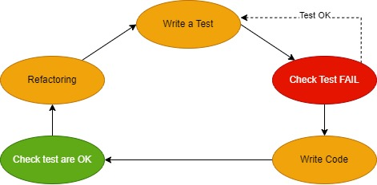
Figure 2. 1 Test-Driven Development Cycle
Implementing new features in software development follows a structured process that begins with writing tests. These tests are brief and clear, serving as a guide for developers to consider system requirements and design before actual coding. Running initial tests is expected to fail because there is no existing application code. This failure is intentional and highlights the development target. If the initial tests succeed, they should be revised to fail. Next, developers write production code only enough to satisfy the tests, being careful not to exceed the scope of the tests. Then, all tests, including new ones, are executed. If all tests pass, it indicates that the new code does not break existing features and meets the new requirements. In case of failure, developers modify the code until all tests pass. The last step involves refactoring the code to improve cleanliness, eliminate duplication, and enhance readability and maintainability. Throughout this process, test cases are regularly executed to ensure that refactoring does not unintentionally affect unrelated features. This systematic approach, known as Test-Driven Development (TDD), encourages careful consideration of requirements, systematic coding, and continuous improvement of the code (Bruel, et al., 2020).

CHAPTER III. RESEARCH METHODOLOGY

Time and Place of Research
This research will be conducted at the State Polytechnic of Malang for 3 months, from April 2024 to July 2024.

Data Collection Methods
Data collection will be conducted at the State Polytechnic of Malang using an experimental method. The subjects of this research are students of the State Polytechnic of Malang. In this experimental process, students will solve problems related to Data Analytics. The learning materials or topic and experiments in the form of document guides, test files, student answer outcomes are the data in this study that the system needs to process. The data that students have uploaded serves as the basis for the compilation of student response results. The uploaded data consists of response codes and student comments from each experiment that they completed. This information will be utilized by researchers to gauge how challenging the experiment is given the Data Analytics Learning content, as well as the success rate of students in completing all job sheets to determine the challenges they encounter.

System Design
This research focuses on the application of Unit Testing using Codewars_test in the context of Data Analytics learning materials. Before writing the system's program code, it is necessary to prepare a system design, as shown in the figure.

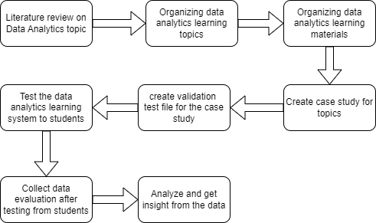
Figure 3. 1 System Design
The graphic displays a flowchart that lists the procedures needed to complete a research project on data analytics learning. To lay the groundwork for the research, a survey of the literature on data analytics-related subjects is the first step in the process. The next step is to arrange the subjects for learning data analytics, and then the learning resources. Student testing of the data analytics learning system is the next step. A validation test file is made for a case study in order to make this easier. Students provide data evaluation once the system has been tested. After then, this data is examined to obtain knowledge. In the context of learning data analytics, the flowchart depicts a cyclical process of research, development, testing, and evaluation.
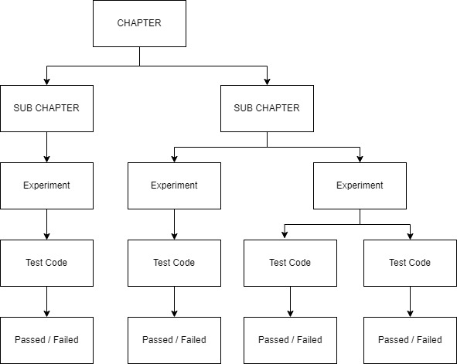
Figure 3. 2 Learning Material Design

In the design of the data analytics learning system in this study, there are main topics or chapters consisting of one to several sub-chapters. Each sub-chapter may contain one to several experiments. Each experiment can have one test code and one passed/failed outcome, and a single experiment may also include multiple test codes and corresponding passed/failed results, depending on the experiment's design.

System Testing
User testing is a testing process conducted by users with the aim of producing test result documents that serve as evidence that the system meets user requirements. This testing involves requesting volunteers to use the system and provide feedback on the experiments conducted. User testing will be directed towards students in the Information Texchnology program at Politeknik Negeri Malang. A trial will be conducted with 40 students over a period of three days.
To evaluate the success of this research, students were asked to provide comments or feedback on the modules or source code provided during the testing phase via Google Forms. The aim of this was to evaluate the effectiveness of implementing tests using Codewarse_test as previously proposed.

CHAPTER IV. SYSTEM ANALYSIS AND DESIGN

This chapter contains an explanation of the system and system requirements, including functional and non-functional requirements. It also includes a system design that covers system architecture, use cases, and activity diagrams.
  - System Description
In this research, a web-based learning system on Data Analytics using codewars_test testing is developed. The learning model consists of three stages: Material Creation, Material Completion, and Evaluation of Completion Results. The material creation activity involves creating materials from the specified topic, which is Data Analytics. Completing the learning materials involves working on practical exercise questions, while evaluating the completion results involves running the test code from the exercise questions to determine the correctness of the work.

4.2 System Requirement Analysis
Explaining the needs for the system that will be constructed during the design phase is the goal of the system requirements analysis phase. A list of needs and user identification are part of the necessary system requirements analysis.

    - Actor Analysis
The system's user identification phase seeks to identify the users who will subsequently communicate with it.
Tabel 4. 1 User’s Identification
User | Description
Admin | Admin is an actor who manages files consisting of test codes, modules files.
Lecturer | Lecturers are the users responsible for examining and checking the work result of each student.
Students | Students are the users responsible for completing the module practicum assignment.

    - Functional Requirement
The requirements that outline the functions of the system are known as functional requirements.
The learning module to be prepared will consist of:
- A module containing material about projects and modules in project work.
- A Test file containing code in Python to test whether the program code being worked on is correct.

    - Non-functional Requirements
Non-functional requirements analysis is a set of specifications that a system must meet. These requirements include both software and hardware needs. The non-functional prerequisites for developing a data analytics learning system are as follows:
            - Google Colaboratory.
            - Processor Inte Core i5
            - RAM 8,00 GB
            - SSD 239GB

  - System Architecture Design
The process of putting a software system's components into a visual representation is called system architecture design. This research focuses on applying Unit Testing using codewars_test to Python learning materials on Data Analytics. Before writing the system's program code, we will design the system comprehensively. This design includes the overall system structure (system architecture), diagrams illustrating user interactions with the system (use case diagrams), and diagrams showing the system's workflow (activity diagrams).

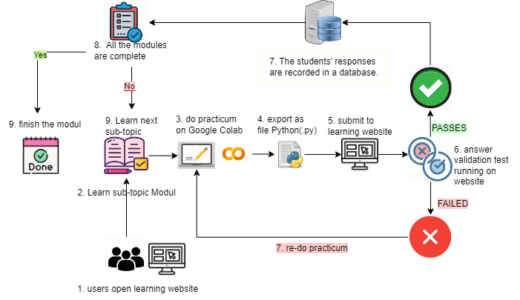

Figure 4. 1 System Architecture Design for Data Analytics Learning
Figure 4.1 presents a sequential overview of the learning process for Data Analytics Learning. The process commences with students preparing their workstations, followed by the distribution of a comprehensive learning module by the instructor. Subsequently, students engage in self-directed study, complete assigned tasks, and conduct self-assessment using provided test codes. Upon successful completion of tasks, the answer will be storen in the database.

4.2.1 Use Case Diagram
A use case diagram is a diagram that represents the interactions between actors and a system. Use case diagrams are commonly used to capture system requirements and to help design the system architecture. Figure 4.2 presents a use case diagram for this research. However, in Figure 4.2, the focus is limited to the development of use cases such as creating a topic, creating learning materials, and create file test.

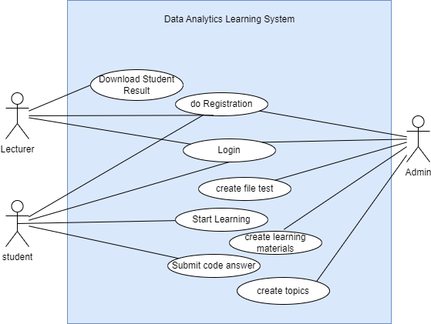
Figure 4. 2 Use Case

Tabel 4. 2 Use case Descriptions
Use Case | Description
creating a topic | Determining and creating topics to learn Data Analytics.
create file test | Developing a set of unit tests using codewars_test in Python.
creating learning materials | Creating Data Analytics learning materials divided into sub-chapter, with each section having corresponding assignments.
Registration | Registering within the system to gain access to iCLOP according to the user's level.
Login | Authenticating a user by selecting a user level and entering a username and password to gain access to the system.
Start Learning | The learning process involves several steps, starting from reading the materials, comprehending the concepts, following the step-by-step instructions, and completing all given assignments.
Submit code answer | Submitting the completed work according to the instructions provided in the learning materials.

4.2.4 Activity Diagram
This research will focus on the topic of Data Analytics, which will later be applied to iCLOP. The following is the workflow of the iCLOP system.
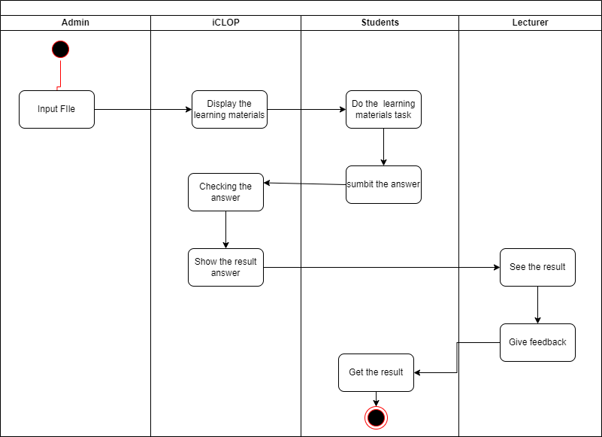
Figure 4. 3 Activity Diagram of iCLOP
Based on the activity diagram of the iCLOP platform, this research focuses on three main stages in the learning process, namely the creation of learning materials, the implementation of learning, and the evaluation of learning outcomes.

4.2.4.1 Creating Learning Materials Activity Diagram
The activity diagram in Figure 4.6 outlines the steps in creating learning materials on Data Analytics. The idea for the materials in the Data Analytics topic is from websites such as W3school.com and realpython.com. First, the admin/author creates a learning topic, in this case, the steps of data analyzing such as loading data, cleaning data, data manipulation, and data visualization. Next, the admin creates test code to validate students' work, ensuring it covers key aspects of the topic. The test code is then validated to ensure it functions correctly. Additional files needed for the lesson, such as images or documents, are extracted. These files, along with the learning content, are compiled into a module, which serves as a structured guide for students. Finally, once all steps are completed, the learning topic is ready for distribution.
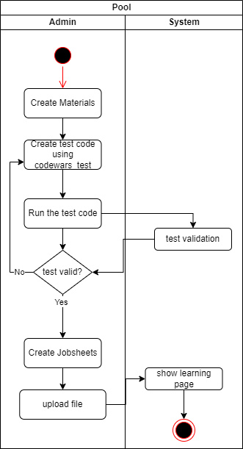
Figure 4. 4 Creating Learning Materials Activity Diagram
4.2.4.2 The implementation of learning Activity Diagram
The activity diagram in Figure 4.7 outlines the steps for completing the learning material on PHP Forms. First, students download two types of files: the Module File and Test Code. The Module File contains instructions on the learning topic, the Test Code file is used to validate their work, and Additional Files may include supplementary materials. Students then follow the Module File instructions to work on the learning topic. After completing the topic, they use the Test Code to check the correctness and functionality of their implementation. If all tests pass, the final step is to submit their work according to the provided guidelines or additional instructions.
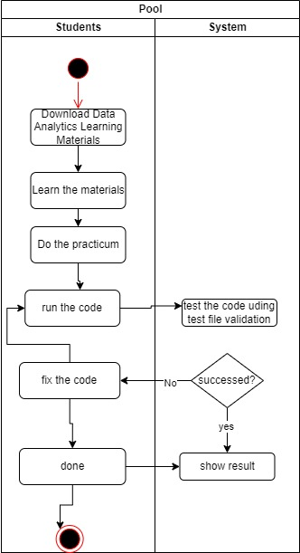
Figure 4. 5 the learning implementation Activity Diagram
4.2.4.3 The evaluation of learning outcomes
The activity diagram in Figure 4.8 outlines the steps in the evaluation process of learning materials on Data Analytics. First, the instructor opens the completed tasks submitted by the students, which include file answer in Python (.py) format. Next, the instructor reviews these results to provide feedback and assessment. The evaluation may consider factors such as the number of code attempts, the number of successful tests, code clarity, and other criteria set by the instructor.

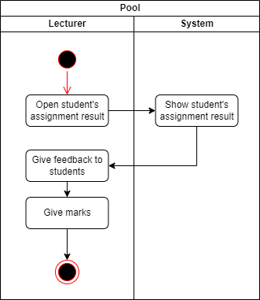
Figure 4. 6 The evaluation of learning outcomes activity diagram

  - Experimental Planning of Learning Materials
Material experimental design is a project of experimental creation of learning topics that will be provided on learning data analytics in the system. Here's a list of 9 experimental learning topics:

Tabel 4. 3 Experimental Learning Topics List
No | Experiment Name | Topic | Description
1. | Get the dataset from url and read as CSV file. | Data Loading | Students were given an experiment to access data sets from external sources into the system. Using this function pd.read_csv(url)
2. | Display the Produk Online Store Data. | Data Loading | Students are given an experiment to delete data columns that are not needed in the data analysis process. Display 5 first rows in the dataset using head_rows().
3. | Handling missing values for Calories data. | Cleaning Dataset | Students are given a practicum to handle missing values in a column and fill them with the column's mean value using the fillna() function.
4. | Cutting a NumPy 2D array on a specific coverage. | Data Manipulations | Taking product-specific sales data and applying slicing to extract specific data on the Numpy 3D array.
5. | Calculate Total Product Revenue. | Data Manipulations | Calculating Total Product Revenue using the sum() function.
6. | Selecting Specific Movies from Movie dataset. | Data Manipulations | Analyses film datasets to find 10 films using argsort() and iloc() functions.
7. | Analyze the Measures of Variability in customer's Age. | Data Manipulations | Analyze the Measures of Variability in customer's Age using mean(), median(), std(), skew(), quantile(), and corr() function.
8. | Electronic Sales Analysis: Understanding Sales Trends Through Measures of Central Tendency. | Data Manipulations | Electronic Sales Analysis: Understanding Sales Trends Through Measures of Central Tendency using mean(), median(), and mode() function.
9. | Visualizing the age distribution of the population based on age range using a Pie Chart. | Data Visualization | analyze the age distribution of the population of a city by visualizing it using pie charts.

CHAPTER V. IMPLEMENTATION AND TESTING
In this section describes the implementation of the system with a detailed display according to the design and components that have been done previously. On the website Python Programming Learning Assistance System – Data Analytics Learning Topic implements Python programming language and testing using Codewars_test.

5.1 Limitations of Implementation
As for the limitations on the implementation of the project on Learning Data Analytics with Python:
1. Development of tasks using Google Colaboratory.
2. Application testing is done using Codewars_test.

5.2 Learning Implementation

5.2.1 Data Analytics Learning Modul
The Data Analytics Learning Module consists of three parts: material review, case studies, and practical exercises. The Data Analytics Learning Module is divided into several sections: Data Analytics material, preparation of Google Colab tools, Data Analytics case study examples, and Data Analytics practical exercises. Table 5.1 provides a description of each practical exercise for each topic.

Table 5. 1 Modul Descriptions
No. | Topics | Descriptions
1 | Chapter 1 Practicum 1 | Students were given an experiment to access data sets from external sources into the system. Using this function pd.read_csv(url)
2 | Chapter 1 Practicum 2 | Students are given an experiment to delete data columns that are not needed in the data analysis process. Display 5 first rows in the dataset using head_rows().
3 | Chapter 2 Practikum 2 | Students were given an experiment to tidy up the column name arrangement to make it uniform. Delete the column using df.rename(columns=clean_names).
4 | Chapter 2 Practicum 3 | Students are given an experiment to handle an empty value on a column and fill it with the mean value of that column using fillna().
5 | Chapter 3 Practicum 1 | Taking product-specific sales data and applying slicing to extract specific data on the Numpy 3D array.
6 | Chapter 3 Practicum 2 | Calculating Total Product Revenue using the sum() function.
7 | Chapter 3 Practicum 3 | Analyze film datasets to find 10 films using argsort() and iloc() functions.
8 | Chapter 3 Practicum 4 | Analyze Measures of Variability on customer's Age using mean(), median(), std(), skew(), quantile(), and corr() function.
9 | Chapter 3 Practicum 5 | Analyzing electronic sales using measures of central tendency (mean, median, and mode).
10 | Chapter 4 Practicum 1 | Analyze the age distribution of the population of a city by visualizing it using pie charts.

5.2.1.1 Chapter 1 Practicum 1
In this module, students will learn how to load data. The given data will be in the form of a URL, and students will learn how to load it into a dataframe. Then, they will display the data in the dataset using the print() function.
import pandas as pd

url="https://raw.githubusercontent.com/noora20FH/skripsi_noora2023/main/purchases.csv"

def data_load():
df =pd.read_csv(url)
return df

print(data_load())

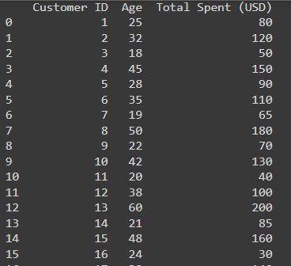
Figure 5. 1 Chapter 1 Practicum 1 Output Result

5.2.1.2 Chapter 1 Practicum 2
In this module, students will learn how to load data. The data provided will be in the form of a URL, and students will learn to load it into a dataframe. Then, they will display the data in the dataset using the print() function. After that, students will be asked to display a sample of the data, specifically a random row from the dataset, using the sample() function.
import pandas as pd

url="https://raw.githubusercontent.com/noora20FH/skripsi_noora2023/main/online_store_data.csv"

def data_load():
df =pd.read_csv(url)
return df

def sample_rows():
sample = data_load().sample()
return sample

sample_rows()

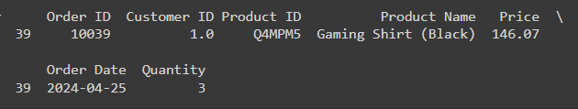
Figure 5. 2 Chapter 1 Practicum 2 Output Result
5.2.1.3 Chapter 2 Practicum 1
In this module, students will learn how to clean data. First, they will remove unnecessary columns in the dataset for analysis using the drop() function. Then, they will tidy up the column names in the dataset using the rename() function. After that, students will display the names of the cleaned columns in the dataset using the print() function.

import numpy as np
import pandas as pd

url = "https://raw.githubusercontent.com/noora20FH/skripsi_noora2023/main/nyc_perumahan.csv" # Replace with your actual URL

def load_data():
df = pd.read_csv(url)
return df

def clean_columns():
unnecessary_columns = ['BLOCK', 'LOT','EASE-MENT','TAX CLASS AT PRESENT','TAX CLASS AT TIME OF SALE']
df = load_data().drop(unnecessary_columns, axis=1)
return df

def clean_columns_name():
clean_names = {
"BUILDING CLASS CATEGORY": "BUILDING_CLASS_CATEGORY",
"BUILDING CLASS AT PRESENT":"BUILDING_CLASS_AT_PRESENT",
"APARTMENT NUMBER": "APARTMENT_NUMBER",
"ZIP CODE": "ZIP_CODE",
"RESIDENTIAL UNITS": "RESIDENTIAL_UNITS",
"COMMERCIAL UNITS": "COMMERCIAL_UNITS",
"TOTAL UNITS": "TOTAL_UNITS",
"LAND SQUARE FEET": "LAND_SQUARE_FEET",
"GROSS SQUARE FEET": "GROSS_SQUARE_FEET",
"Box Office (Millions USD)": "Box_Office",
"YEAR BUILT": "YEAR_BUILT",
"BUILDING CLASS AT TIME OF SALE": "BUILDING_CLASS_AT_TIME_OF_SALE",
"SALE PRICE": "SALE_PRICE",
"SALE DATE": "SALE_DATE"
}
data = clean_columns().rename(columns=clean_names)
return data
print(clean_columns_name().columns)

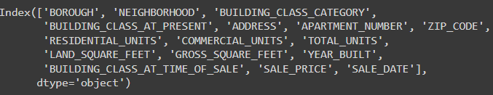
Figure 5. 3 Chapter 1 Practicum 2 Output Result

5.2.1.4 Chapter 2 Practicum 3
In this module, students will learn how to clean a dataset by removing null values. First, students will extract rows of data from the dataset that contain null values using the isnul() function. Then, they will fill in the null values with the average value of that column using the fillna() and mean() functions. Finally, they will display all the columns that have null function using the print() function. The output must has 0 value for all columns that indicate there is no null values anymore because it’s already replaced by the average value.
import pandas as pd

def load_data():
url = "https://raw.githubusercontent.com/noora20FH/skripsi_noora2023/main/data.csv"
df = pd.read_csv(url)
return df
print(load_data().isnull().sum())

def updated_data():
updated_df = load_data().fillna(load_data()['Calories'].mean())
return updated_df

print(updated_data()[["Calories"]].iloc[17:142])

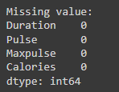
Figure 5. 4 Result Chapter 2 Practicum 3

5.2.1.5 Chapter 3 Practicum 1
In this module, students will learn to extract specific data from a 3-dimensional array using array slicing. Then, they will display the specific data using the print() function.
import numpy as np

data_penjualan = np.array([
[[10, 20, 30],
[40, 50, 60],
[70, 80, 90]],

[[100, 110, 120],
[130, 140, 150],
[160, 170, 180]],

[[190, 200, 210],
[220, 230, 240],
[250, 260, 270]]
])
data_spesifik = data_penjualan[0, 1, 1:3]
print(data_spesifik)

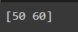
Figure 5. 5 Result Chapter 3 Practicum 1
5.2.1.6 Chapter 3 Practicum 2
In this module, students are taught to manipulate datasets in the data analysis process. In this topic, students will update the dataset by adding a new column. Then, students will calculate the total value of that column using the sum() function.
import pandas as pd

url = "https://raw.githubusercontent.com/noora20FH/skripsi_noora2023/master/data_toko.csv" # Replace with your actual URL

def data_load():
data_toko = pd.read_csv(url)
return data_toko
def head_rows():
return data_load().head()

def updated_data():
df = data_load().copy()
df["Total "] = df["Unit price"] * df["Quantity"]
return df

def total_pendapatan():
total_pendapatan = updated_data()['Total Revenue'].sum()
return total_pendapatan

print(total_pendapatan())

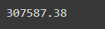
Figure 5. 6 Result Chapter 3 Practicum 2
5.2.1.7 Chapter 3 Practicum 3
In this module, Data Manipulation, students will learn how to effectively transform and analyze data. To utilize the argsort() function from the NumPy library, students will first convert the data_load() output from a Pandas Series to a NumPy array. Subsequently, they will apply the argsort() function to sort the data based on the 'Critic scores' column. Finally, the top 10 movies with the highest critic scores will be displayed using the print() function..
import pandas as pd

url = "https://raw.githubusercontent.com/noora20FH/skripsi_noora2023/main/clean_movie_data.csv" # Replace with your actual URL

def data_load():
data_toko = pd.read_csv(url)
return data_toko

def critic_scores():
critic_scores = data_load()["Critic_Score"].to_numpy()
return critic_scores

# Sort the movies by Critic Score in descending order (highest to lowest)
def sorted_indices():
sorted_indices = critic_scores().argsort()[::-1]
return sorted_indices

def top_10_movies():
top_10_movies = data_load().iloc[sorted_indices()[:10]]
return top_10_movies

print(top_10_movies())

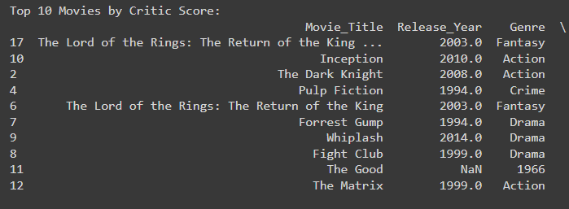
Figure 5. 7 Result Chapter 3 Practicum 3
5.2.1.8 Chapter 3 Practicum 4
In this module, students will learn about Sales Trends through measures of central tendency using the functions mean(), median(), and mode(). Additionally, they will learn about the Correlation Coefficient to understand whether there is a significant relationship between two variables using the function corr().

import pandas as pd

url = 'https://raw.githubusercontent.com/noora20FH/skripsi_noora2023/main/purchases.csv'

def data_load():
df = pd.read_csv(url)
return df

def head_rows():
return data_load().head()

print(data_load().describe())

print("Customer Age:")
print(f" Mean: {data_load()['Age'].mean()}")
print(f" Median: {data_load()['Age'].median()}")
print(f" Standard Deviation: {data_load()['Age'].std()}")
print(f" Skewness: {data_load()['Age'].skew()}")
print(f" Quartiles: {data_load()['Age'].quantile([0.25, 0.5, 0.75])}")

print("\nTotal Spent:")
print(f" Mean: {data_load()['Total Spent (USD)'].mean()}")
print(f" Median: {data_load()['Total Spent (USD)'].median()}")
print(f" Standard Deviation: {data_load()['Total Spent (USD)'].std()}")
print(f" Skewness: {data_load()['Total Spent (USD)'].skew()}")
print(f" Quartiles: {data_load()['Total Spent (USD)'].quantile([0.25, 0.5, 0.75])}")

correlation = data_load()["Age"].corr(data_load()["Total Spent (USD)"])
print(f"\nCorrelation Coefficient: {correlation}")

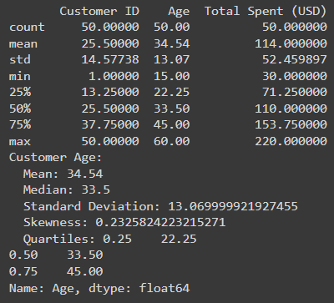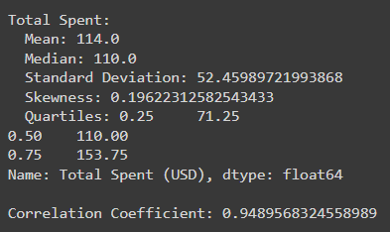

Figure 5. 8 Result Chapter 3 Practicum 4
5.2.1.9 Chapter 3 Practicum 5
In this module, students will learn about the use of the mean(), median(), and mode() functions in the electronic sales case study.
import pandas as pd

url = "https://raw.githubusercontent.com/noora20FH/skripsi_noora2023/main/penjualan_elektronik.csv"

def load_data():

data = pd.read_csv(url)
return data
def mean_penjualan():
mean_penjualan = load_data()['Jumlah Terjual'].mean()
return mean_penjualan

def median_penjualan():
median_penjlan = load_data()['Jumlah Terjual'].median()
return median_penjualan

def mode_penjualan():
mode_penjualan = load_data()['Jumlah Terjual'].mode().iloc[0]
return mode_penjualan

print(f"Rata-rata penjualan: {mean_penjualan()}")
print(f"Median penjualan: {median_penjualan()}")
print(f"Mode penjualan: {mode_penjualan()}")
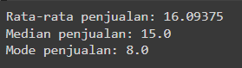
Figure 5. 9 Result Chapter 3 Practicum 5
5.2.1.10 Chapter 4 Practicum 1
In this module, students will delve into the art of data visualization by creating insightful pie charts. By effectively utilizing the Matplotlib or Seaborn libraries, students will learn to represent data in a visually engaging and informative manner. They will explore how to customize pie charts with labels, colors, and titles to enhance clarity and interpretation. Through hands-on exercises, students will gain practical experience in creating pie charts that effectively convey the distribution of categorical data.
import pandas as pd
import matplotlib.pyplot as plt

def load_data():
url = ""
df = pd.read_csv(url)
return df

fig_size= plt.figure()

get_population_col = load_data()['']

get_age_col = load_data()['']

plt.pie(get_population_col, labels=get_age_col, autopct='%1.1f%%', startangle=90)
plt.legend(title="Age Group")
plt.title('Age Distribution in the City')
plt.axis('equal')
plt.show()
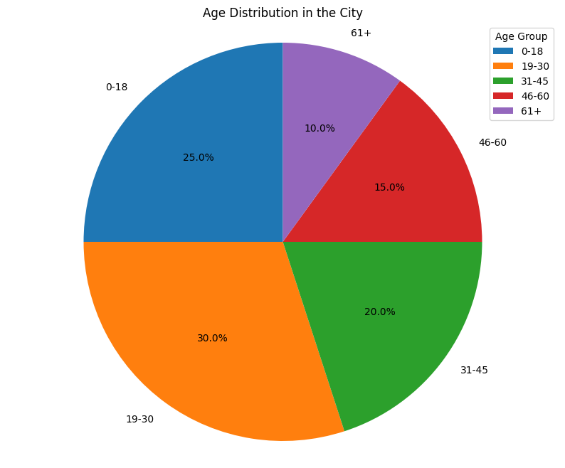
Figure 5. 10 Result Chapter 4 Practicum 1

5.2.2 Test File Python
A test file is a set of instructions designed to evaluate student responses to a specific document guide. Each test file focuses on a single Jobsheet. This file is saved as a .py file on Google Drive for students to download and upload into their Google Colab projects.

Student code submissions are tested using Codewars_test. Students are required to run these tests after completing each task. Students will test their own code using provided test files after completing each task. The goal is to ensure that the code they produce is correct and meets the specified criteria. The number of test codes depends on the test cases created for each experiment. Testing code typically consists of three parts: loading data test code, function test code, and output test code. The following is an example of a test file from the practical session in Chapter 2, Experiment 2: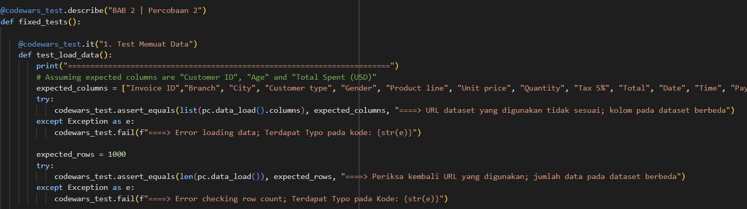
Figure 5. 11 Loading Data Test Case
In figure 5. 11, the test code runs a test to test whether the dataset has been loaded successfully by checking the line and column equality with the expected answer. Checking the column names in the actual loaded dataset against the expected column names stored in expected_columns. If the column names in the actual dataset differ, a message will appear saying "The URL of the dataset used is incorrect; the columns in the dataset differ". However, if there is an error in the code writing, codewars_test.fail will display an error message "Error Loading data; There is a Typo in the code: {location of the typo}.
"Meanwhile, to check the amount of data in a dataset, we use len(). If the length of the dataset is incorrect, a message will appear saying "Check the URL used, the number of datasets is different." However, if there is an error in the code, codewars_test.fail will display an error message "Error Loading data; There is a Typo in the code:
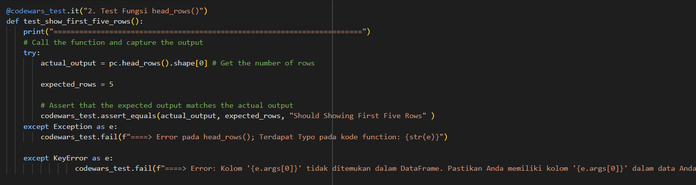
Figure 5. 12 Function Test Case
Figure 5. 12, the testcode runs the test to check whether the requested function is running properly, in this case the head_rows().head(). Try-except is used to handle errors that may occur during code execution. It allows a program to continue running even if an error occurs, instead of immediately stopping with a generic error message. The code that has the potential to cause an error is placed inside the try block. If no error occurs, the code within the try block will execute normally. If an error occurs within the try block, execution will immediately jump to the except block. Inside the except block, code is written to handle the error, such as displaying a more informative error message.
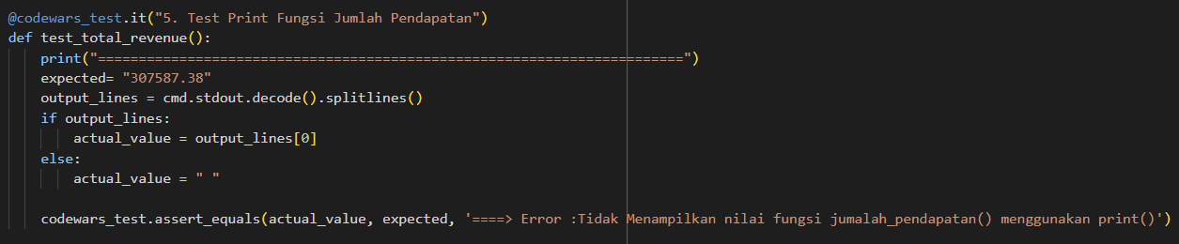
Figure 5. 13 Output Test Case
In Figure 5. 13, which represents the output test case, the output from the command prompt (cmd) will be captured as a string. This string will then be compared against the expected output. If there is no output from the cmd, an empty string will be assigned as the value, and a message will appear stating 'Does not display the function value using print(). The test codes check whether the output of the print() function already matches the answer keys.

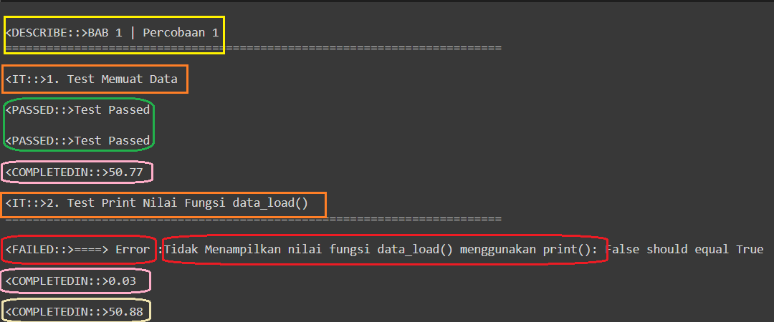
Figure 5. 14 Validation Result Output
The results of the test files that have been run can be seen in figure 5. 14. The output is structured with colored squares to denote different segments of the test execution. A yellow square marks the beginning of a test or experiment, labeled "Chapter 1 | Experiment 1." The subsequent orange square highlights the first test case, which involves loading data. A green square indicates the successful completion of this data loading test. The pink square likely represents the time elapsed for the data loading test in seconds. Following this, a red square signals a failed test case related to printing the value of the data_load() function. The error message specifies that the expected output of True was not achieved. Finally, a white square might denote the total time elapsed for both test cases, encompassing both successful and failed attempts.

Here is the specific instructions for students to run validation can be found in the module:

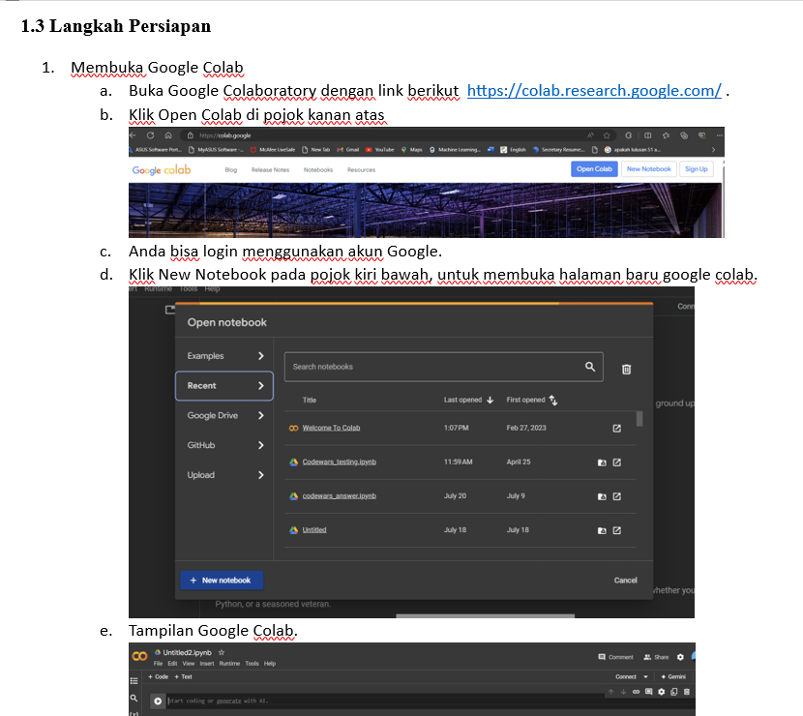

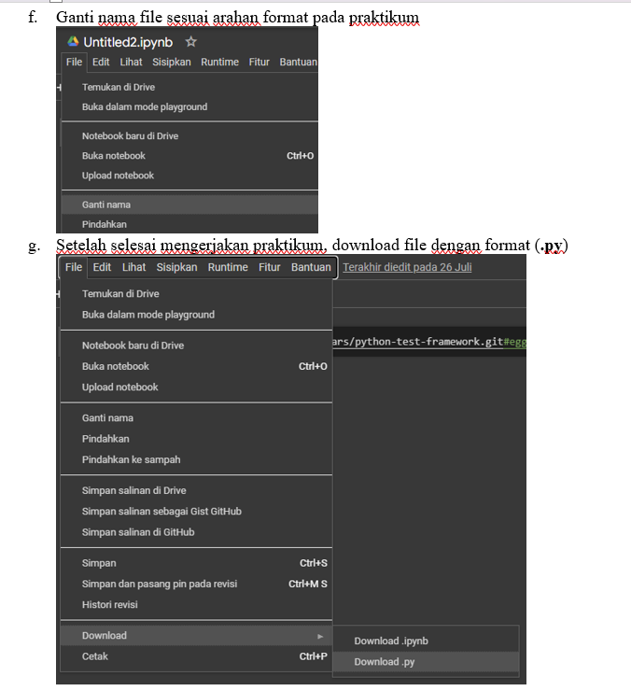

Figure 5. 15 Google Colab Preparation steps on the modul

5.3 Learning Website Implementation
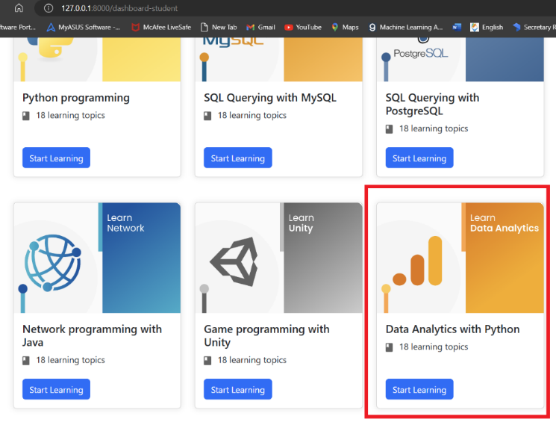
Figure 5. 16 Topic Data Analytics with Python on the website
On the figure 5. 16 that is the learning topic for Data Analytics with Python. Students can click the Start Learning button to open the learning page.

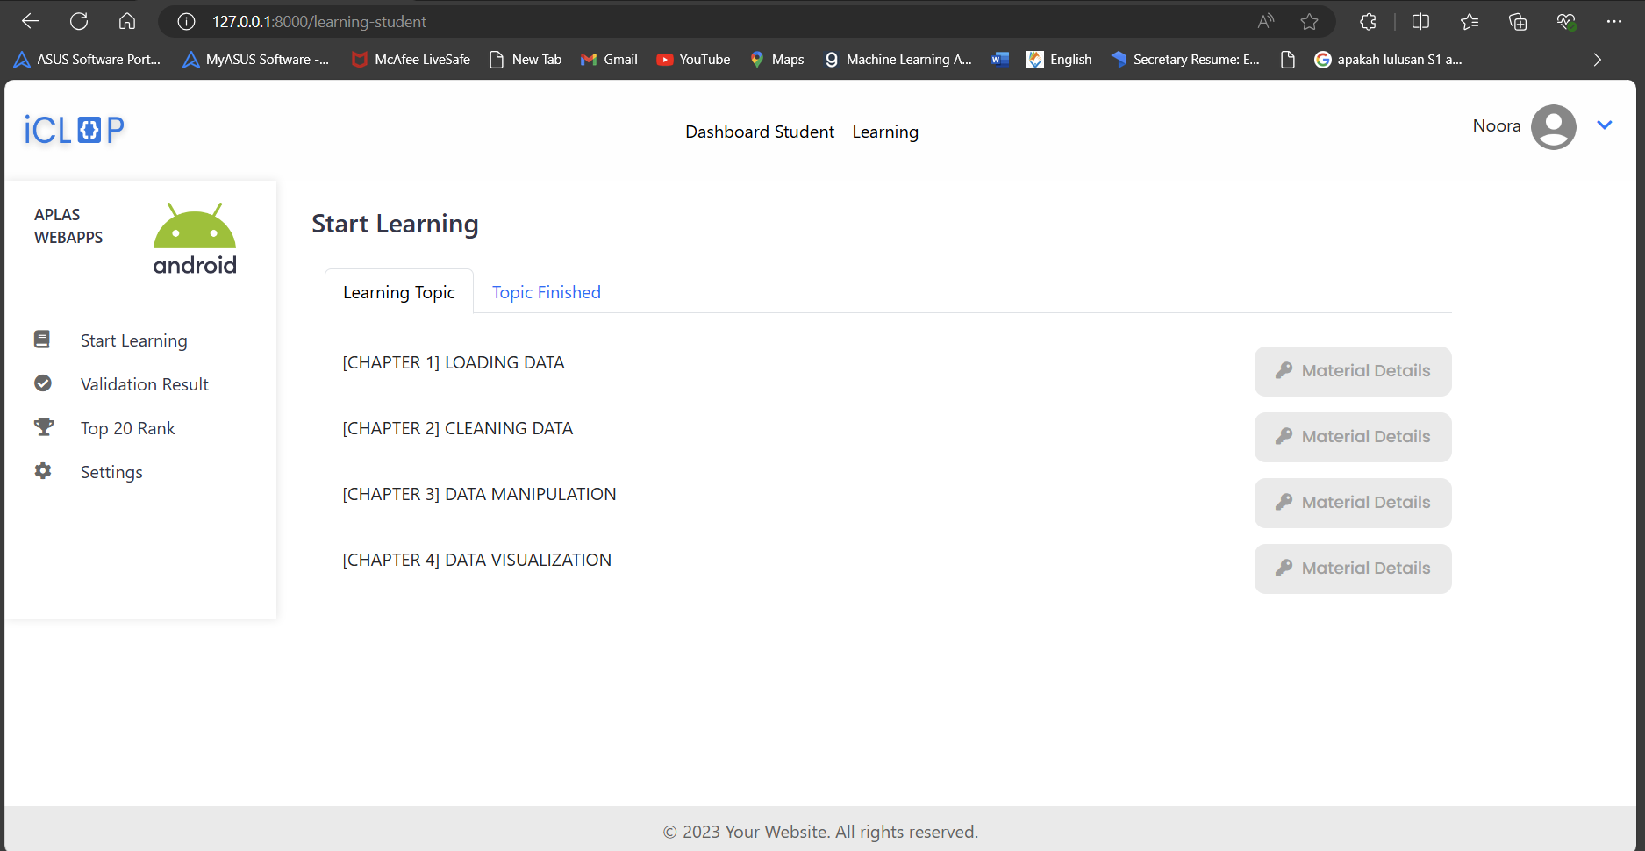
Figure 5. 17 Dashboard student
On the figure 5.17, after the student login and go to the Data Analytics with Python topic. Then the students will redirect to the student’s dashboard page. On this page displayed the chapters provided in this Data Analytics topic. For each chapter, there is Materials details that contains some material and tasks related to the learning chapter.

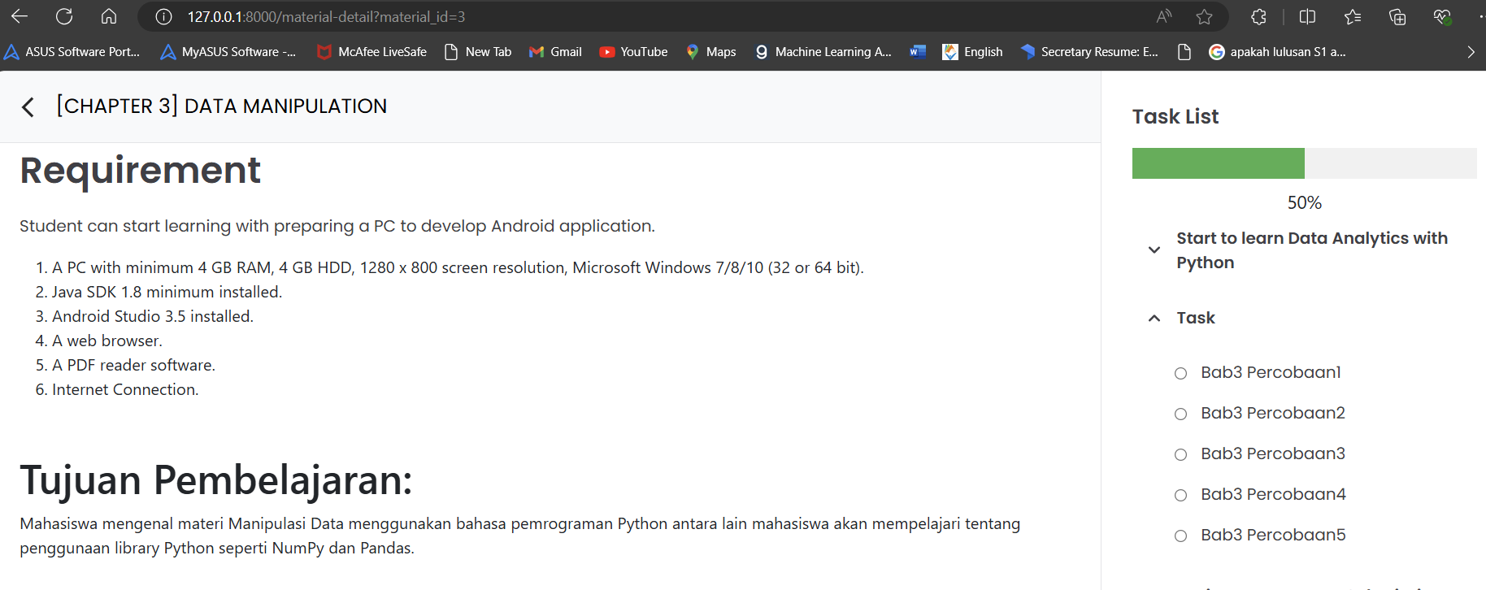
Figure 5. 18 Tasks page
On the figure 5. 18, The website provides some tasks related to each chapter. Students need to complete all the tasks.

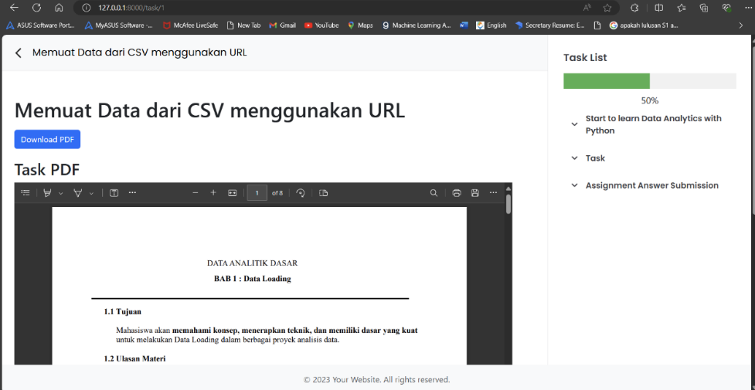
Figure 5. 19 Show PDF Modul
This page provides the pdf module for Data Analytics learning. The students can also download the pdf.

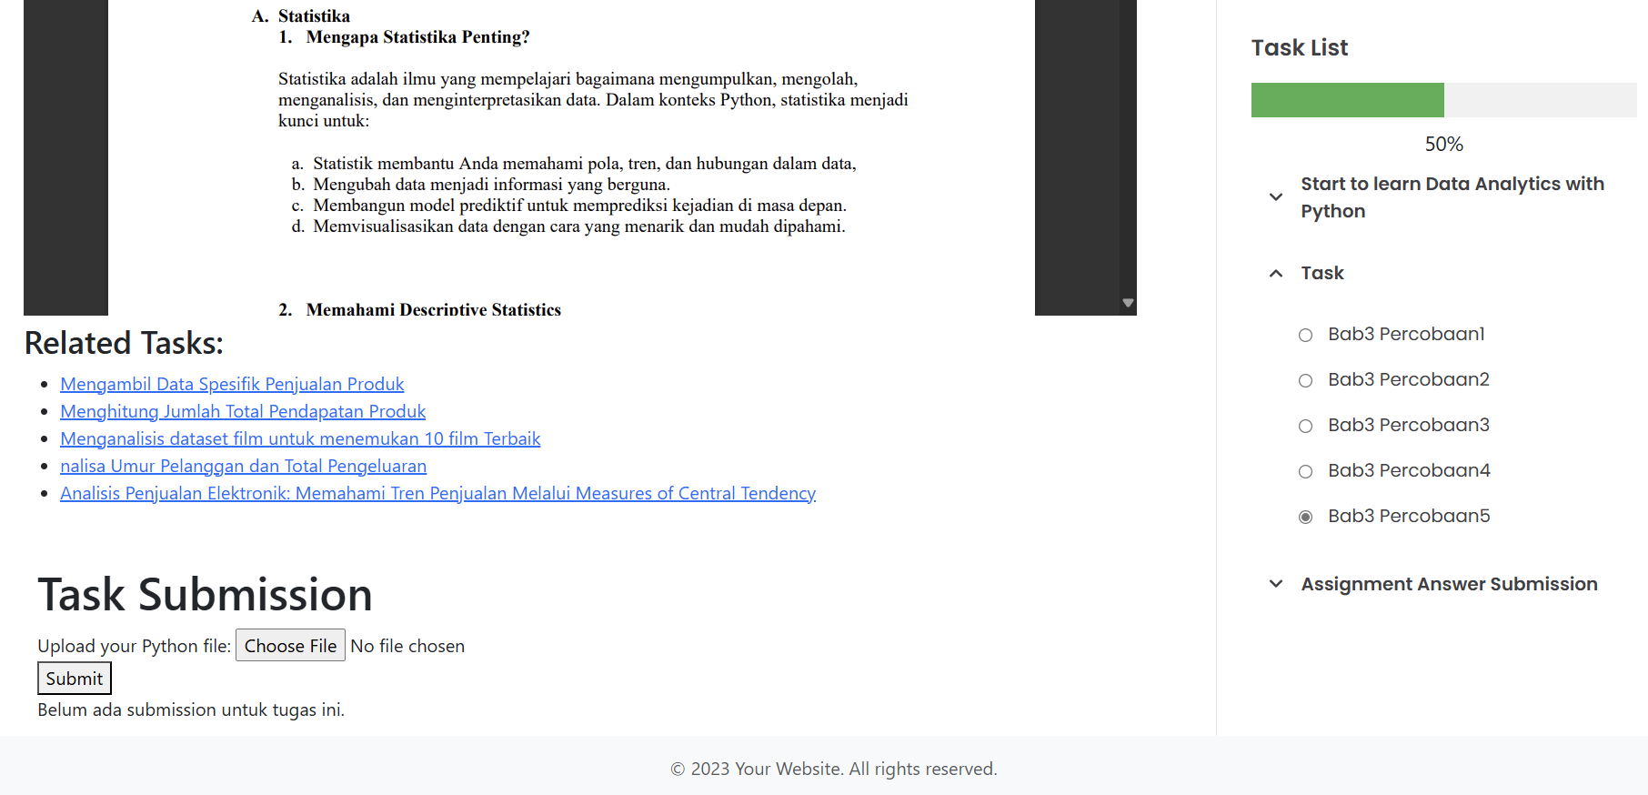
Figure 5. 20 Task Submission Form
On the figure 5. 20, there is task submission form for student to upload their code answer. The file uploaded by the students must be in a Python file. There is also radio button that ease student to go to another task in the same chapter, same with the Related Tasks that link to another task in the same chapter.

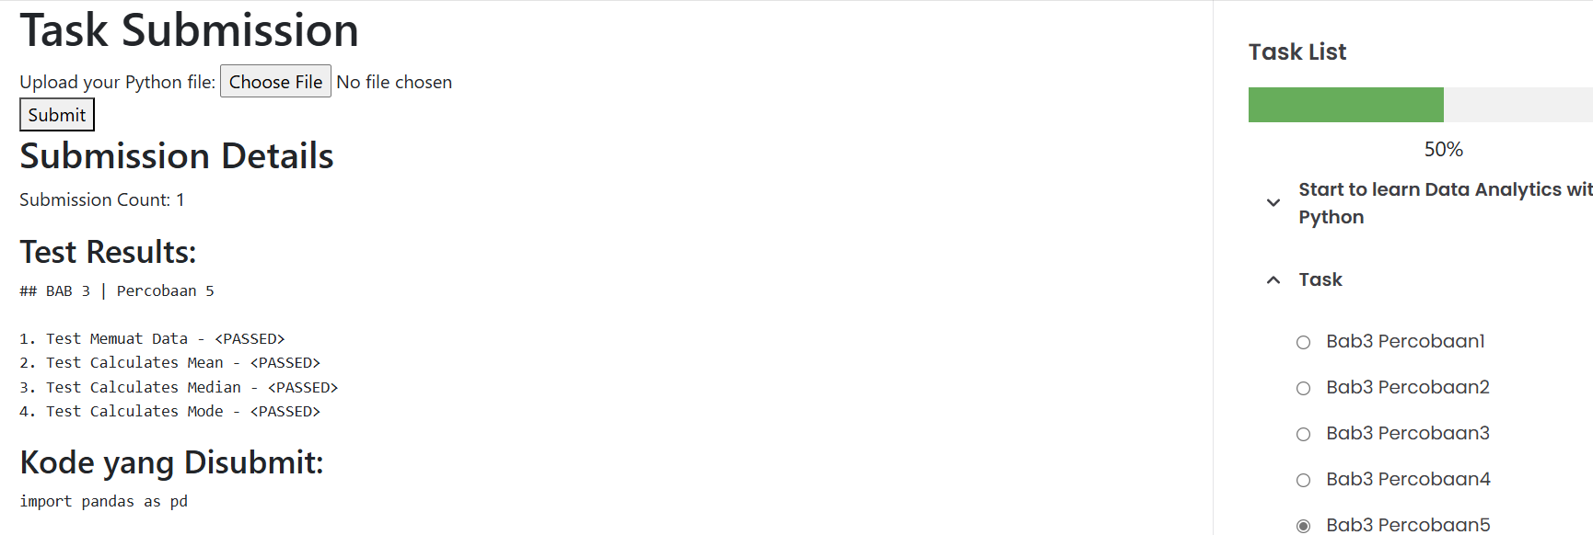
Figure 5. 21 Test Result
On the Figure 5. 21, the result from the validation showing the correctness of the submitted code.
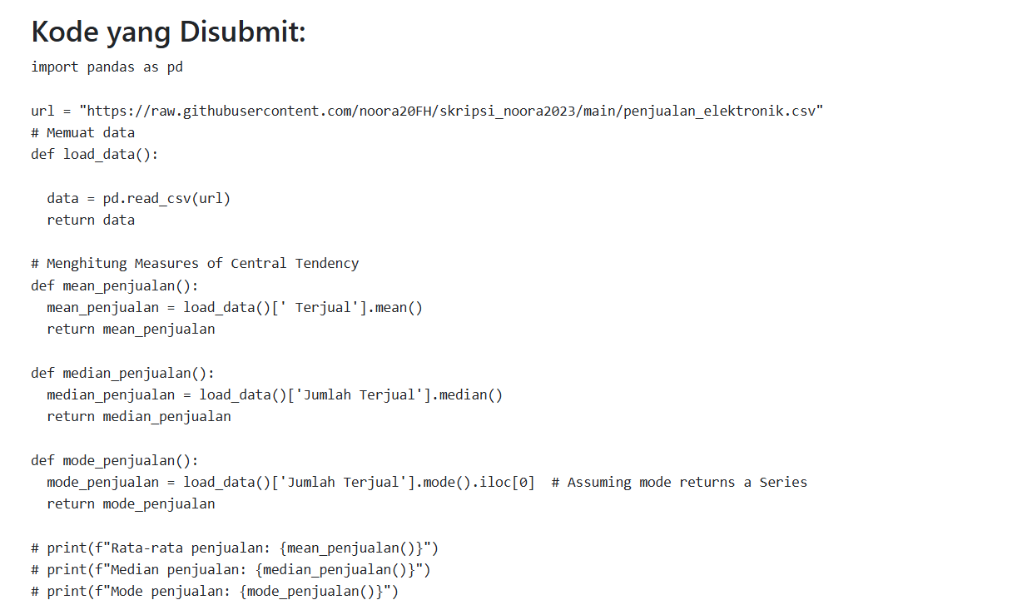
Figure 5. 22 Submitted Code Content
On the figure 5. 22 there is a section on this page that showing the content on the submitted code.

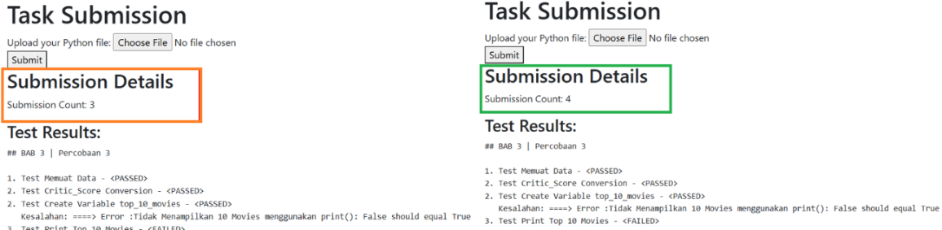
Figure 5. 23 Submission Count
The Submission Count section on the figure 5. 23 below, showing that for each submission for the same task will be counted. So, if the students submit their answer for the first time then it will be counted one, after that if the result test validation still showing FAILED which mean the students need to fix and re-submit their answer, then the second submission will be counted two and so on.

5.4 Testing
User Testing
Tests were conducted on 40 students of the Faculty of Information Technology at Politeknik Negeri Malang. The task was completed within 3 days. Each student is given 10 experimental learning topics to complete. The students then began working on the tasks according to the instructions and conducted the tests independently. After finish all the jobsheet for 10 topics, the students are provided with Google Forms to record the completion of experimental work along with feedback. Students test on laptop devices and use Google Colaboratory to test the answer code with the test file. Test results from all students are analyzed to determine the difficulty level of the learning materials and to identify challenges faced by students. This information is then used to improve or refine the existing learning materials. In addition to improving the materials, information about student challenges can also be used to modify the way the material is delivered or to change the teaching methods.

The stages of conducting tests in Python learning with the topic of Data Analytics will be explained as follows.
  - If the automatic test fails, students need to fix their code based on the error message that appears and then re-run the test. Finally, if the test is successful, students can continue to the next module.
  - The first step students will take after completing their coding task is to download the test file provided. They can download it through the link provided in the learning module. The module will also explain how to place the test file in Google Colab.
  - After that, students can run the test file to test and verify whether the code they have written meets the requirements.
  - If the test they run fails, they need to fix their code, and if there are still errors or if they have completed all modules, they can submit their work.

CHAPTER VI. RESULTS AND DISCUSSION
Chapter ini menjelaskan tentang hasil pengujian dan pembahasan dari pengerjaan Pembelajaran Python dengan Topik Data Analytics menggunakan Codewars_test.
  - Testing Result
The test was conducted on 40 students of the Faculty of Information Technology of the State Polytechnic of Malang. Students tested the entire learning subject within three days. In Table 6.1 below is a list of names of students who have participated in the experiment:

Table 6. 1 List of 40 Student Names
No | Name | NIM | Major
1 | Abdulilah Ali Qaid Al-shabany | 2041720203 | Jurusan Teknologi Informasi
2 | Ahmad Farrel Sirajudin Zaidan | 2041720238 | Jurusan Teknologi Informasi
3 | Akhmadheta Hafid Prasetyawan | 2041720221 | Jurusan Teknologi Informasi
4 | Alifiyul Akyun | 2041720036 | Jurusan Teknologi Informasi
5 | Amalia Nuraini | 2041720160 | Jurusan Teknologi Informasi
6 | Andre Maulana Mustofa | 2041720211 | Jurusan Teknologi Informasi
7 | Annisa Aulia Nadhila | 2041720023 | Jurusan Teknologi Informasi
8 | Annisa Fitri Yuliandra | 2041720123 | Jurusan Teknologi Informasi
9 | Atmayanti | 2041720016 | Jurusan Teknologi Informasi
10 | Chan Paul Amol | 2041720202 | Jurusan Teknologi Informasi
11 | Deatrisya Mirela Harahap | 2041720013 | Jurusan Teknologi Informasi
12 | Della Jannata Febiana | 204120034 | Jurusan Teknologi Informasi
13 | Dherisma Hanindita Utami | 2041720018 | Jurusan Teknologi Informasi
14 | Elvira Sania Mufida | 2041720080 | Jurusan Teknologi Informasi
15 | Eva Monika Septiana | 2141764017 | Jurusan Teknologi Informasi
16 | FAHREZA PRIMA HAKIM | 2041720210 | Jurusan Teknologi Informasi
17 | farah zulfa hamidah | 2041720069 | Jurusan Teknologi Informasi
18 | Hafidz Irwan M | 2141764079 | Jurusan Teknologi Informasi
19 | Hanif Widyantoro | 2141764039 | Jurusan Teknologi Informasi
20 | Hilda Khoirotul Hidayah | 2041720161 | Jurusan Teknologi Informasi
21 | Ibnu Khalis Rabbani | 2041720159 | Jurusan Teknologi Informasi
22 | Iftitah Hidayati | 2041720006 | Jurusan Teknologi Informasi
23 | Izzatun Nauly | 2041720166 | Jurusan Teknologi Informasi
24 | Khofifah Amanda | 2041720119 | Jurusan Teknologi Informasi
25 | Lelyta salsabila | 1941720026 | Jurusan Teknologi Informasi
26 | M. Thosin Yuhaililul Hilmi | 2141764032 | Jurusan Teknologi Informasi
27 | Maulana Bintang I. | 2041720132 | Jurusan Teknologi Informasi
28 | Mochammad Hairullah | 2041720074 | Jurusan Teknologi Informasi
29 | Mohammad Izamul Fikri Fahmi | 2141720171 | Jurusan Teknologi Informasi
30 | Muhammad Ilham El Hakim | 2041720162 | Jurusan Teknologi Informasi
31 | Nanda Shabrina Putri Kurnia | 2141762064 | Jurusan Teknologi Informasi
32 | Neha Viranica Nauly | 2141764127 | Jurusan Teknologi Informasi
33 | Nurlaily Asrobika | 2041720172 | Jurusan Teknologi Informasi
34 | Rabiatul Fitra Aulia | 2041720154 | Jurusan Teknologi Informasi
35 | Rofika Nur 'Aini | 2041720099 | Jurusan Teknologi Informasi
36 | Rossa Akmalia | 2041720219 | Jurusan Teknologi Informasi
37 | Salwa Zhafira Pratiwi Wahyudi | 2041720138 | Jurusan Teknologi Informasi
38 | Shine Devi Oktaviana Ronix Syah Putri | 2041720065 | Jurusan Teknologi Informasi
39 | Yaldika Putra Sinaga | 2041720056 | Jurusan Teknologi Informasi
40 | Yoby Ryaian Pratama | 2041720039 | Jurusan Teknologi Informasi

There are 9 topics they need to complete. They do the practicum on Google Colaboratory and save the answer file as Python File (.py) for each topic. After they complete all of the topics practicum, then they need to upload directly on task submission section on the web page. As shown on figure 5.20.
Students' activities were timed using a timer to determine how long it took to finish each practicum topic. Following the completion of each assignment provided in the Data Analytics Jobsheet, students filled out a specific form. The purpose of this form is to document the amount of time needed to finish each practicum topic.

6.2 Testing Result Discussions
The results of a trial conducted with 40 Information Technology students who completed a Data Analytics learning module showed a wide range of outcomes.

6.2.1 Time Completion for each Topic
On Figure 6.1 is a graph of the results of the test based on the student's work time of each learning topic. The bottom green line indicates the fastest time a student has spent completing each learning topic, the red line shows the longest time the student has had spent finishing each learning subject, whereas the blue line between the green and red lines represents the average length of time it takes a student to complete each learning theme.

Table 6. 2 Time Completion for each Topic
 | b1_p1 | b1_p2 | b2_p3 | b3_p1 | b3_p2 | b3_p3 | b3_p4 | b3_p5 | b4_p1
max | 313.2 | 420 | 600 | 450 | 660 | 738.6 | 752.4 | 462 | 900
average | 114.78 | 178.08 | 241.515 | 237.09 | 310.71 | 508.365 | 480.555 | 336.15 | 416.415
min | 60 | 60 | 90 | 80.4 | 60 | 60 | 120 | 120 | 180

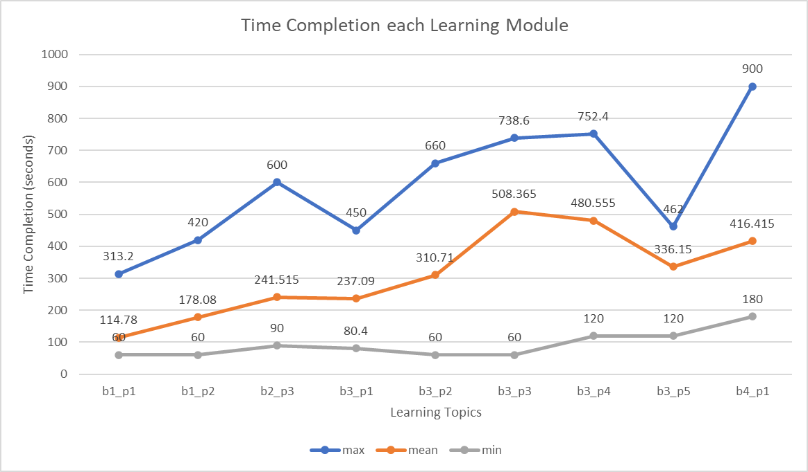
Figure 6. 1 Graphic of Student’s Completion Time

From Figure 6. 1 we can assigning categories it can be concluded that the difficult experiments are chapter 3 experiments 3, chapter 3 experiments 4, and chapter 4 experiments 1. Chapter 3 experiment 3 is selecting specific movies from movies dataset. Chapter 3 experiments 4 is the analysis of the Measures of Variability in customer's Age. Chapter 4 experiment 1 is an visualizing the age distribution of population based on age range using a Pie Chart. The reason is that students are unable to understand the guidelines given on the practicum jobsheet.
While the less difficult/medium experiments are chapter 2 experiments 3, chapter 3 experiments 1, chapter 3, experiments 2, and chapter three experiments 5. Chapter 2 experiments 3 is handling missing values for calories data. Chapter 3 experiment 1 is cutting the Numpy array 3 dimensions. Chapter 3 experiment 2 is counting the total revenue. Chapter 3 of Experiment 5 is Electronic Trends Sales Analysis. The given material is more complicated than the previous material.
The last category is the experiment with the fastest completion time that is relatively easy to complete: chapter 1 practicum 1 and chapter 2 practicum 2. Chapter 1 Experiment 1 is to load a.csv dataset using URLs. Chapter 1 Practicum 2 is display the product of Online Store Data. The reason is that students can understand basic matters easily and can be followed by students well.

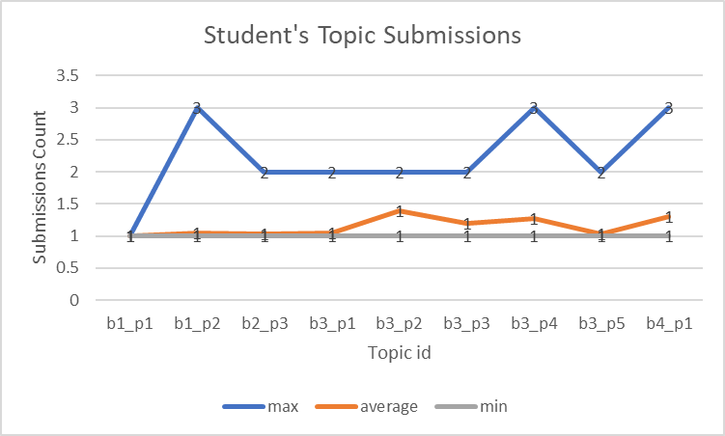
Figure 6. 2 Student’s topic submission
From figure 6. 2, the submission counts vary across the topics. Some topics have received a high number of submissions, while others have received relatively few. maximum number of submissions for a single topic is 3. This indicates that some students are submitting multiple times for certain topics, which could be due to various reasons such as seeking feedback, clarification, or making revisions. The average number of submissions per topic falls between 1 and 2. This suggests that, on average, students are submitting 1-2 times per topic. The minimum number of submissions for a topic is 1. This means that there are no topics with zero submissions, and each topic has received at least one submission.

    - Students Feedback
The feedback from the students has been collected. There are positive comments and suggestions given. Here's a collection of feedback from students:
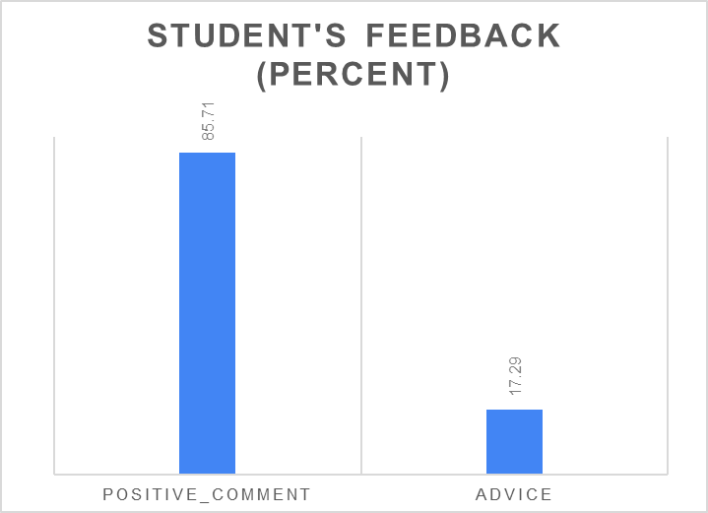
Figure 6. 3 Student’s Feedback
The majority of students provided positive comments, constituting 85.71% of the total feedback. This indicates a high level of satisfaction with the practicum. While the overall sentiment is positive, 17.29% of students offered advice or suggestions for improvement. This suggests that there are areas where the practicum could be enhanced.
- Positive comments:
            - It's good, because it's possible to know if the answers are right or wrong through testing.
            - the explanations and guides on the jobsheet make it very easy for the user to understand the material.
            - I hope it can be applied as a learning module.
            - The jobsheet allowed me to learn independently about data analytics.
- Advice:
            - The consistency of the language used in the module to use one language or make two versions.
            - The module should be more detailed. It doesn't matter if the sentences are long as long as they are detailed and easy to understand.
            - Perhaps the module presentation could be made more creative to make it a bit more colorful.
            - the guidance in the jobsheet needs to be clarified for better understanding.

CHAPTER VII. CONCLUSION AND ADVICE
  - Conclusion
      - The implementation of test-driven development (TDD) using Codewars_test in a Python programming learning context, as demonstrated with the 40 student participants from the Department of Informatics Engineering at Politeknik Negeri Malang, has yielded positive results. The provided module materials were found to be effective in facilitating students' understanding of Data Analytics concepts and guiding them through practical tasks. The positive feedback and suggestions provided by the students further validate the effectiveness of the learning system. Students provided 85.71% positive feedback. Their comments indicate that the module materials were clear, easy to follow, and helpful in facilitating independent learning.

      - The findings of this study suggest that the integration of TDD with Codewars_test in a Data Analytics learning assistance system can be a valuable approach for enhancing students' learning experiences and outcomes. By providing immediate feedback, encouraging a structured approach to problem-solving, and fostering independent learning, TDD can help students develop a deeper understanding of the underlying concepts and improve their coding skills.
  - Advice
A suggestion that can help develop Python's basic learning system independently is as follows:
            - For further development of learning materials, it is expected that the document guides are available in two languages Indonesian and English.
            - Validation tests for outputs in the form of graphs can improve the accuracy of the tests.

References
Amarnath, R. (2023, January 11). www.forbes.com. Retrieved from Five Data Analytics Trends On Tap For 2023: https://www.forbes.com/sites/forbestechcouncil/2023/01/11/five-data-analytics-trends-on-tap-for-2023/?sh=3e026a716cfd
Bruel, J., Capozucca, A., Mazzara, M., Meyer, B., Naumchev, A., & Sadovykh, A. (2020). Applying Test-Driven Development for Improved Feedback and Automation of Grading in Academic Courses on Software Development. FISEE 2019, 310–323.
Codewars. (n.d.). Pyhon Codewars Test Framework | The Codewars Docs. Retrieved from docs.codewars.com: https://docs.codewars.com/languages/python/codewars-test/
Forcier, J., Bissex, P., & Chun, W. J. (2008). Python Web Development with Django. Addison-Wesley Professional.
Gartner. (2022, May 3). www.gartner.com. Retrieved from Gartner Predicts 65% of B2B Sales Organizations Will Transition from Intuition-Based to Data-Driven Decision Making by 2026: https://www.gartner.com/en/newsroom/press-releases/gartner-predicts-65--of-b2b-sales-organizations-will-transition-
Goasduff, L. (2022, April 5). www.gartner.com. Retrieved from 12 Data and Analytics Trends to Keep on Your Radar: https://www.gartner.com/en/articles/12-data-and-analytics-trends-to-keep-on-your-radar
Hasibuan, A. N. (2021). Pengujian dengan Unit Testing dan Test case pada Proyek Pengembangan Modul Manajemen Pengguna. Automata, 2(1).
Hnin, H. W., & Zaw, K. K. (2021). Element Fill-in-Blank Problems in Python Programming Learning Assistant . IEEE.
Mitra, J. (2023). Studying the Impact of Auto-Graders Giving Immediate Feedback in Programming Assignments. SIGCSE 2023, 388 - 394.
Mukhopadhyay, S. (2018). Advance Data Analytics using Python. Kolkata: APRESS.
Parsa, S. (2023). Software Testing Automation: Testability Evaluation, Refactoring, Test Data Generation and Fault Localization. Tehran: Springer.
Patnaik, R. (2019). Data Analytics and Visualization in Libraries. 12th International CALIBER-2019.
Runkler, T. A. (2020). Data Analitics Models and Algorithms for Intelligent Data Analysis. München: Springer Vieweg.
Watequlis Syaifudin, Y. F.-C. (2021). A Web-based Online Platform of Distribution, Collection, and Validation for assignment in Android Programming Learning Assistance System. Engineering Letters, 29(3), 1178–1193.
Yosifova, A. (2023, Agustus 10). 365datascience.com. Retrieved from The Data Analyst Job Outlook in 2023: Research on 1,000+ LinkedIn Job Postings: https://365datascience.com/career-advice/data-analyst-job-outlook/
Yulvarisma, Q. (2022). IMPLEMENTASI PEMBELAJARAN DASAR PEMROGRAMAN PADA PYTHON PROGRAMMING LEARNING ASSISTANCE SYSTEM. Diploma thesis, Jurusan Teknologi Informasi.

Apendices

      - Questionnaire
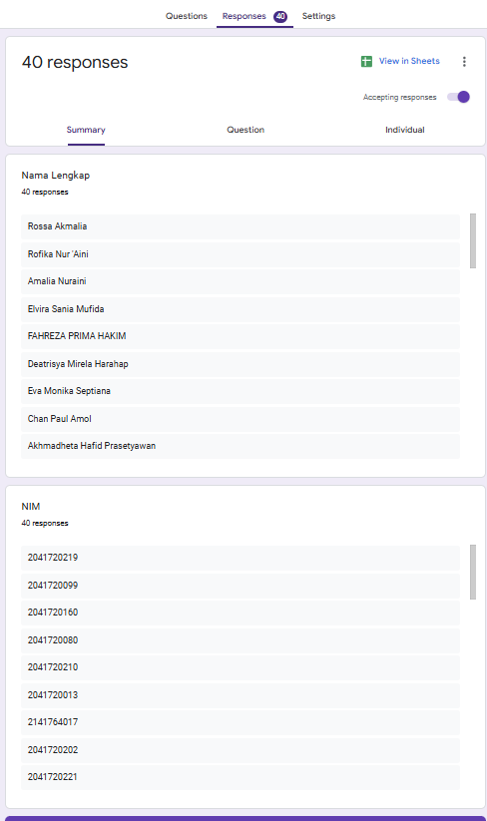
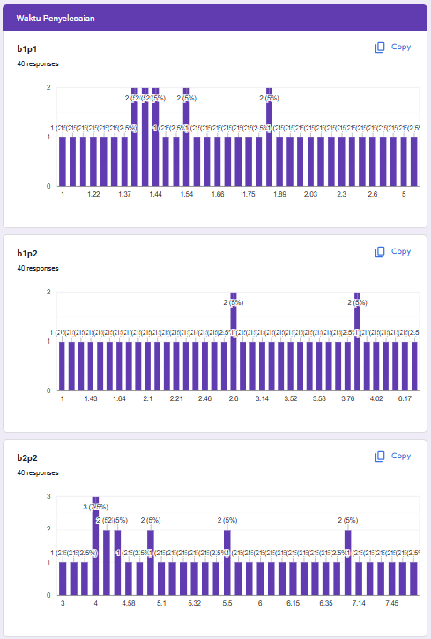
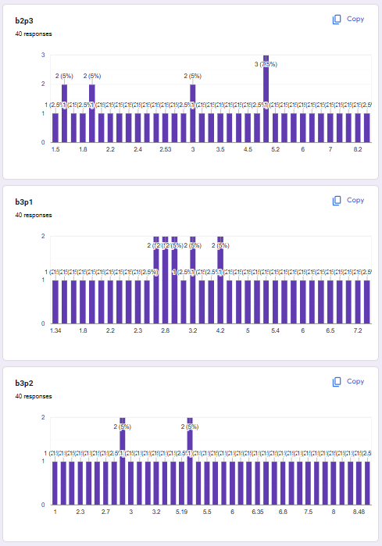
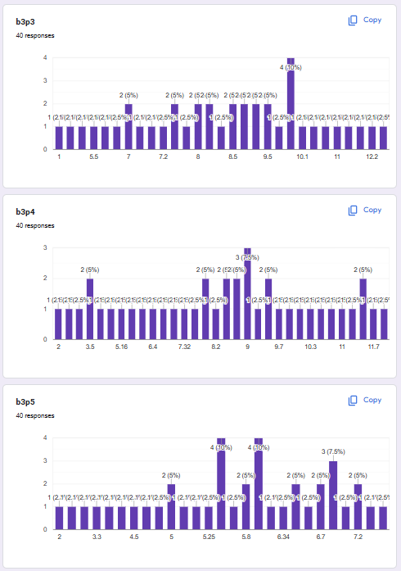
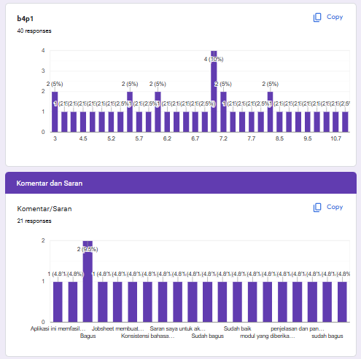

      - Test Code Validation

2.1 Chapter 1 Practicum 1 Test file
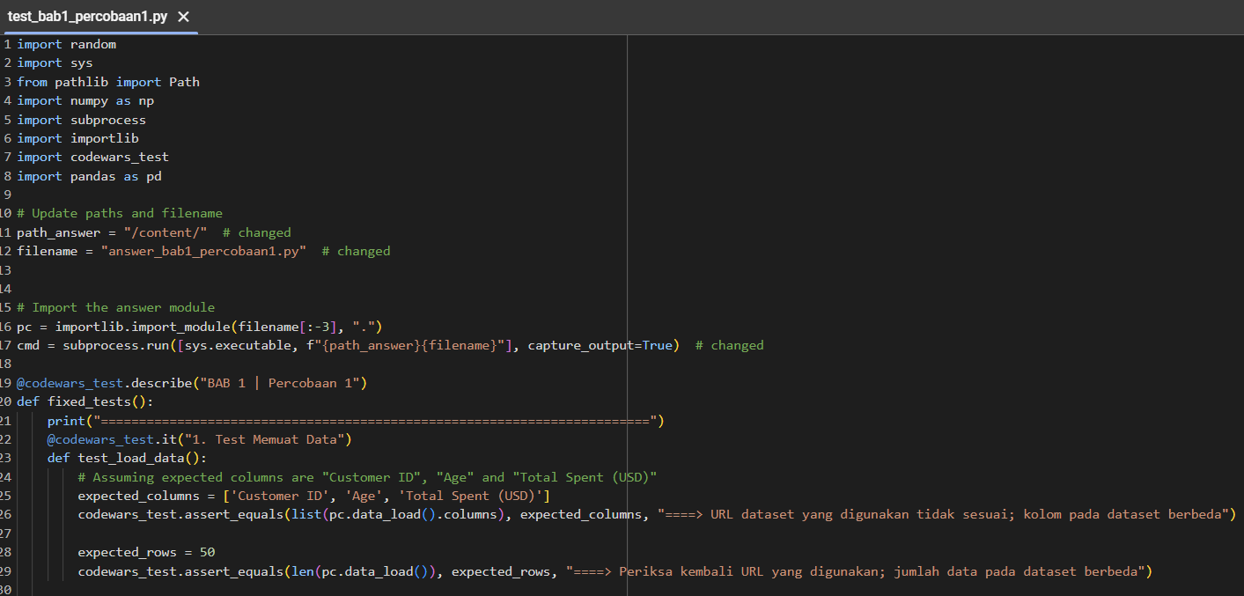
  - Chapter 1 Practicum 2 Test file
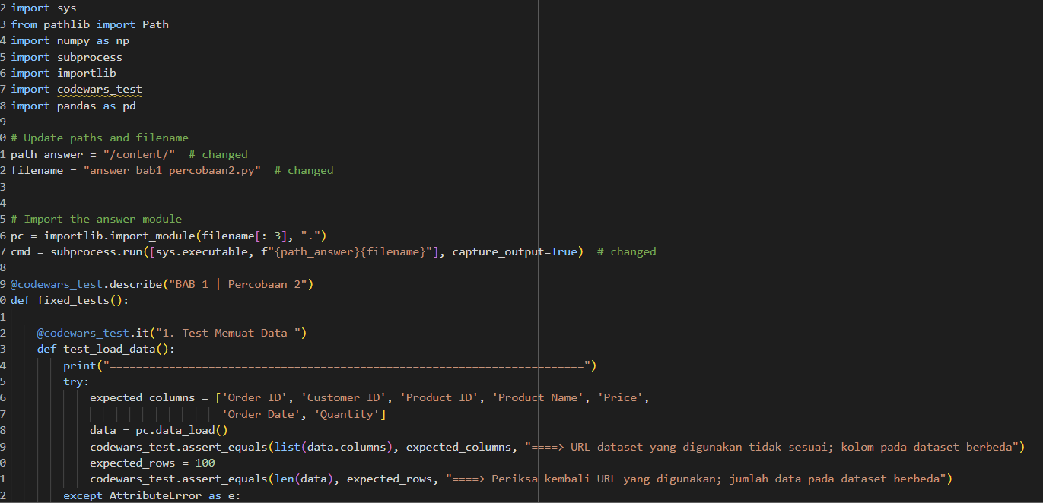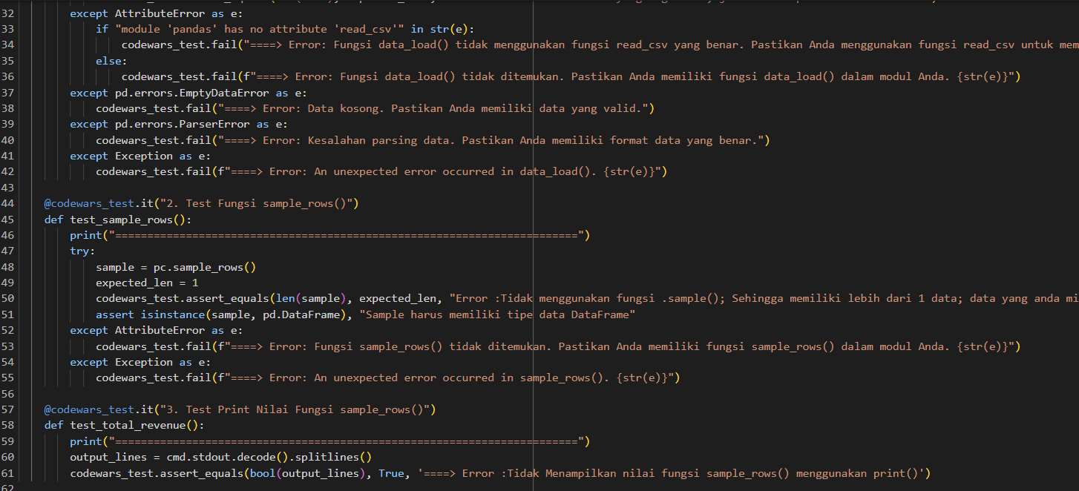
  - Chapter 2 Practicum 2 Test file
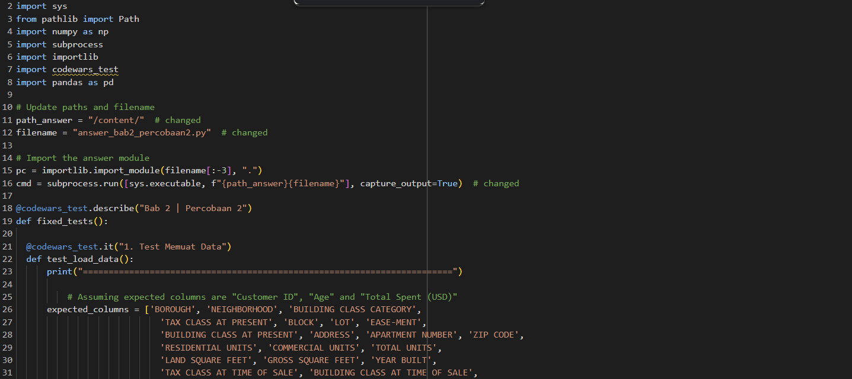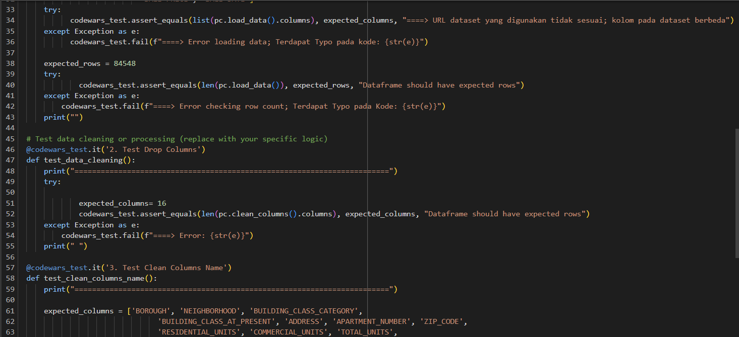
  - Chapter 2 Practicum 3 Test file
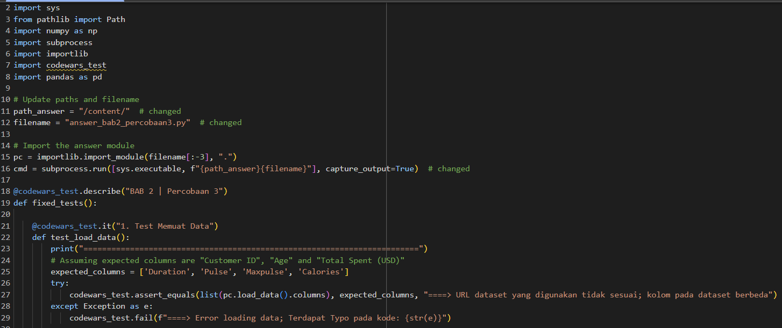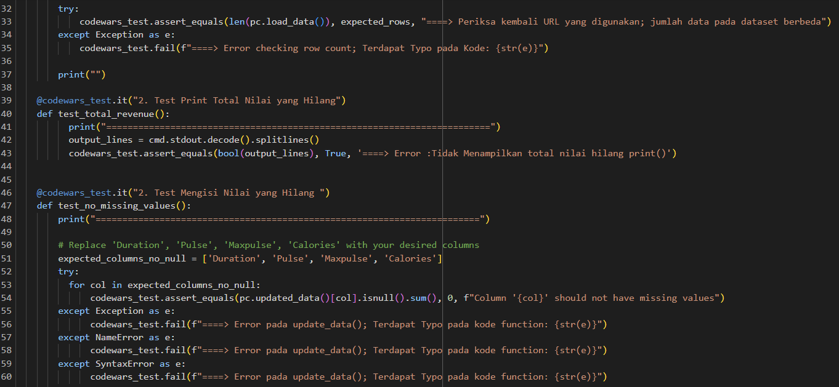
  - Chapter 3 Practicum 1 Test file
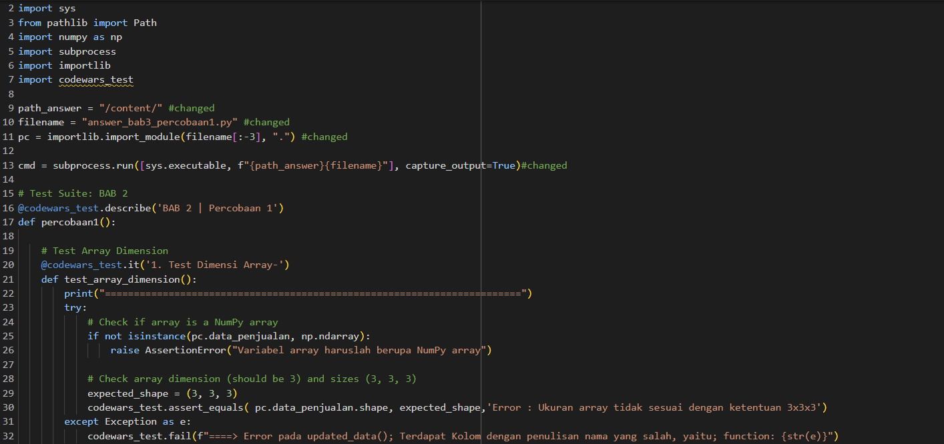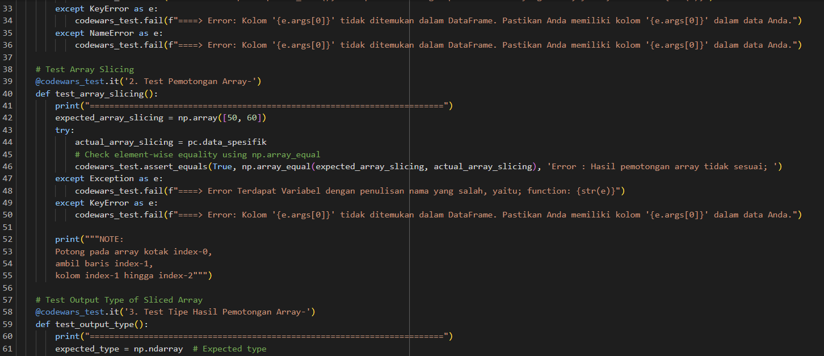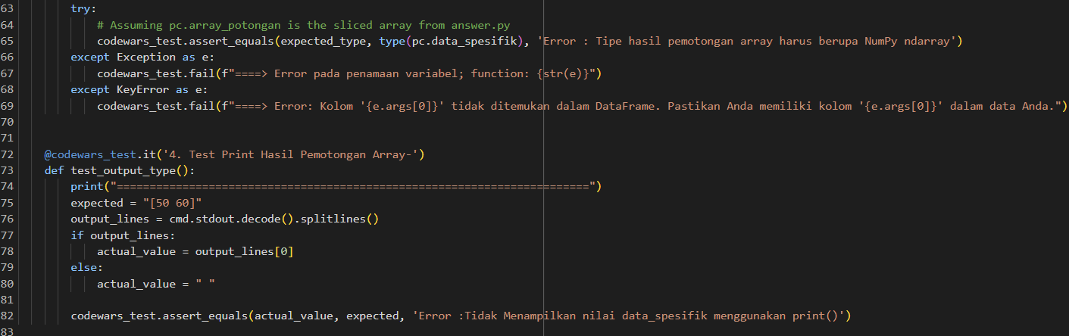
  - Chapter 3 Practicum 2 Test file
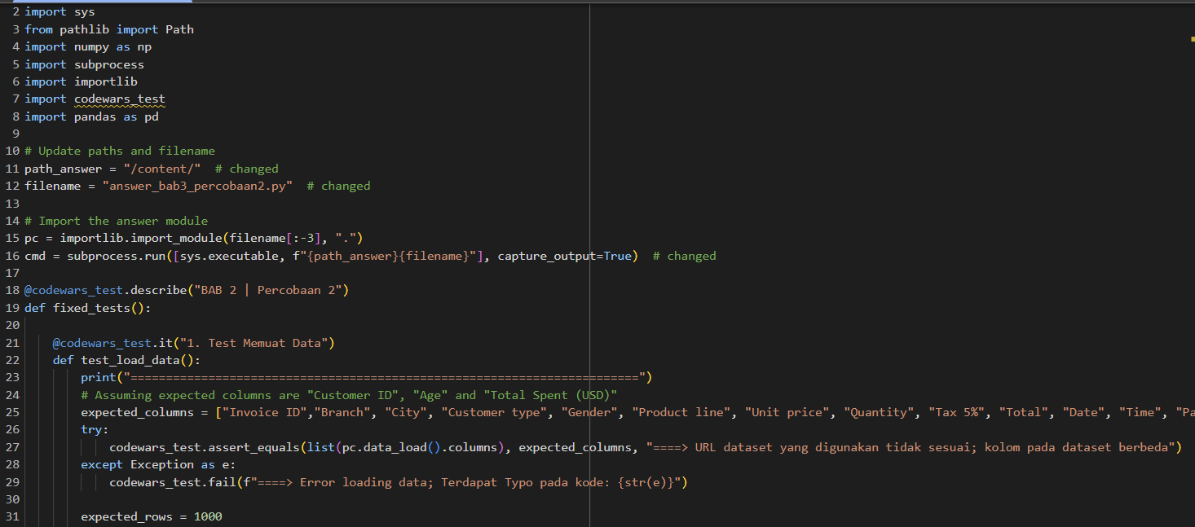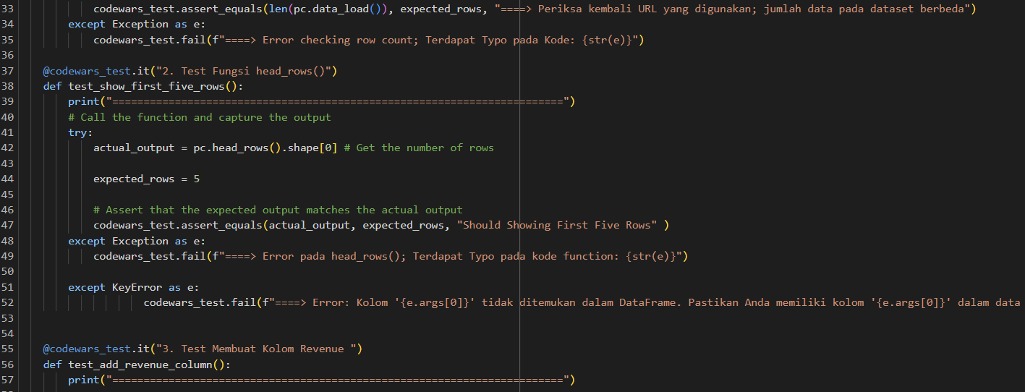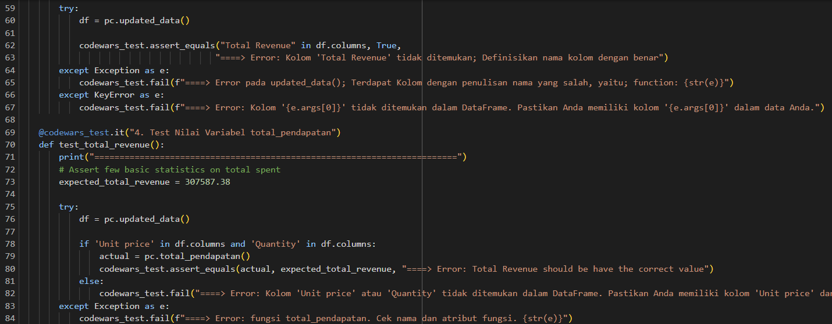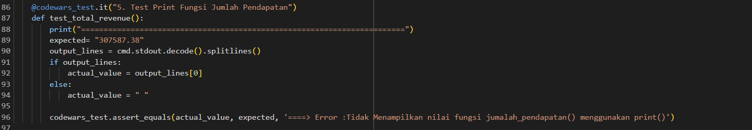
  - Chapter 3 Practicum 3 Test file
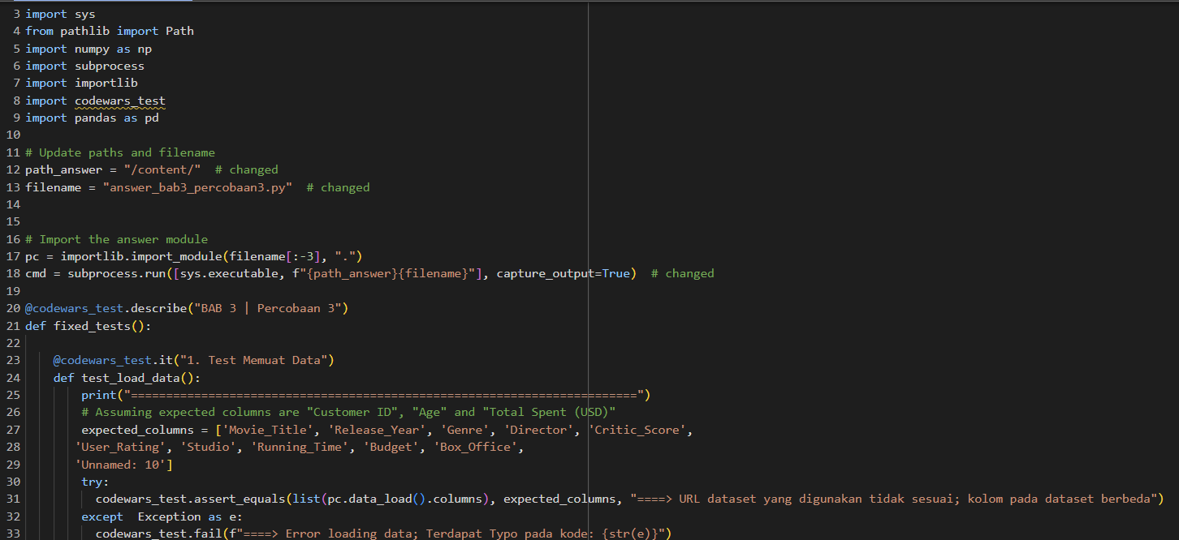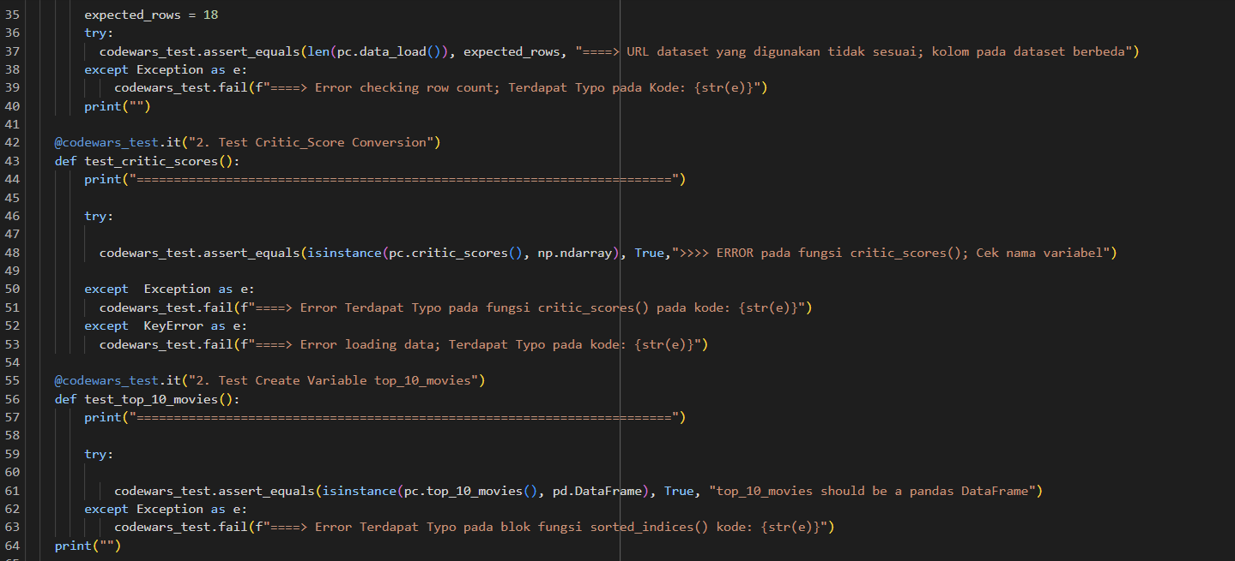
  - Chapter 3 Practicum 4 Test file
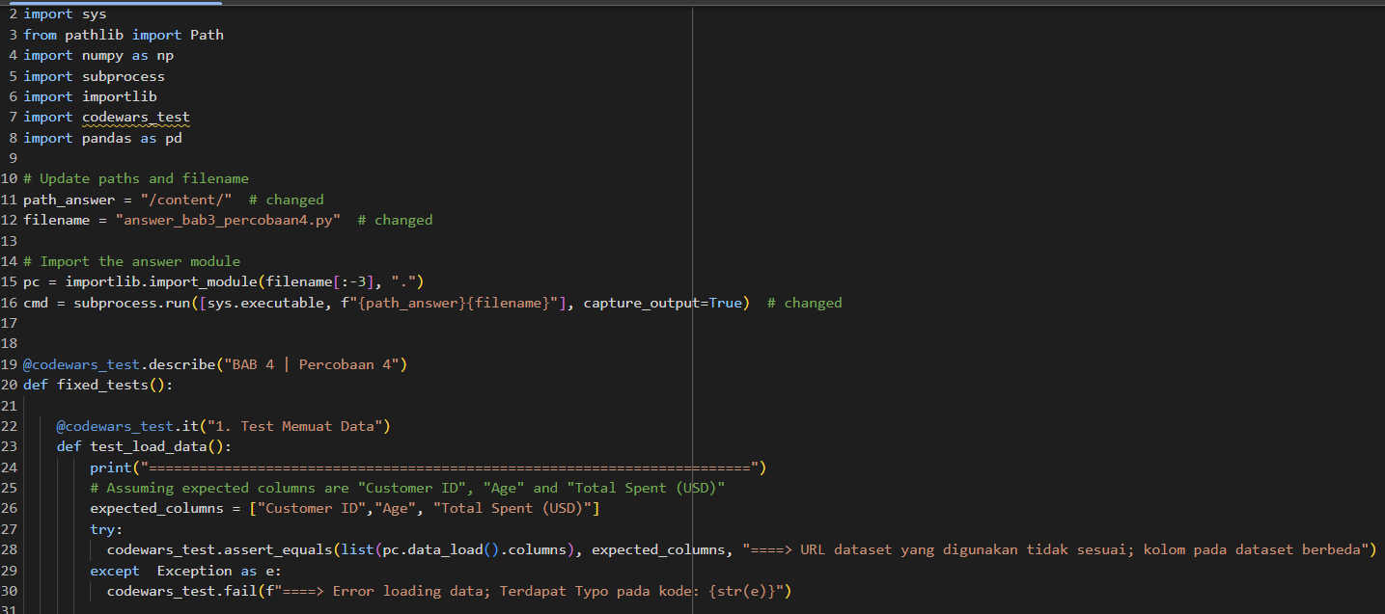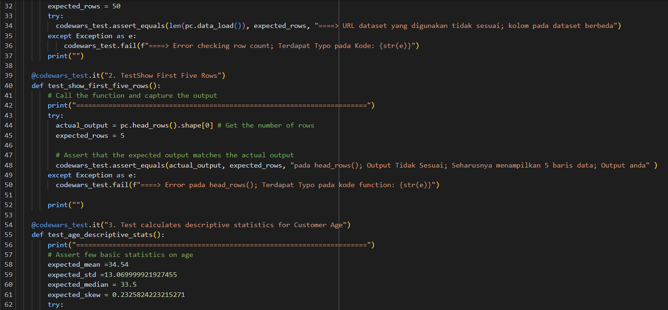
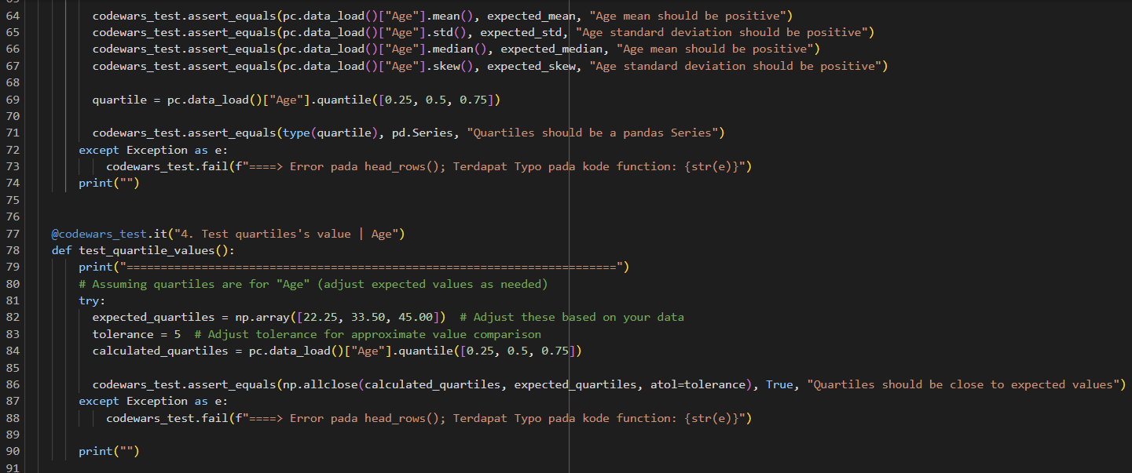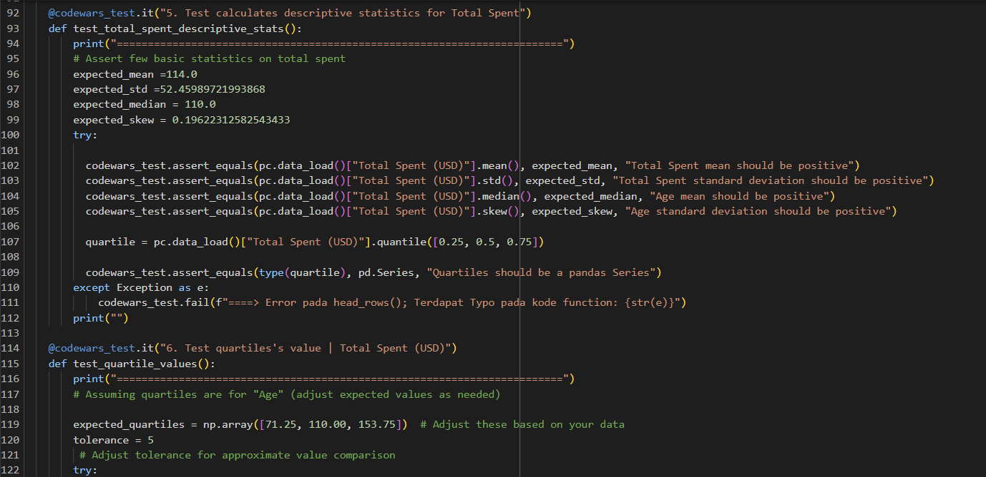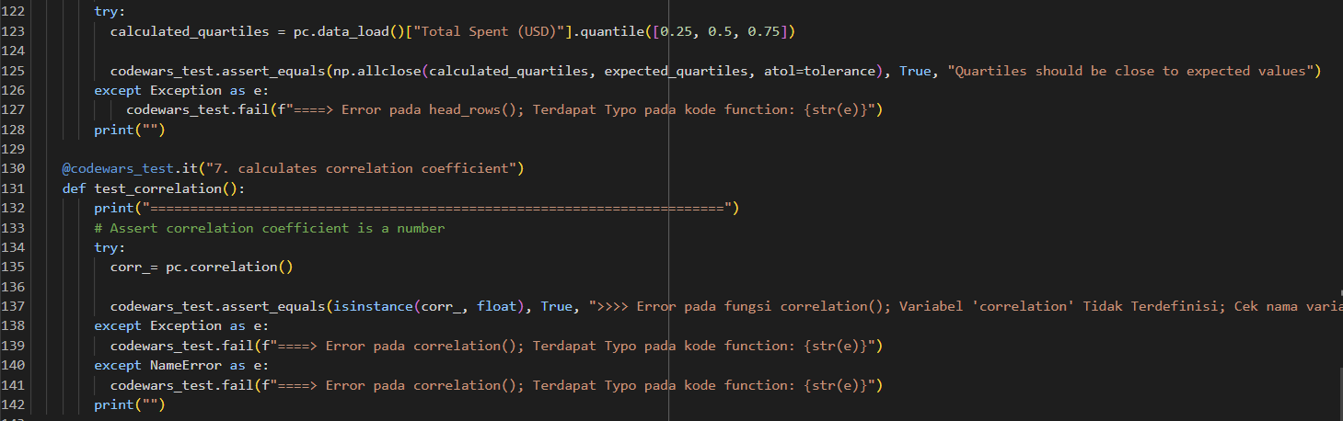
  - Chapter 3 Practicum 5 Test file
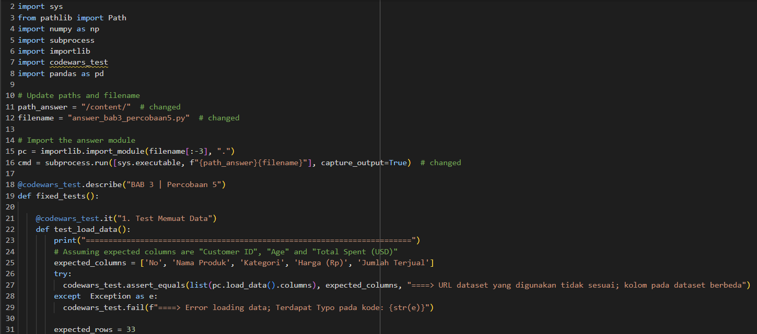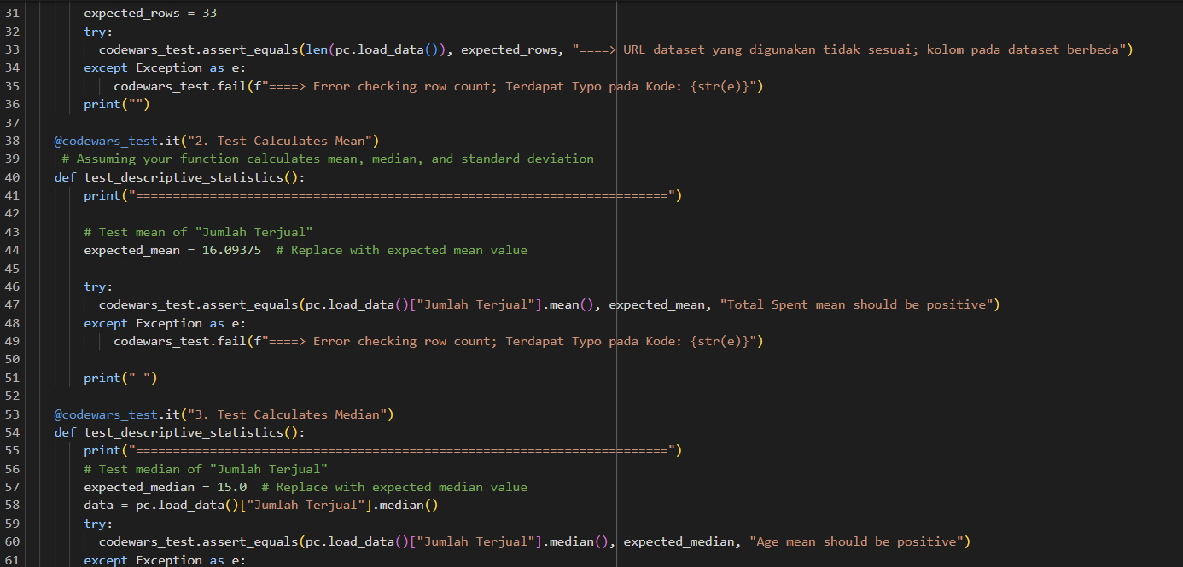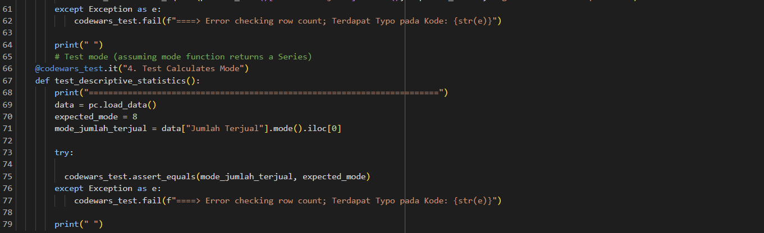
  - Chapter 4 Practicum 1 Test file

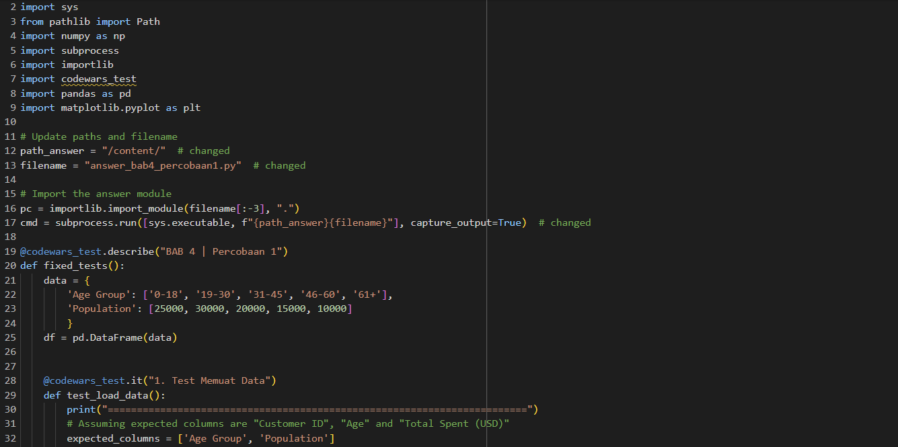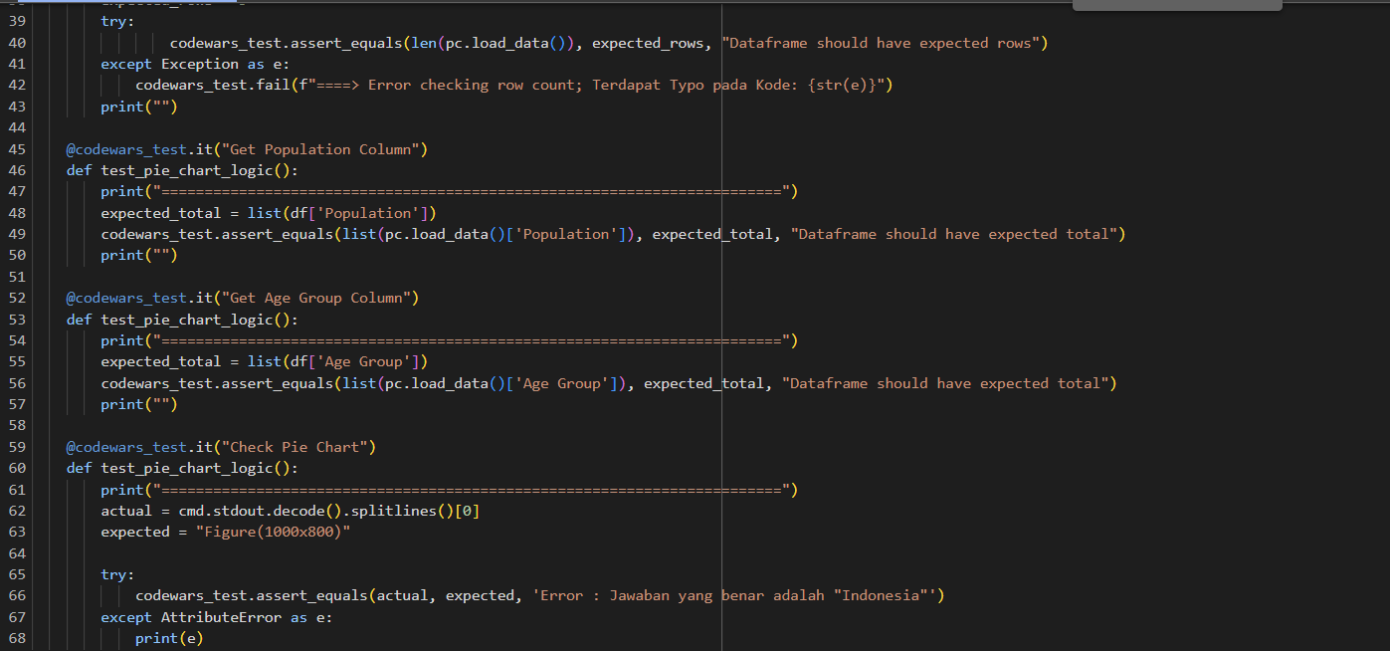

- Data Analytics Learning Module
Study Case and Practicum

3.1 Chapter 1 Practicum 1
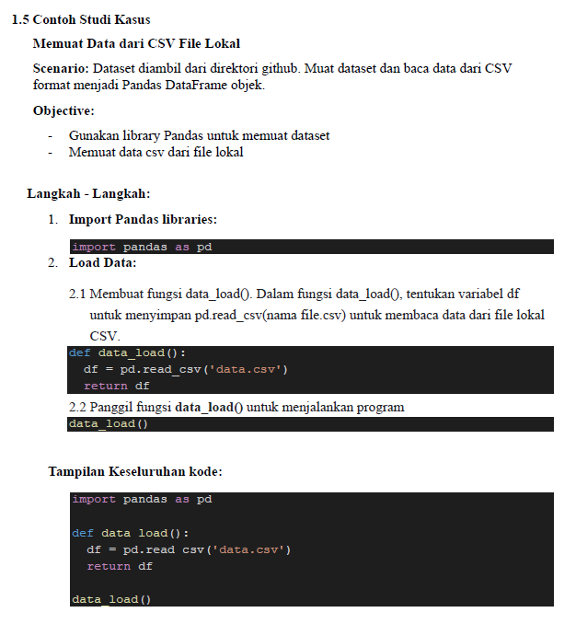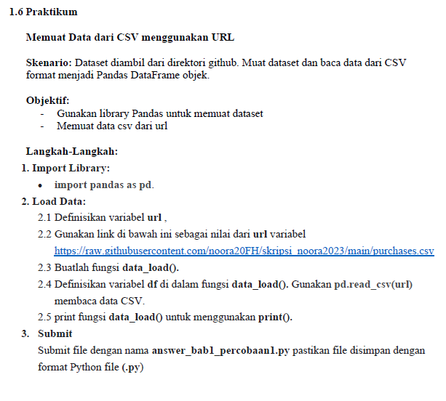

3.2 Chapter 1 Practicum 2
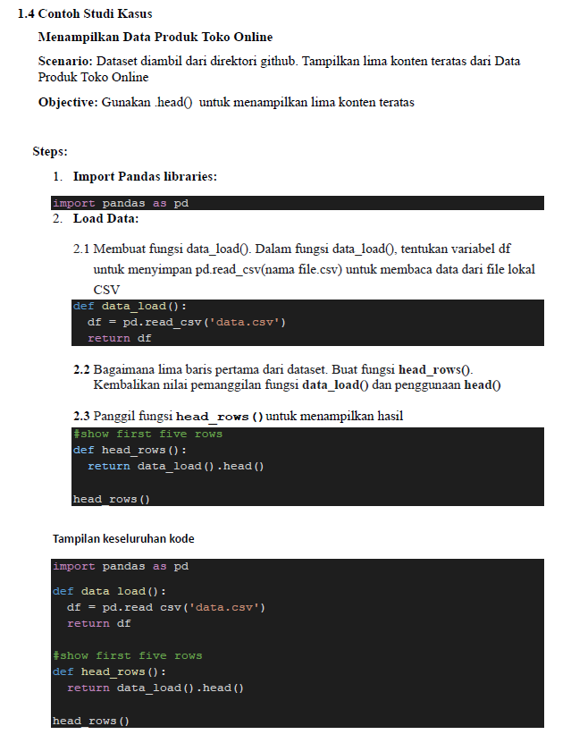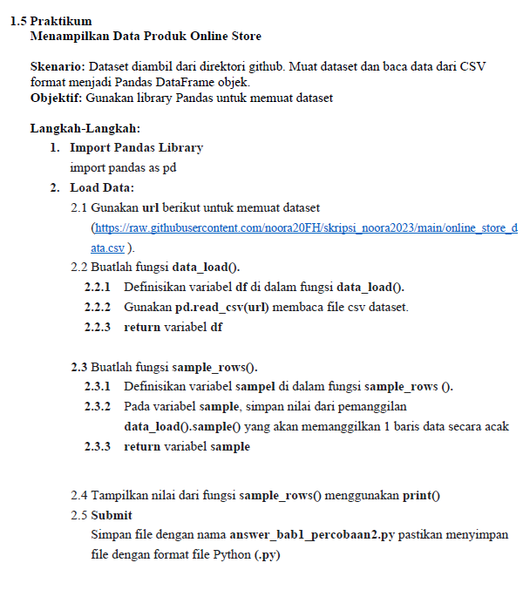

3.3 Chapter 2 Practicum 3
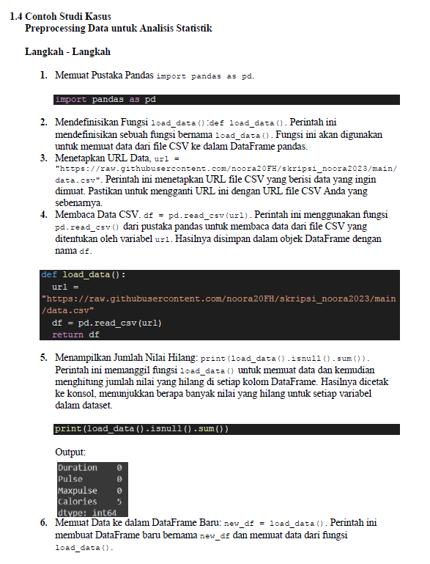
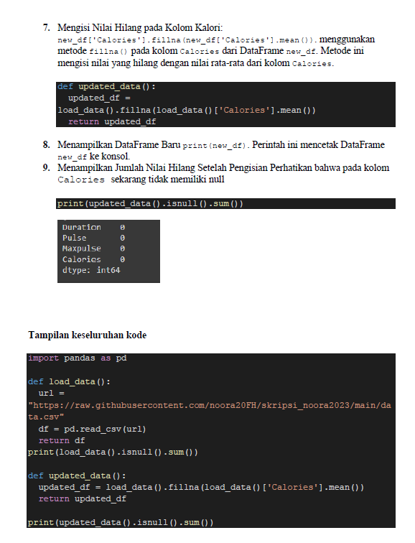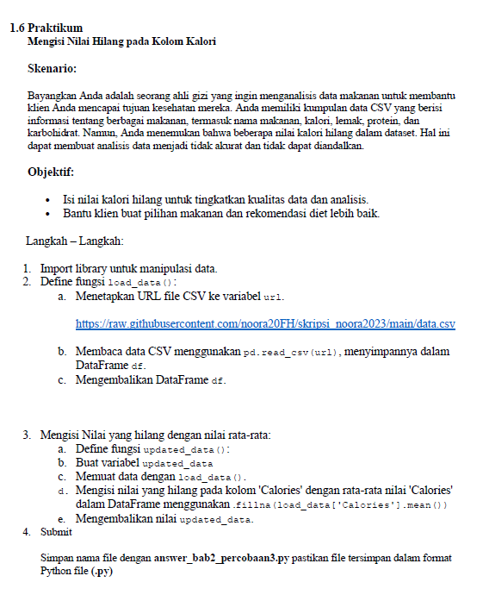

3.4 Chapter 3 Practicum 1
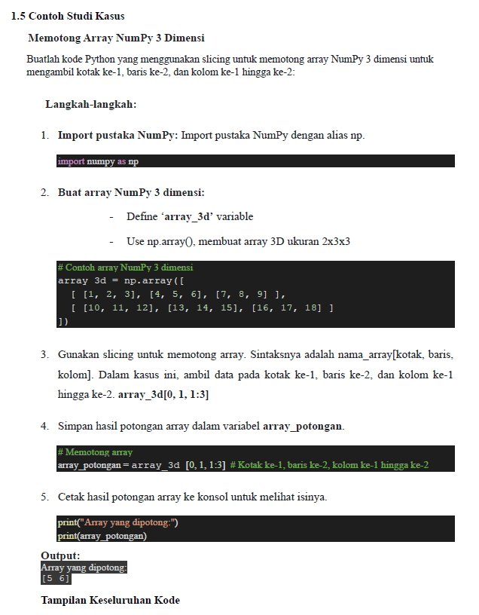
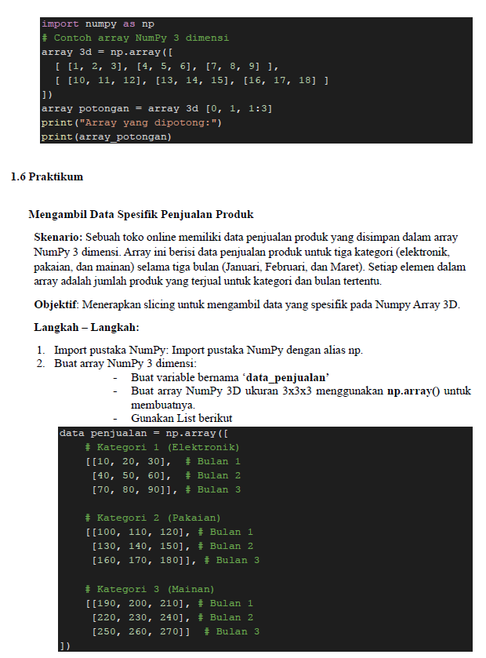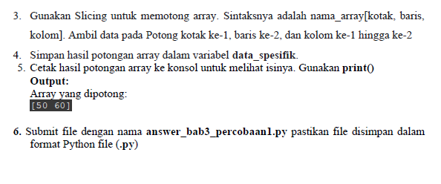

3.5 Chapter 3 Practicum 2
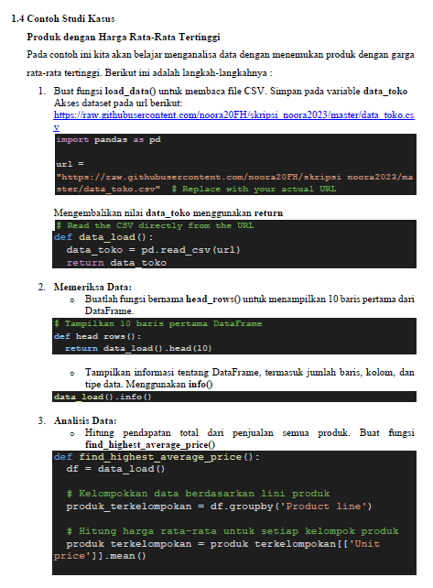
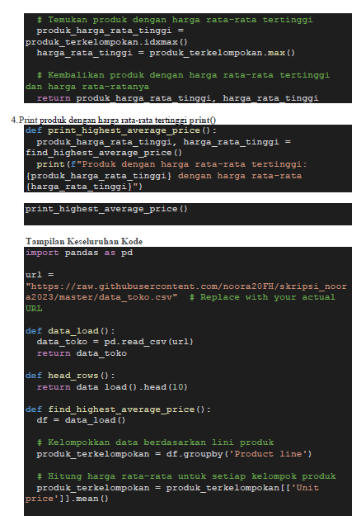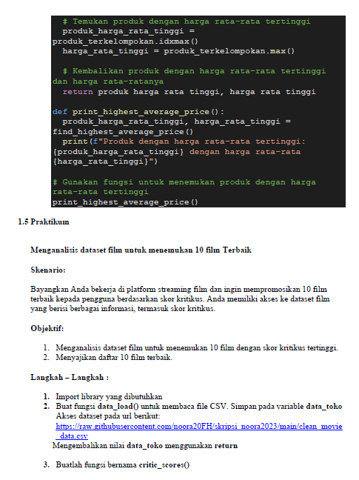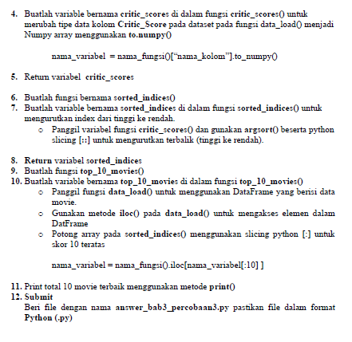

3.6 Chapter 3 Practicum 4
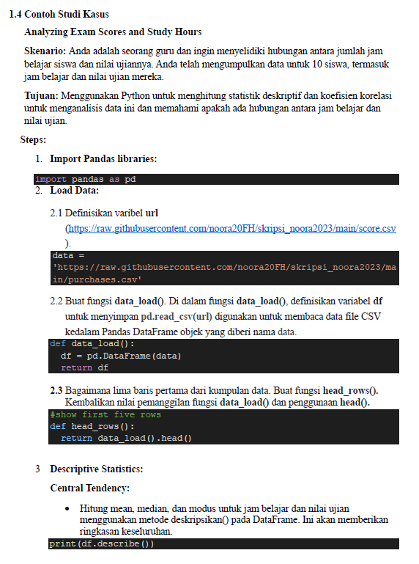
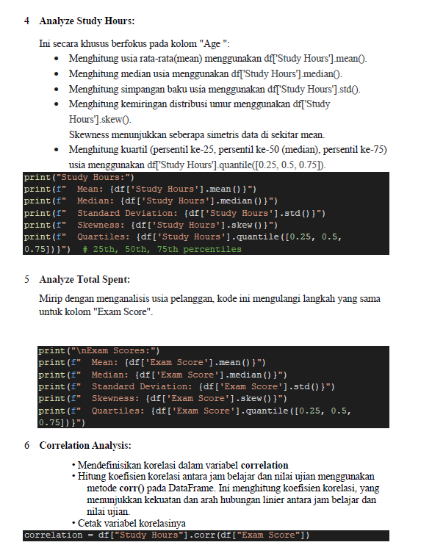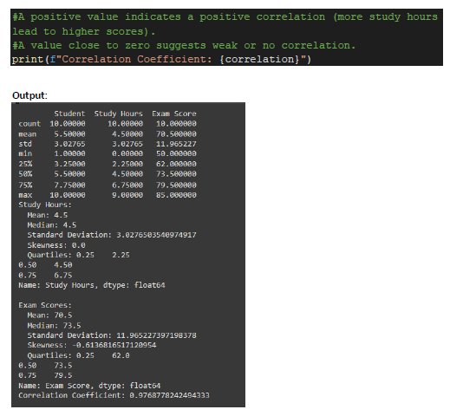
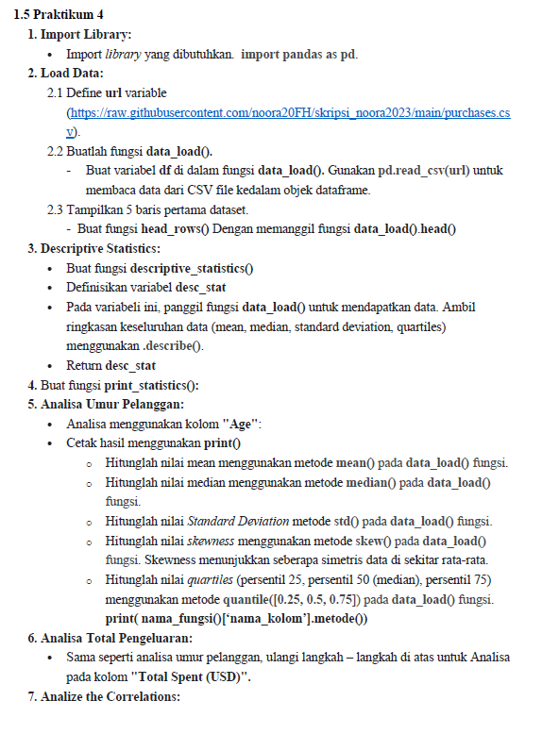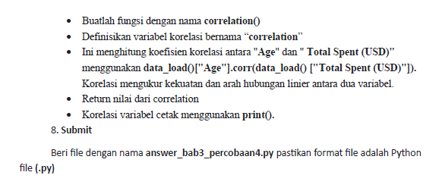

3.7 Chapter 3 Practicum 5
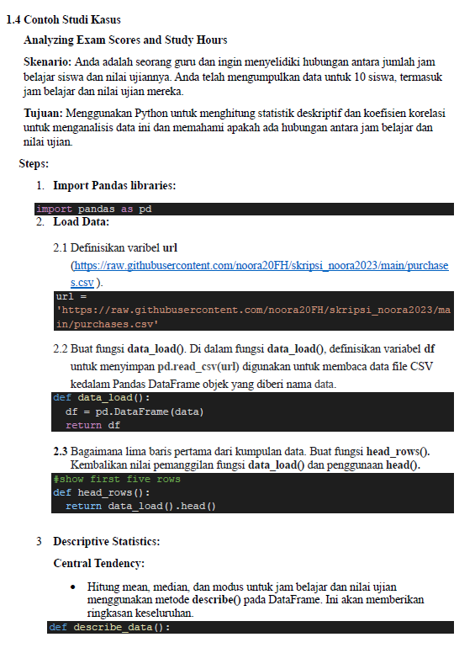
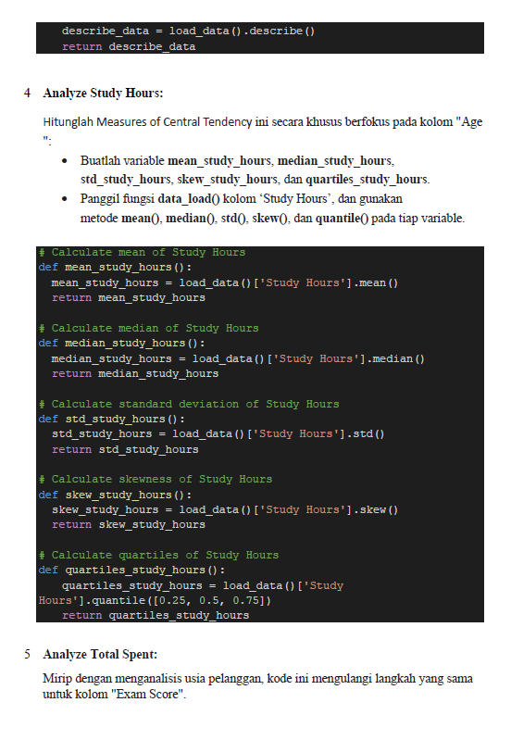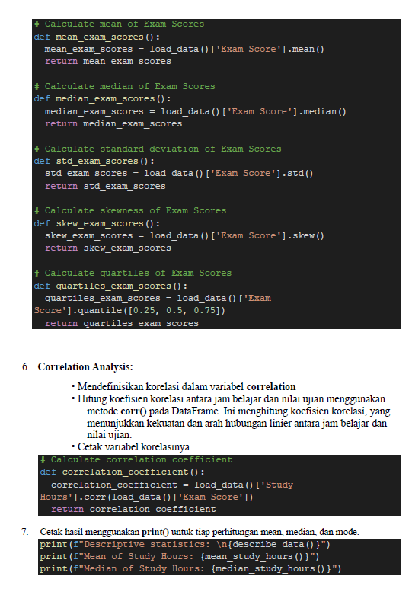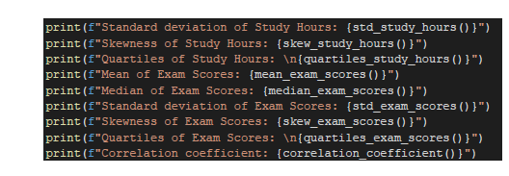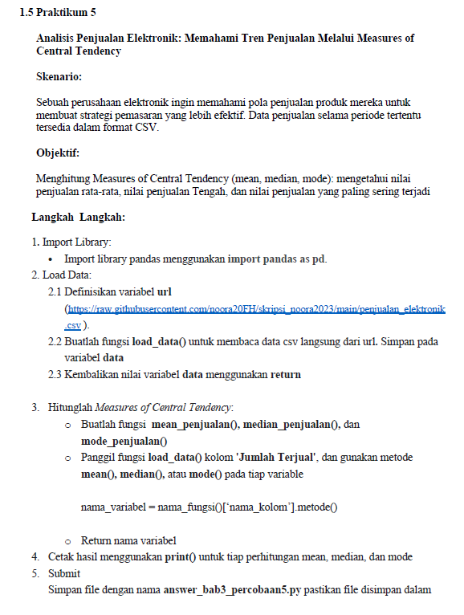

3.8 Chapter 4 Practicum 1
